**DAY-01**

**08/10/2021**

**Name**: Harshal Acharya

**Roll No**: 12

**Batch**: B11

**Topics:-**

1. Dimensions ,Measures
2. Exploring Menus
3. 3 ways to add data source
4. Exploring 24 Charts
5. Adding Colours
6. Adding labels and formatting

**Datasets:** Office Supplies

**Dimensions:-**

* Item
* Order Date
* Region
* Rep (Representative)
* Measure Names

**Measures:-**

* Unit Price
* Units
* Measure Values

**Exploring Menus:-**

* Worksheets
* Dashboard
* Story

**3 Ways To Add Data Source:-**

* Data Menu
* Data Source(Bottom Left)
* Home

**Exploring 24 Charts:-**

Pie Chart

Area Chart

Bar Graphs

.

.

.

**How many units sold in each region?**

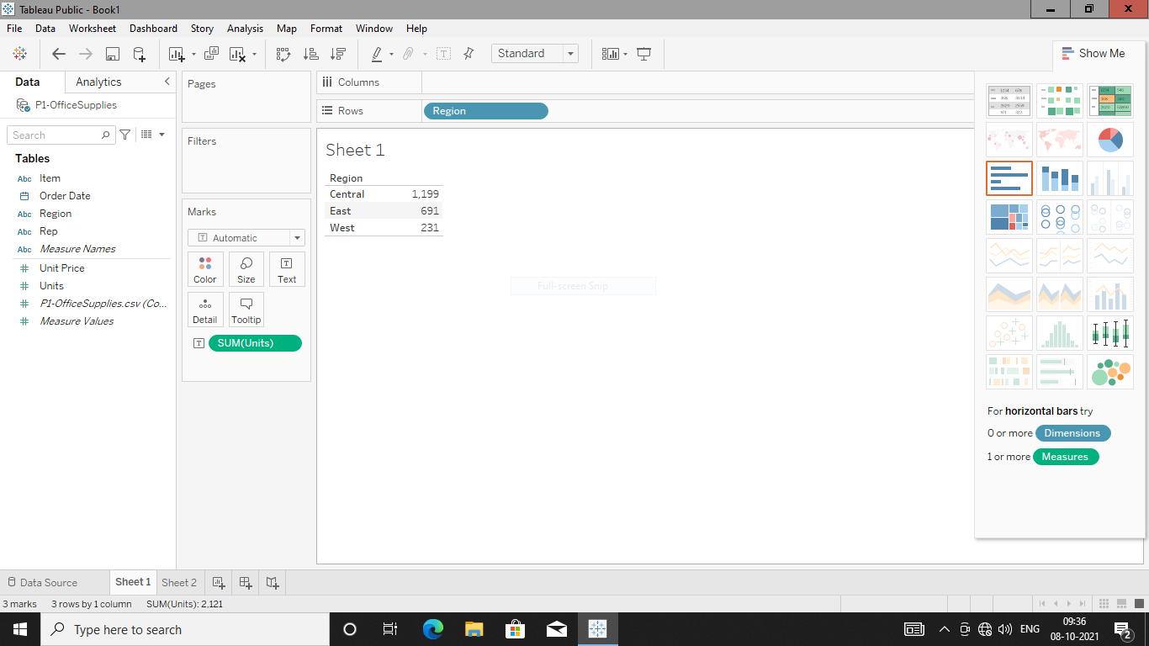

**Create Bar Chart (Sorted Region) for the same.**

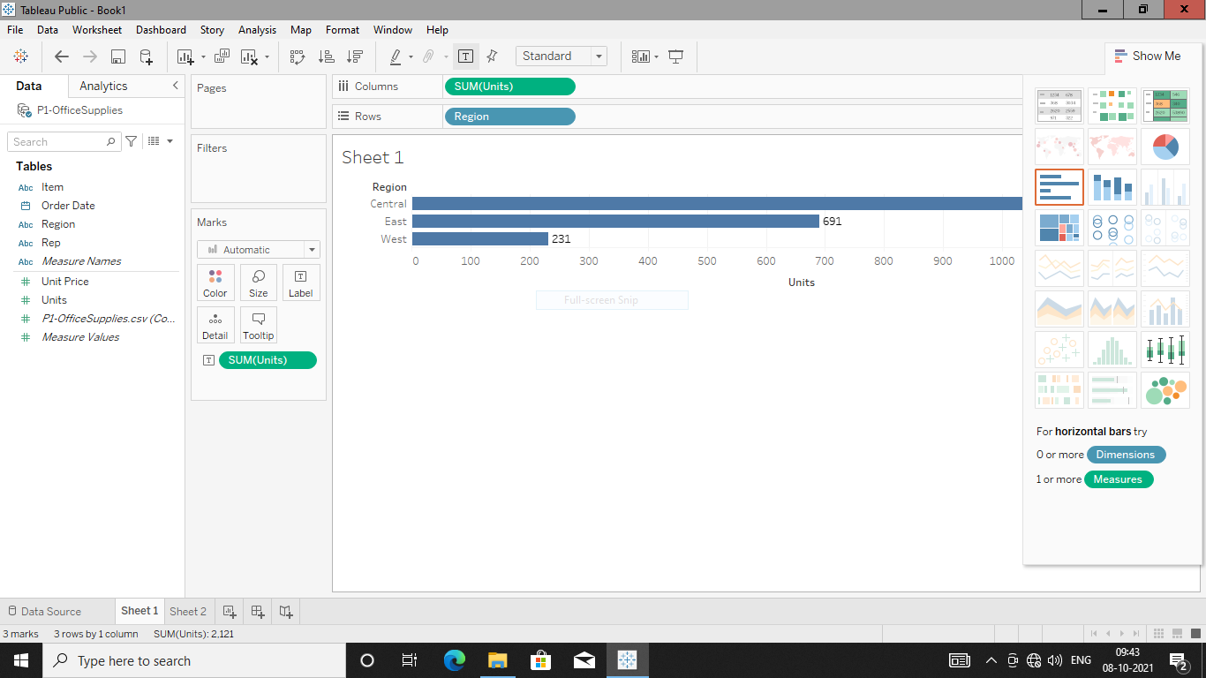

**Area Charts:**

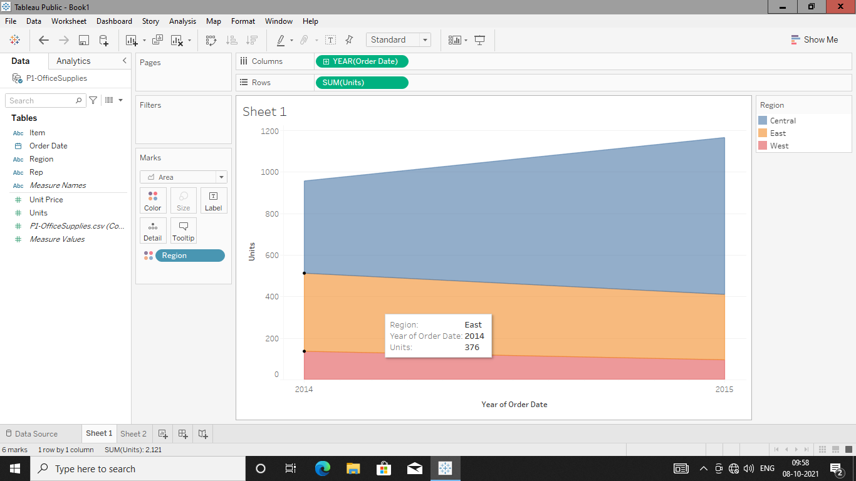

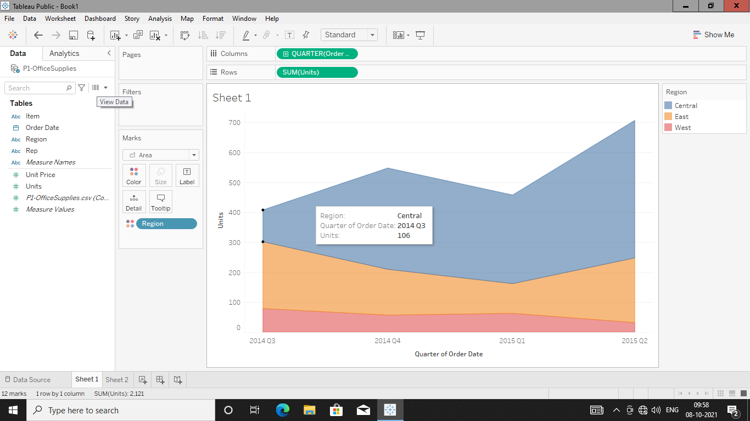

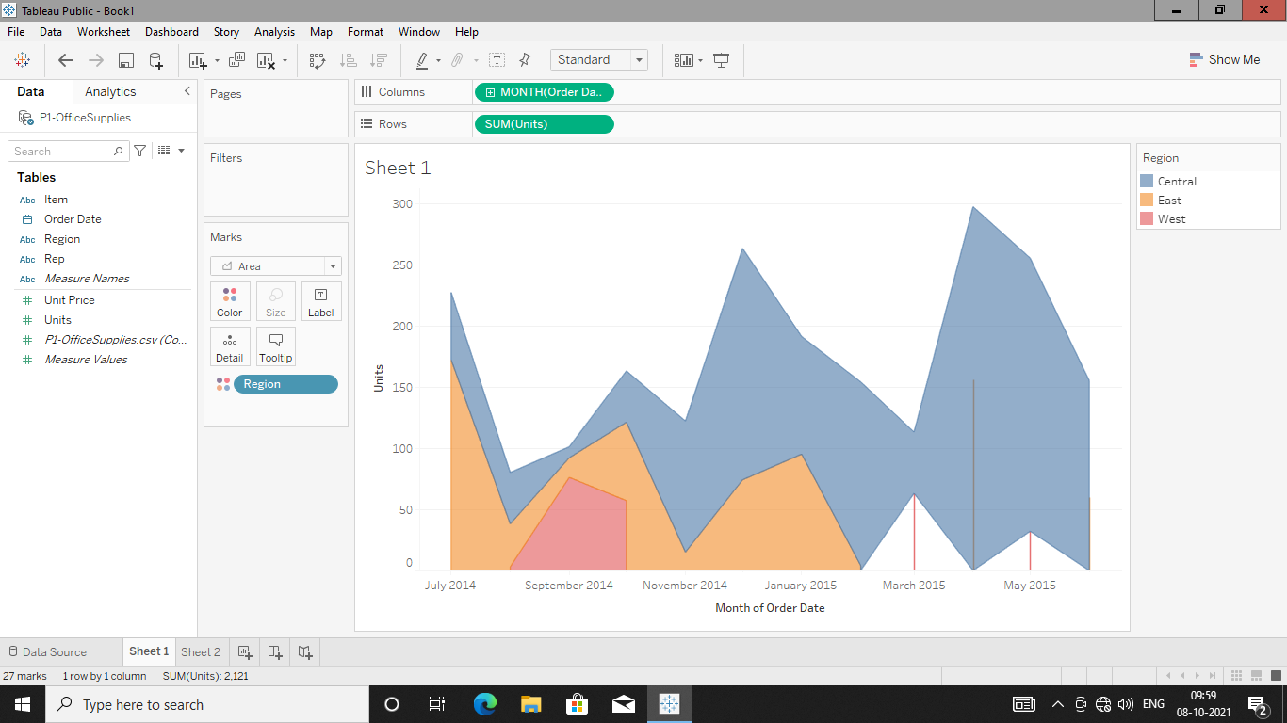

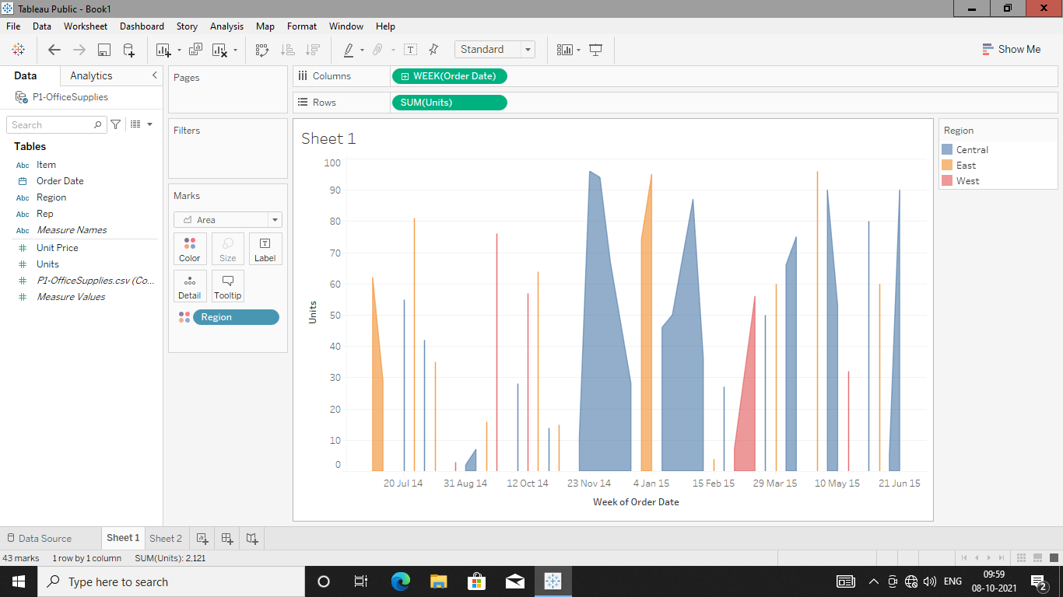

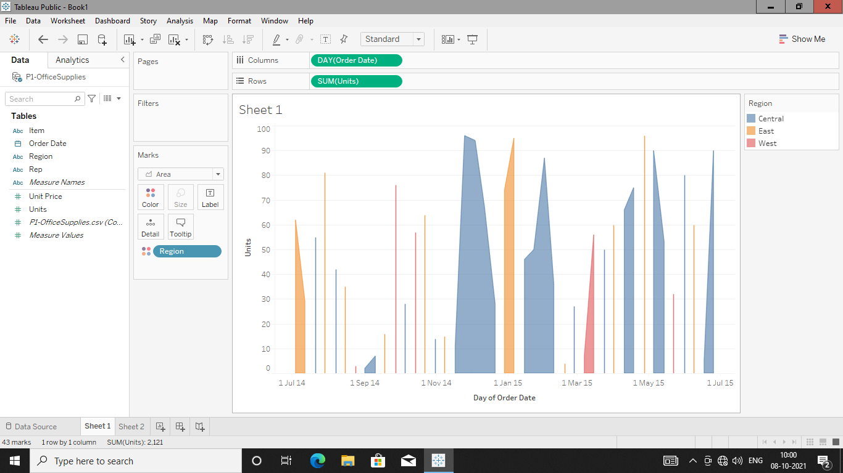

**Representative who have sold highest units:-**

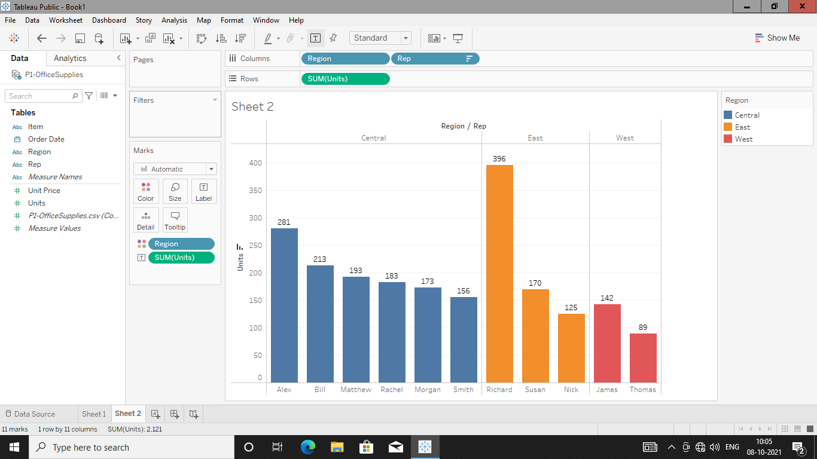

**Find Total Sales (Calculated fields) who got bonus?**

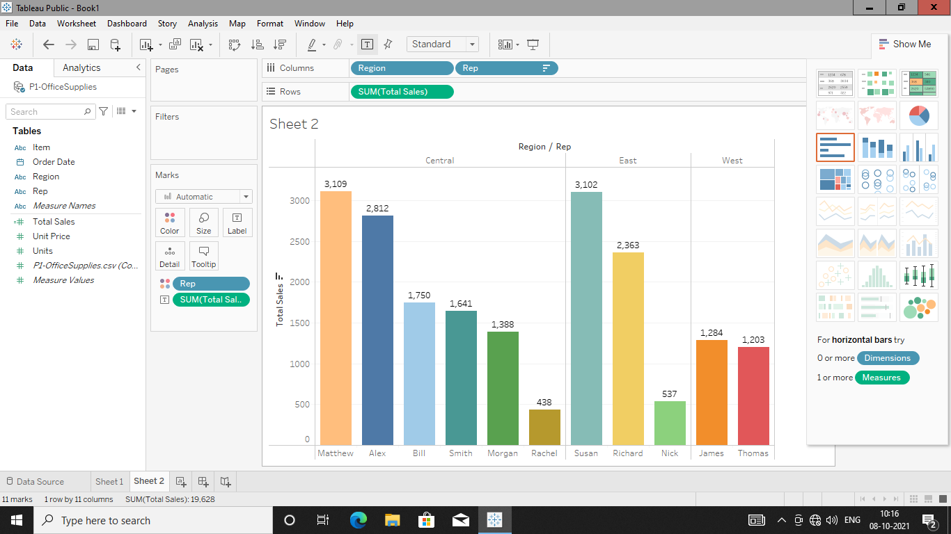

**Exploring Colour Pallete**

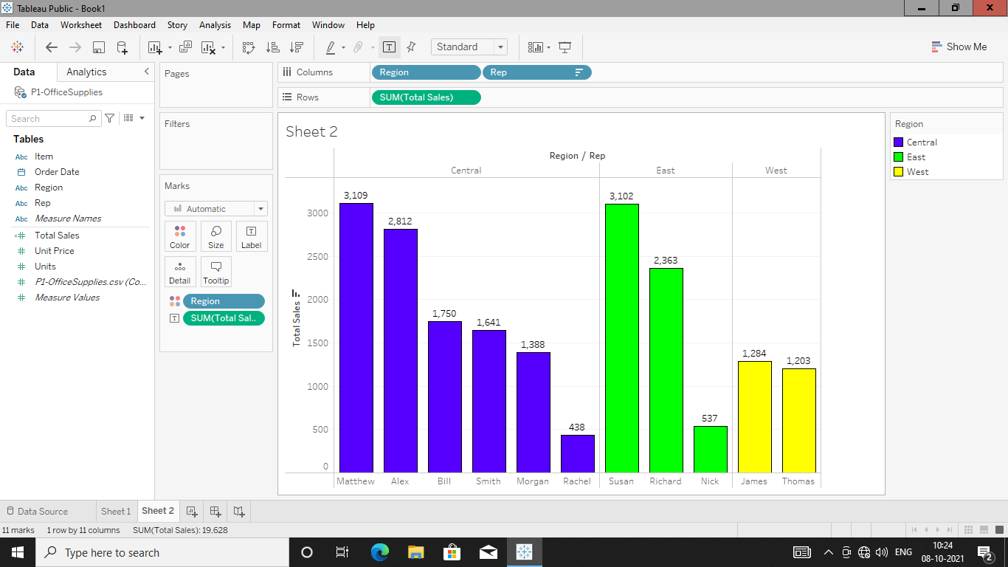

**Adding Labels 🡪 Edit Labels i.e. $301K and formatting Axis,Pane Labels.**

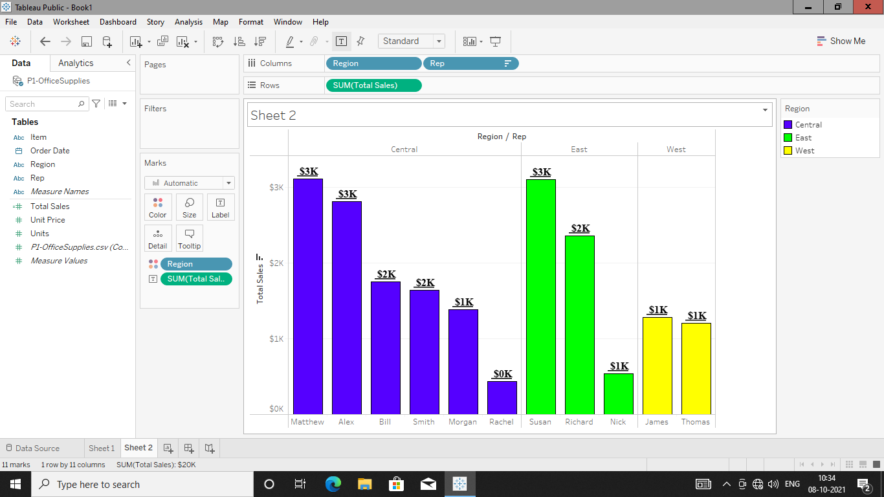

**24 Charts From “Show Me” Tab:**



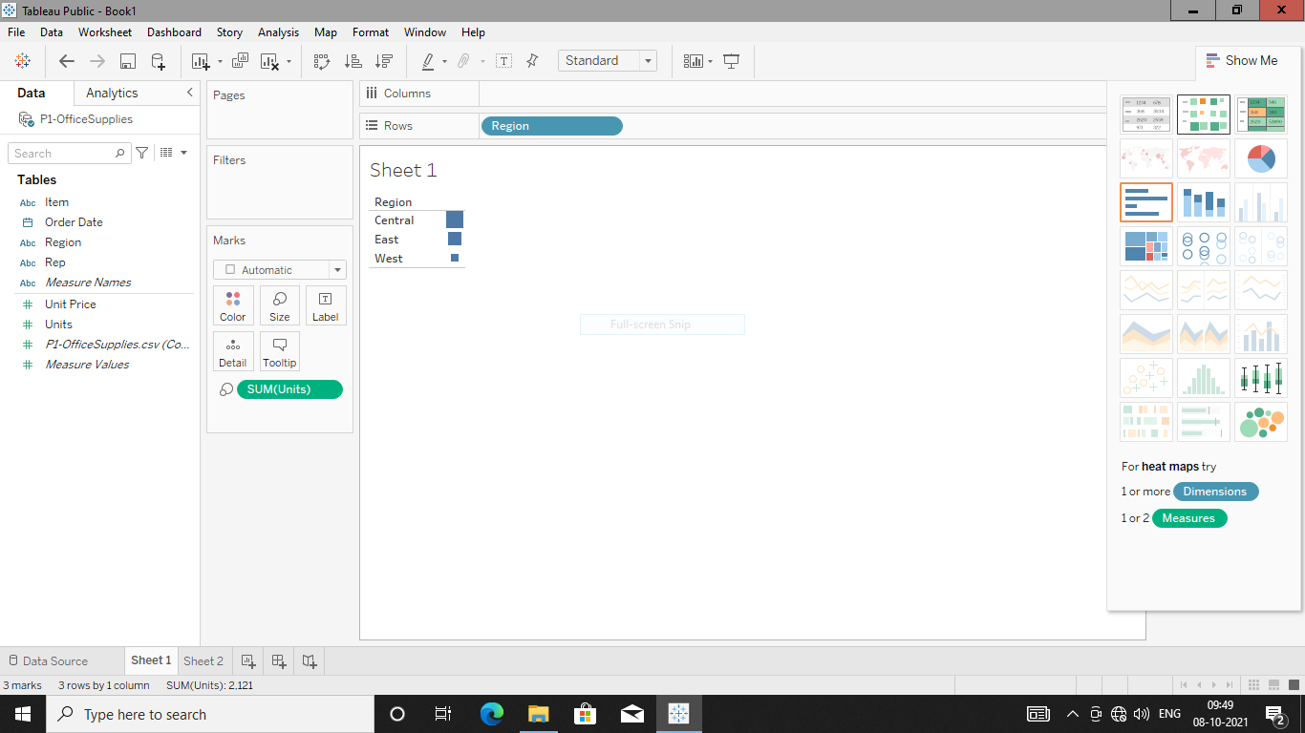



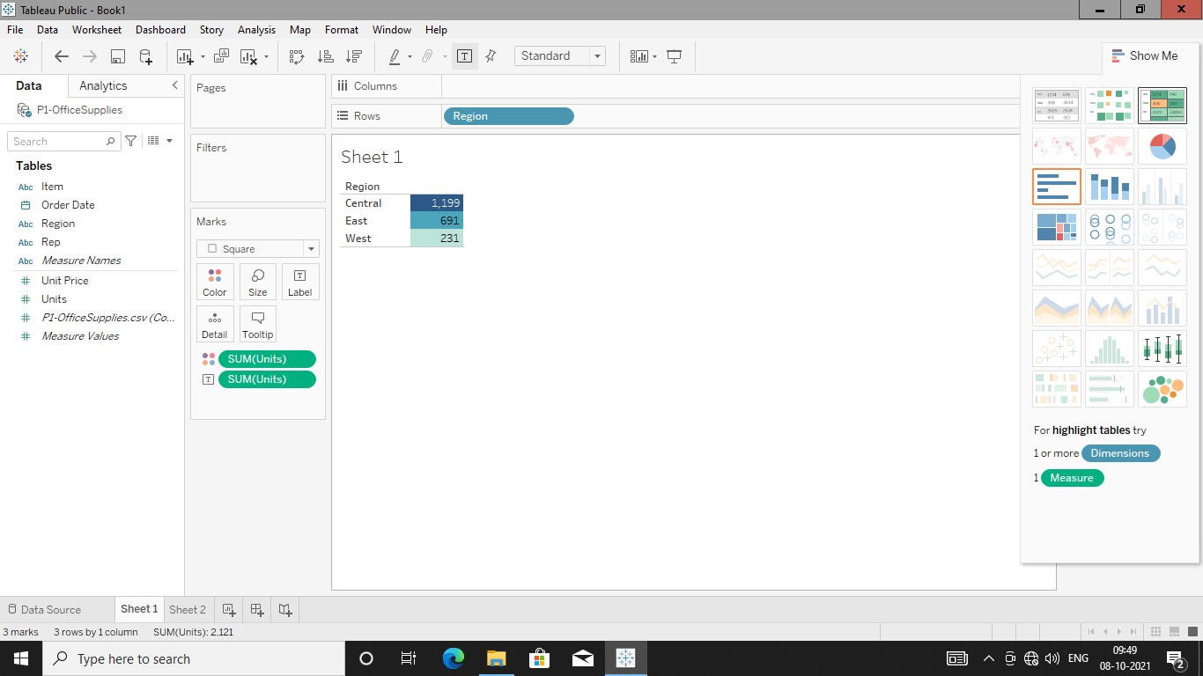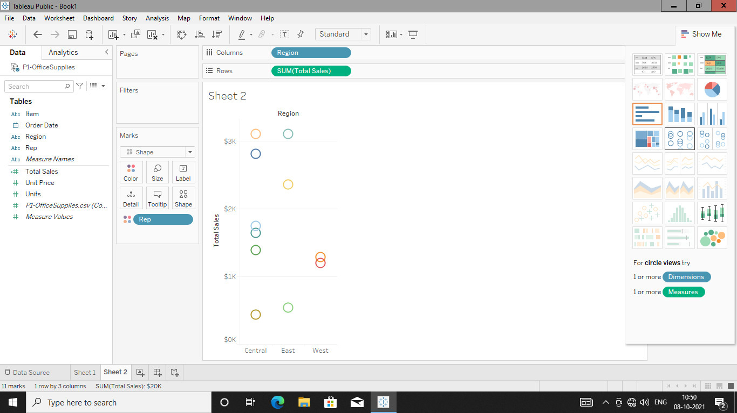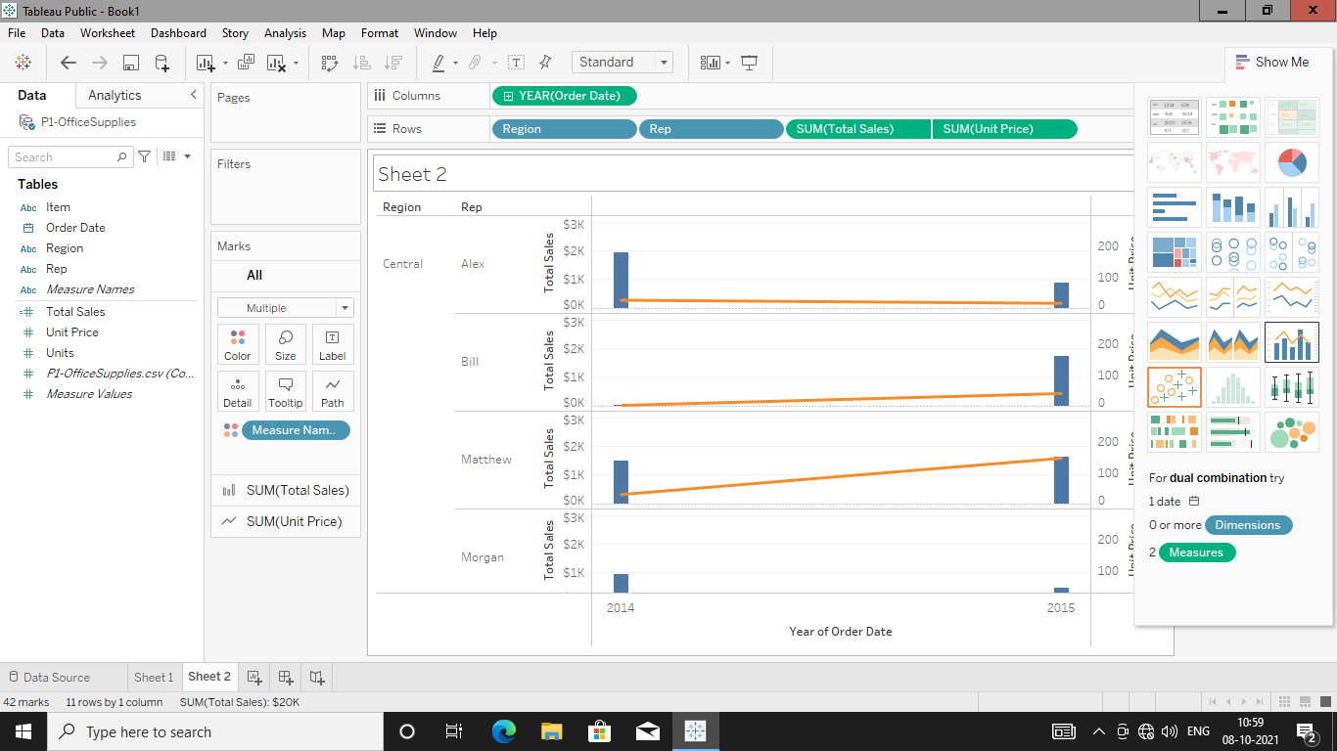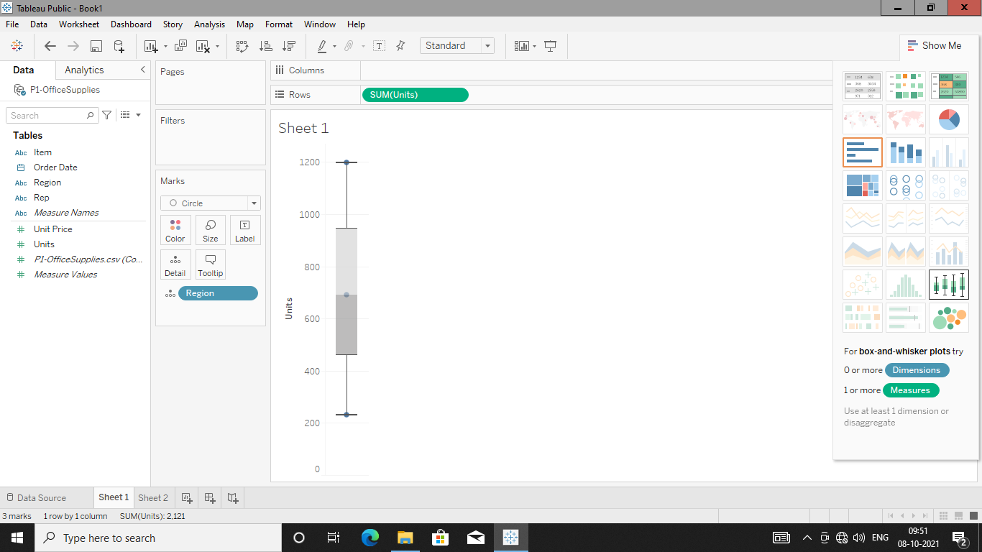

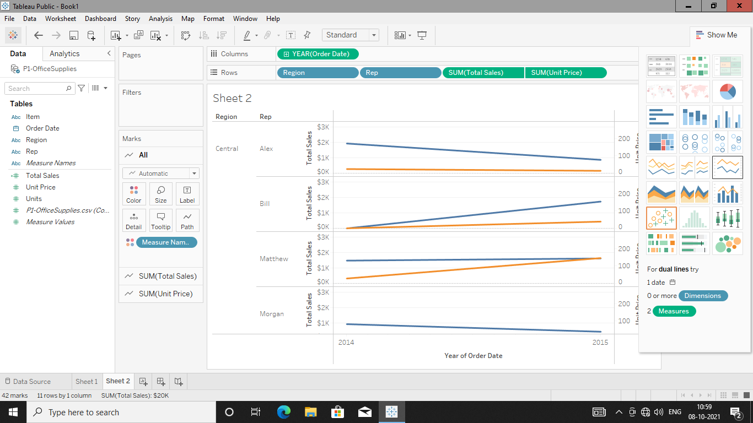

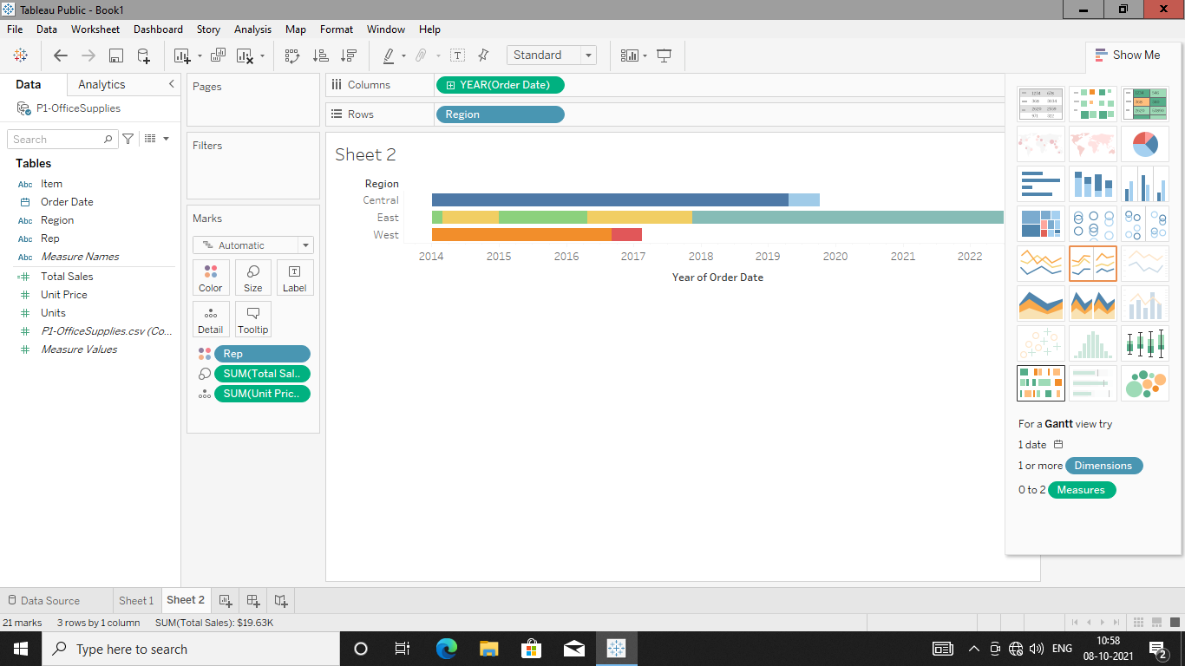

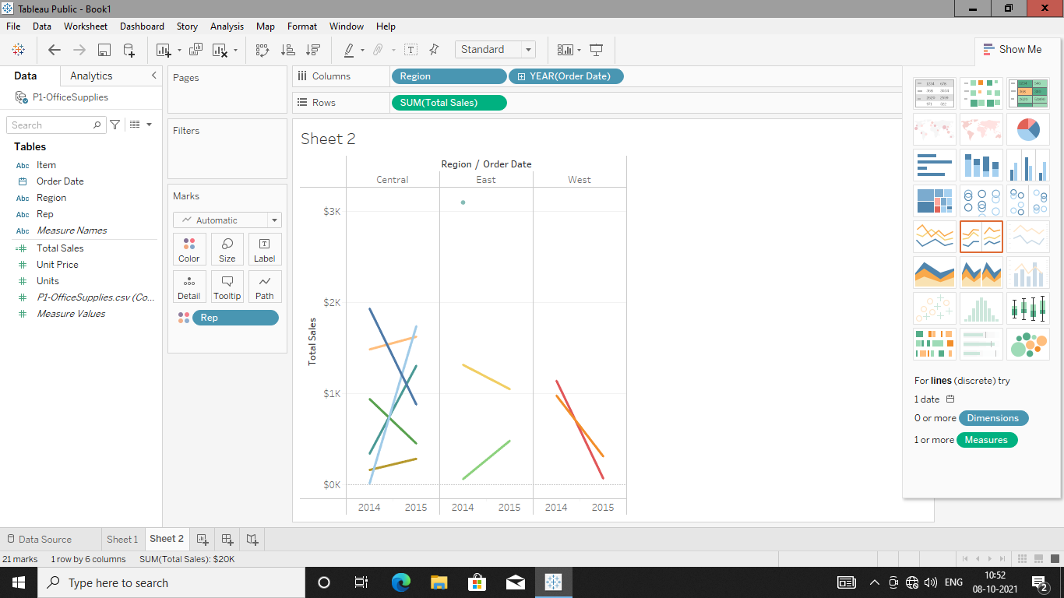

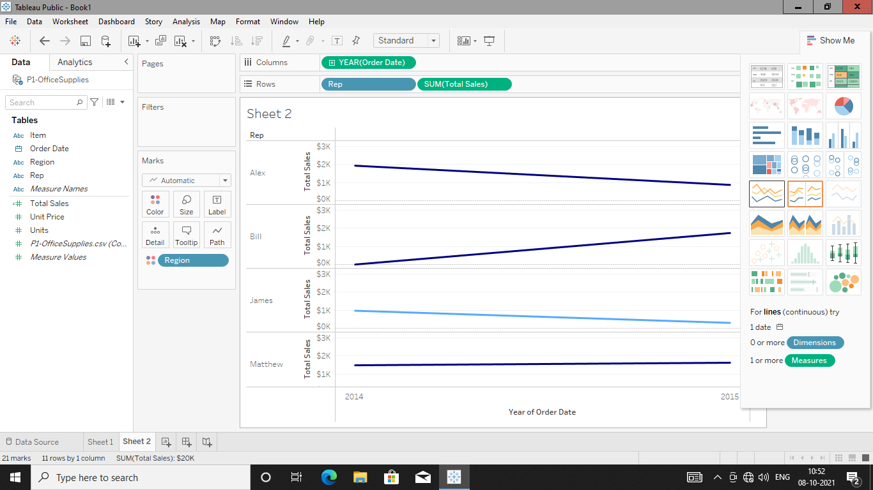

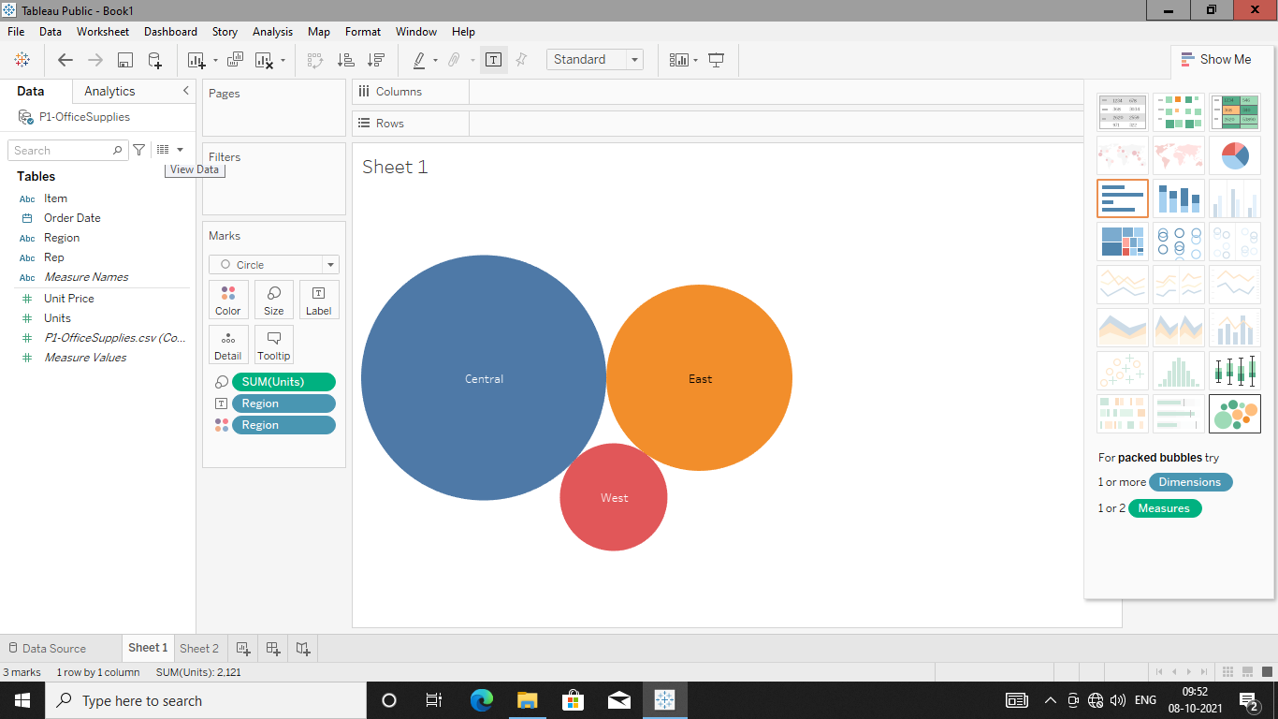

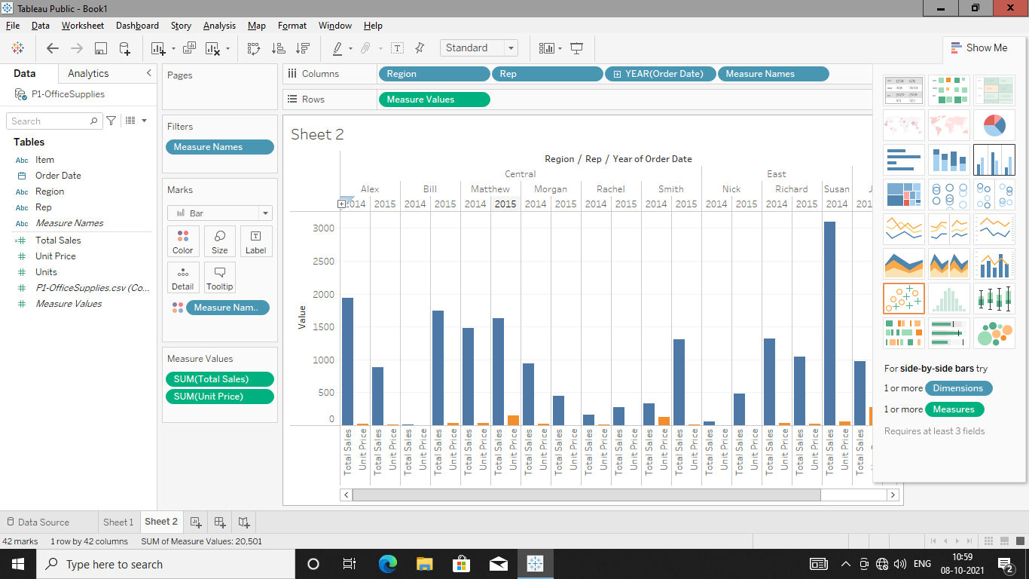

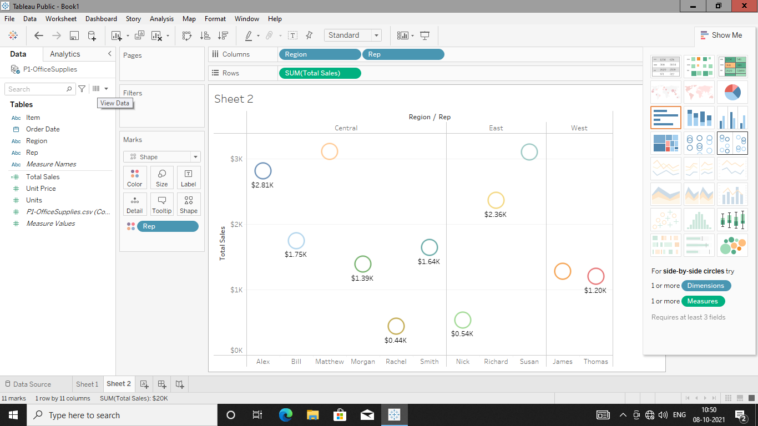

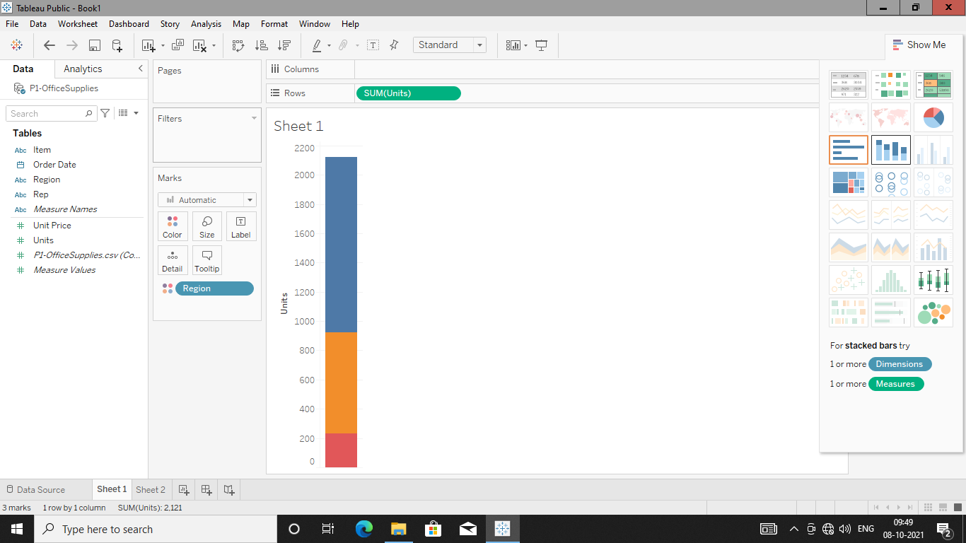

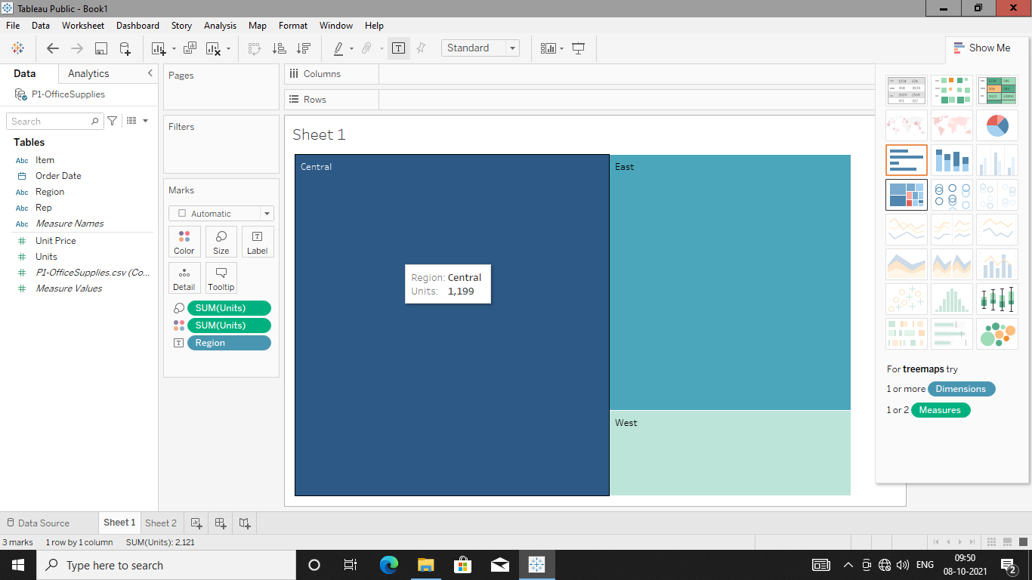

**DAY-02**

**09/10/2021**

**Name**: Harshal Acharya

**Roll No**: 12

**Batch**: B11

**Topics:-**

1. Aggregation and Granularity

**Datasets:** Long Term Unemployment Statistics

**Dimensions:**

* Age
* Gender
* Period

**Measures:**

* Unemployment Ratio

**Aggregation and Granularity:-**

* Measures get aggregated and dimensions specifies level of granularity.

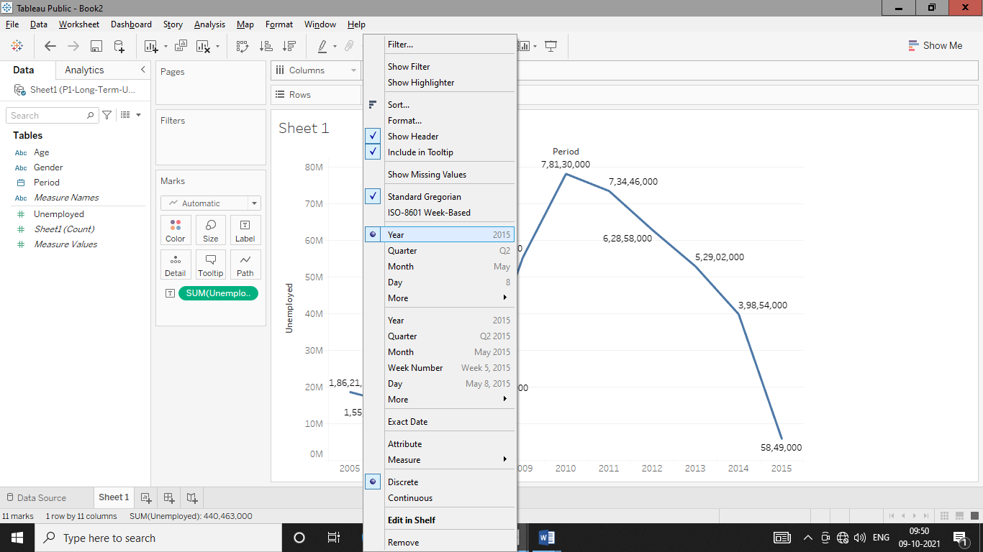

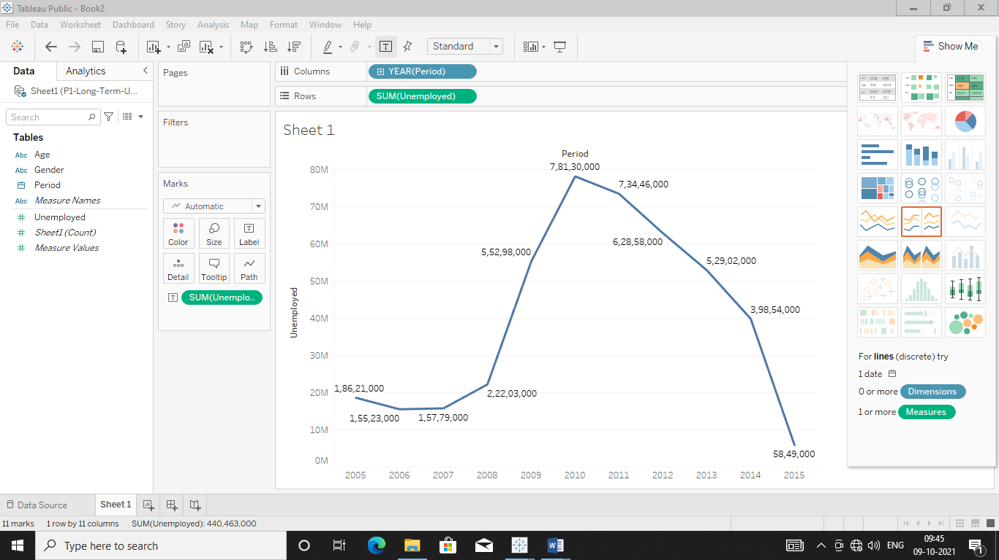

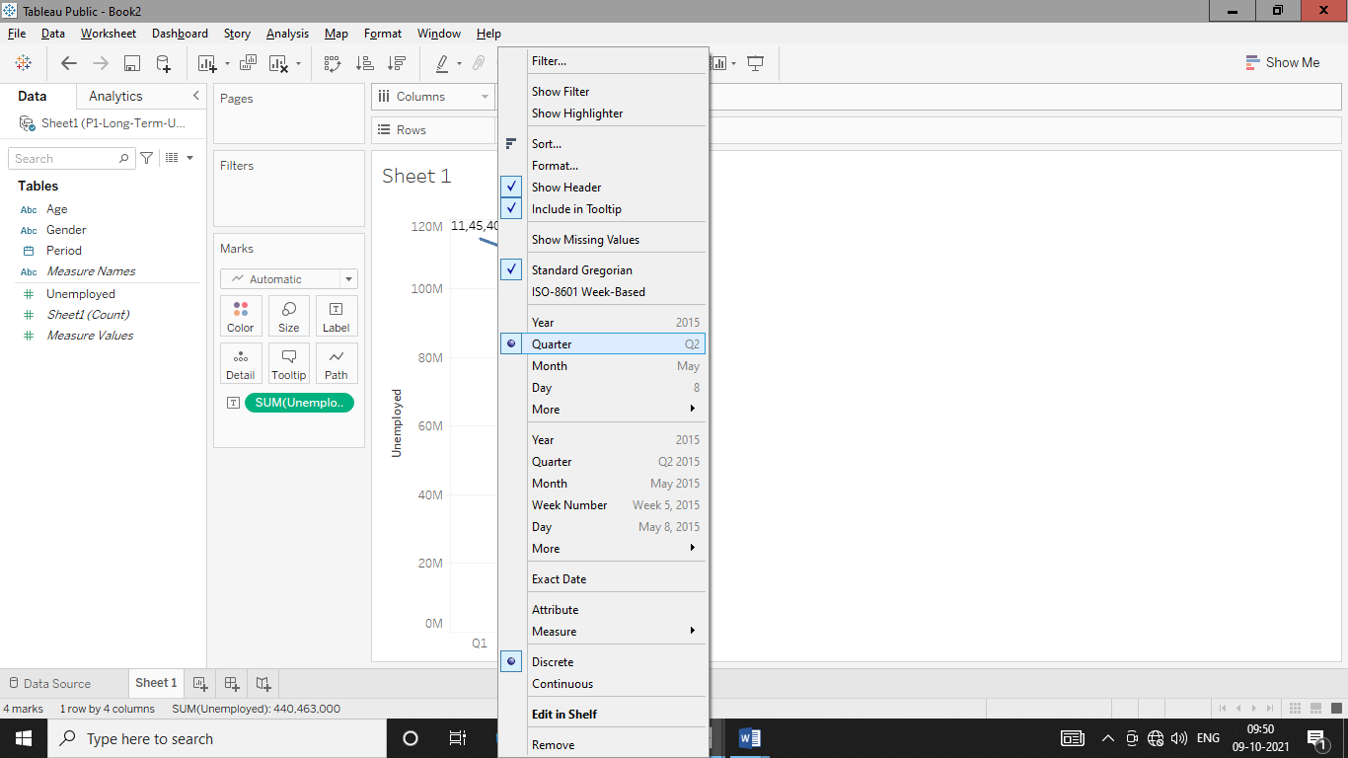

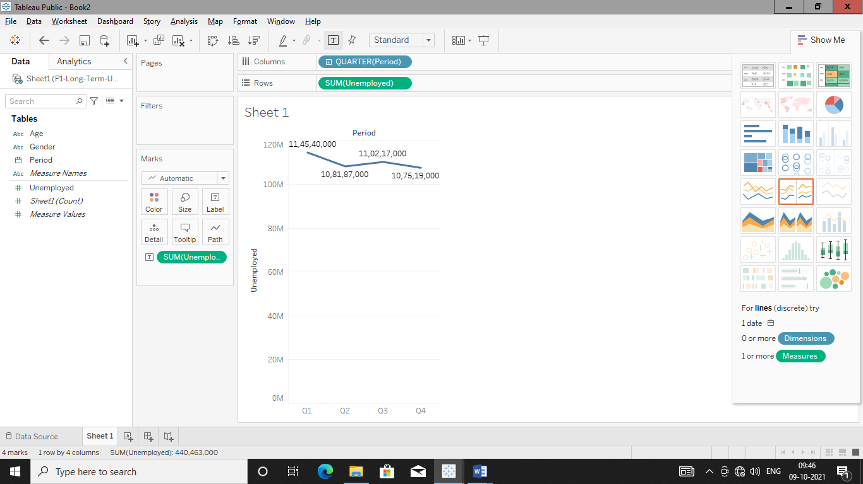

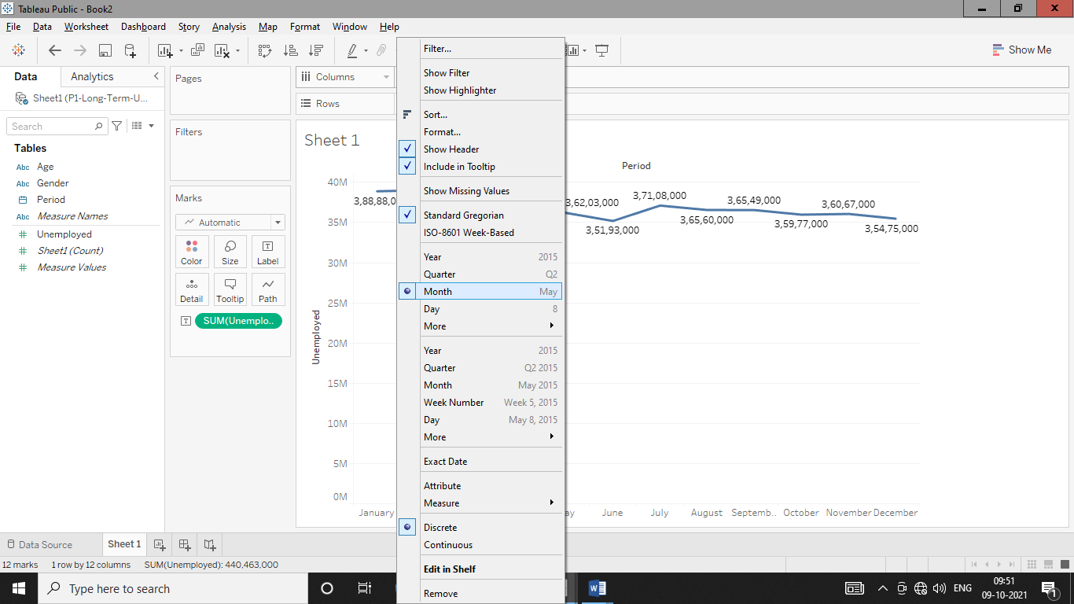

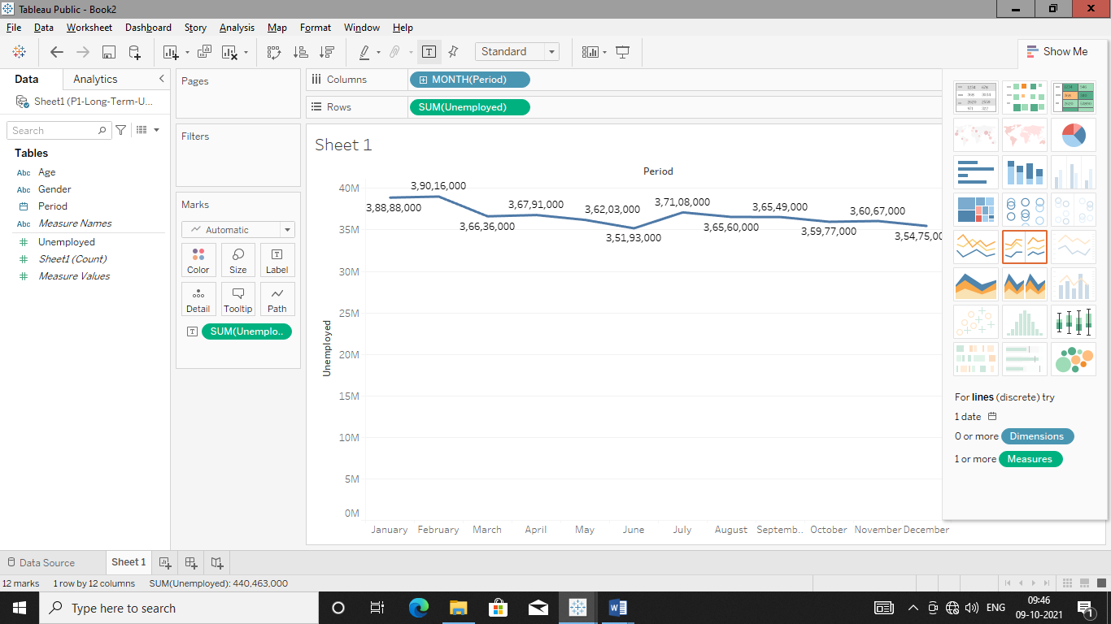

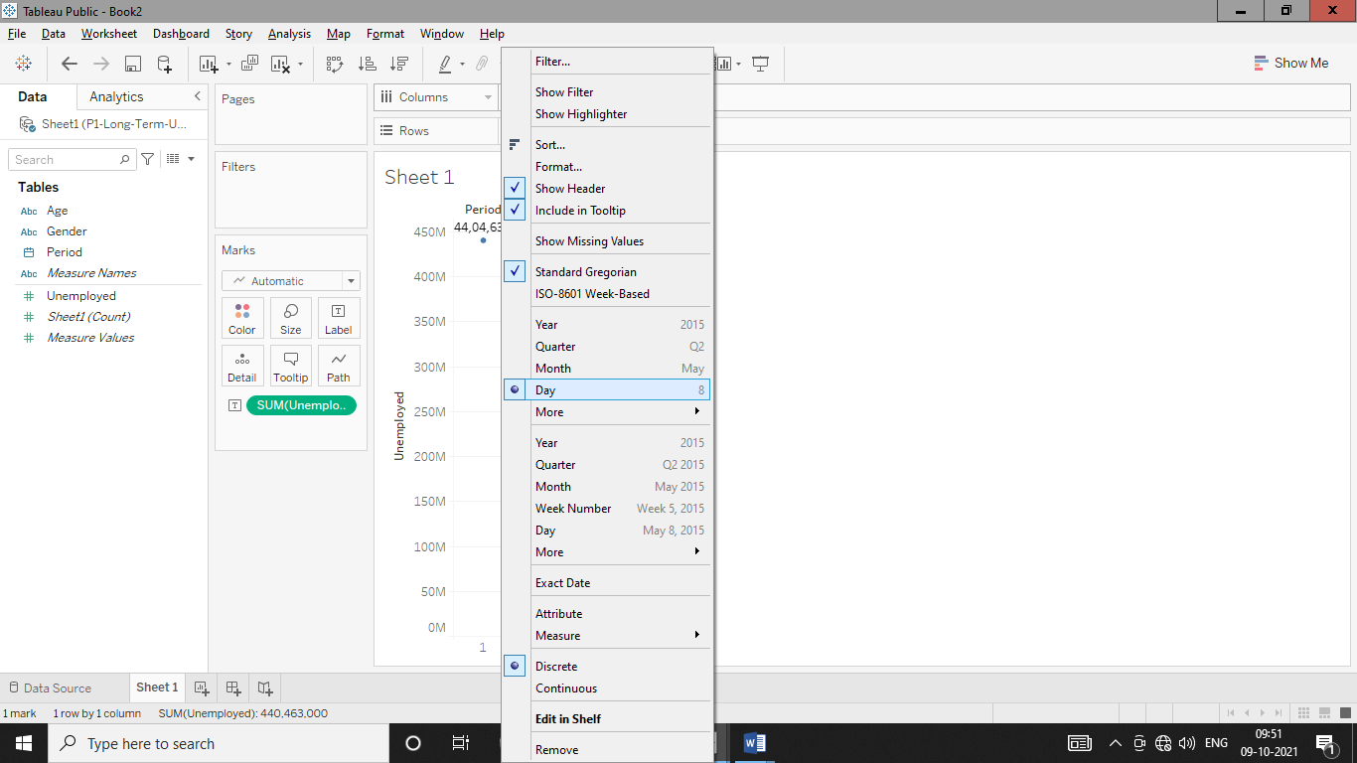

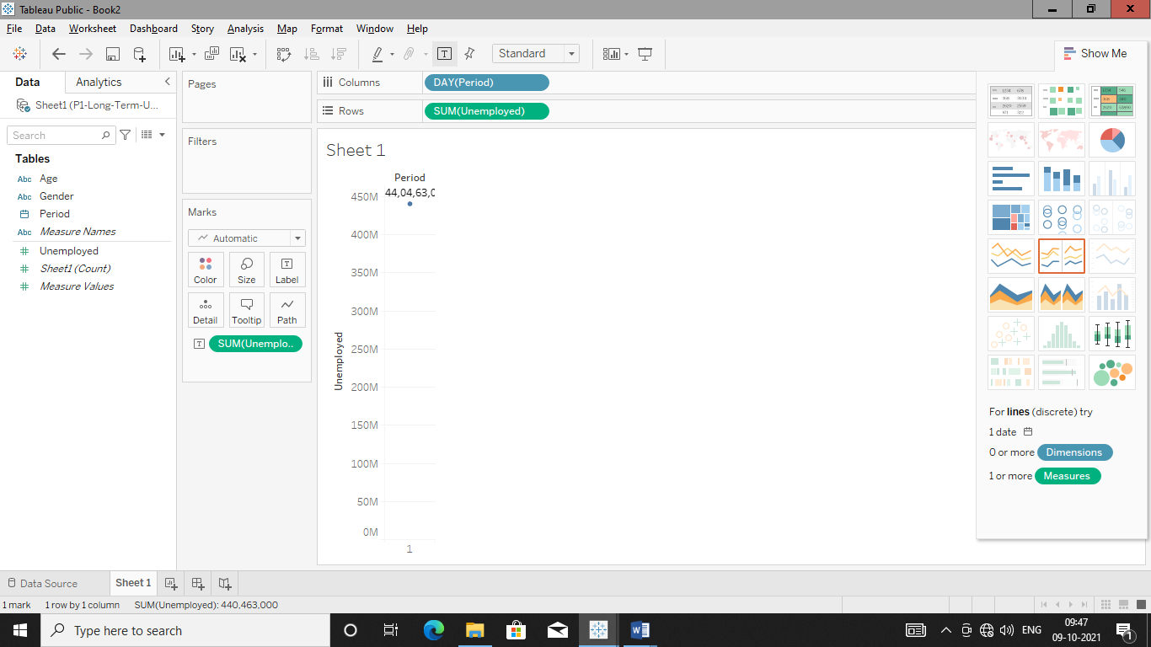

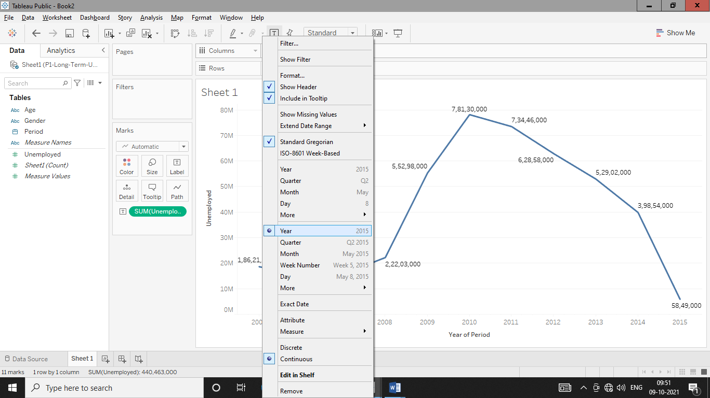

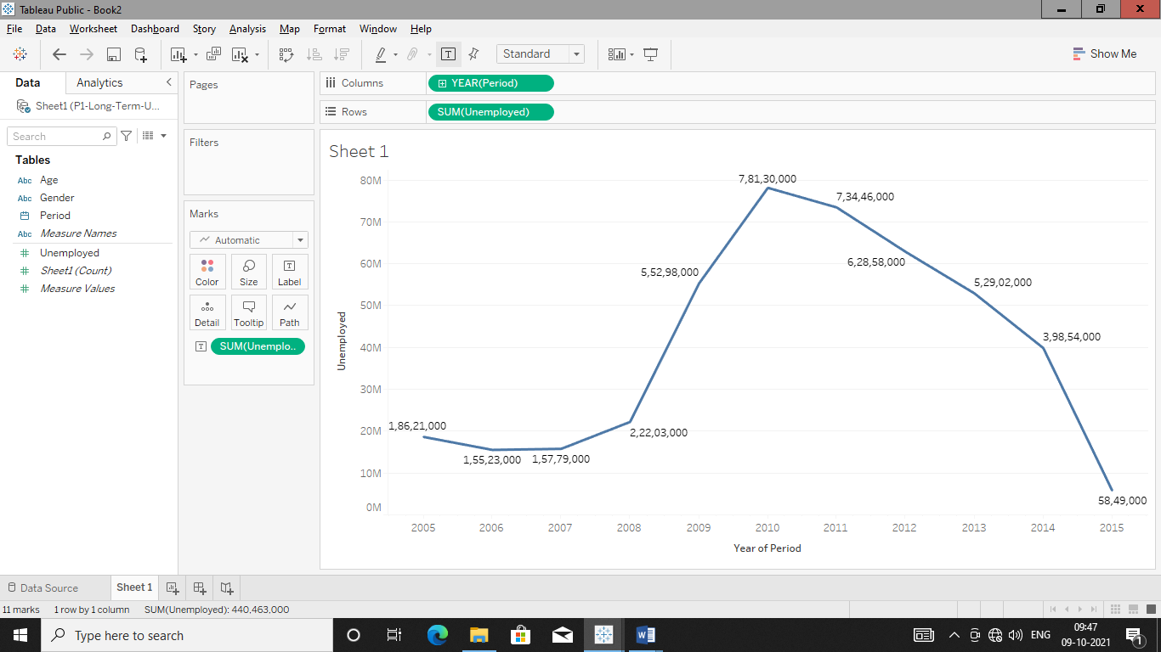

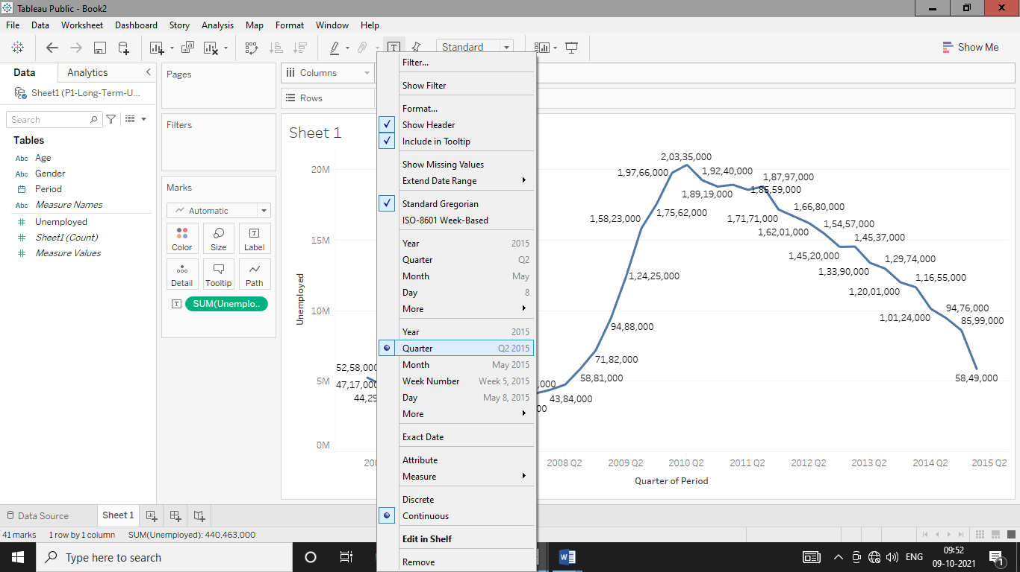

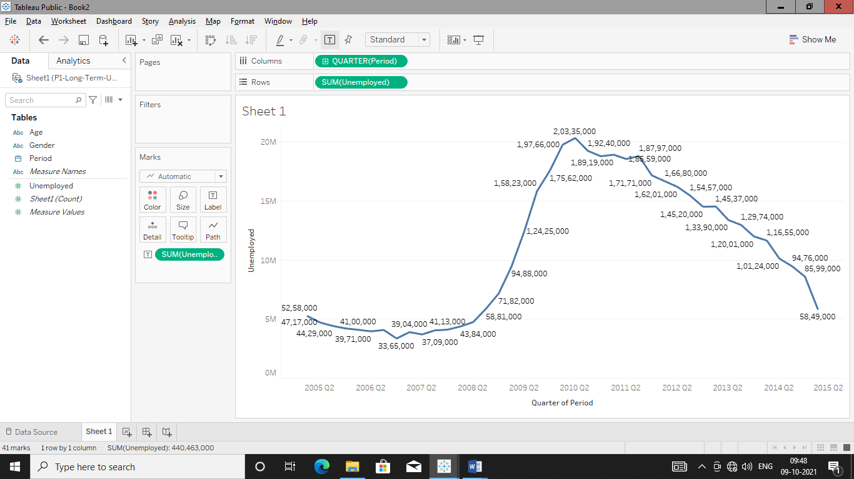

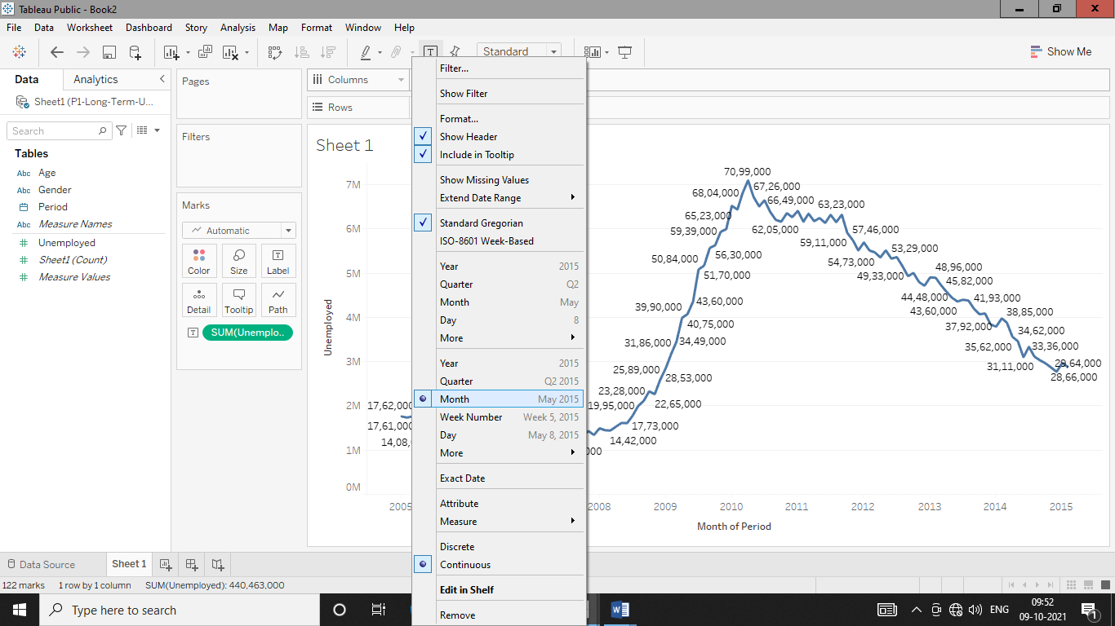

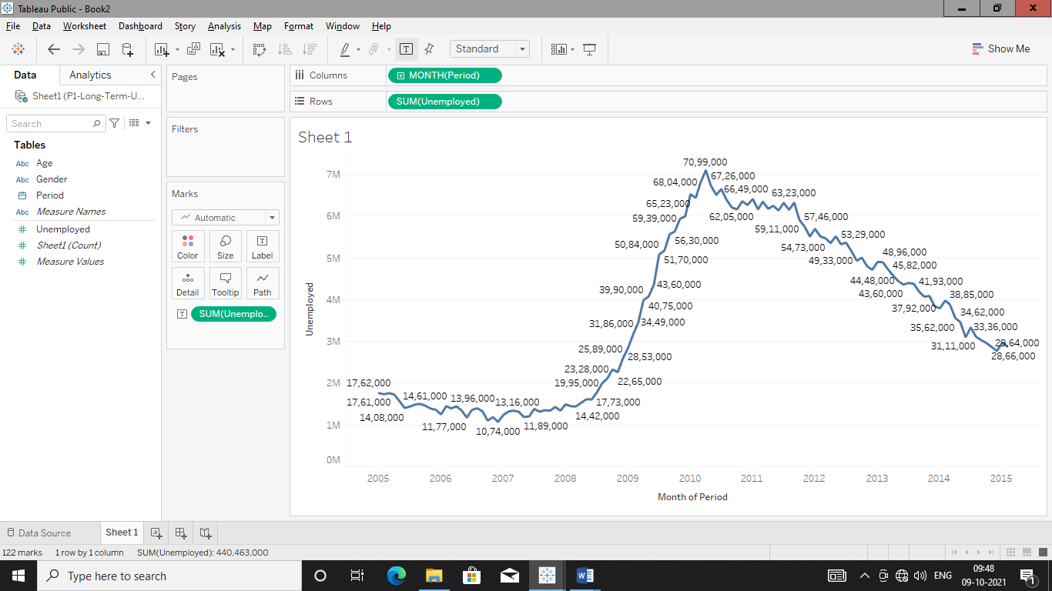

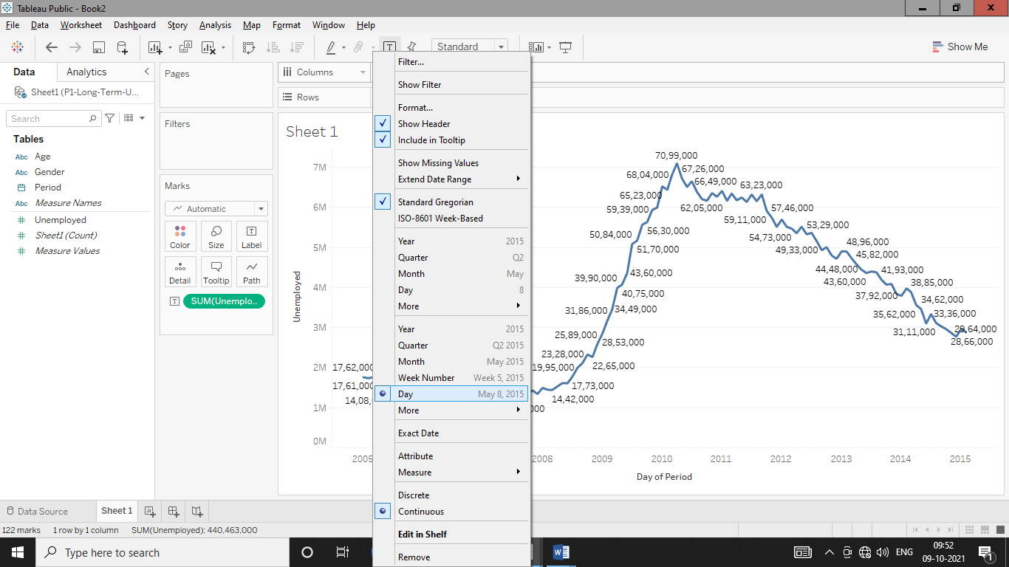

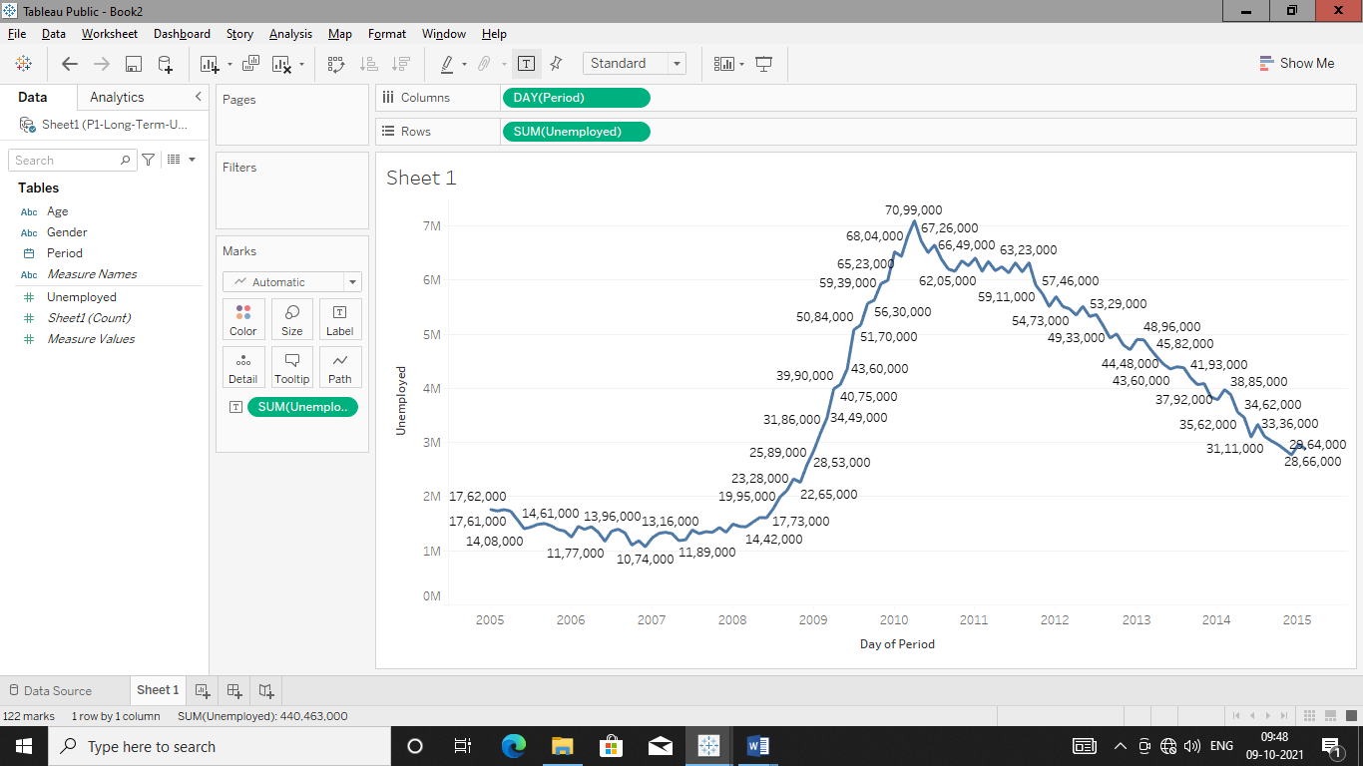

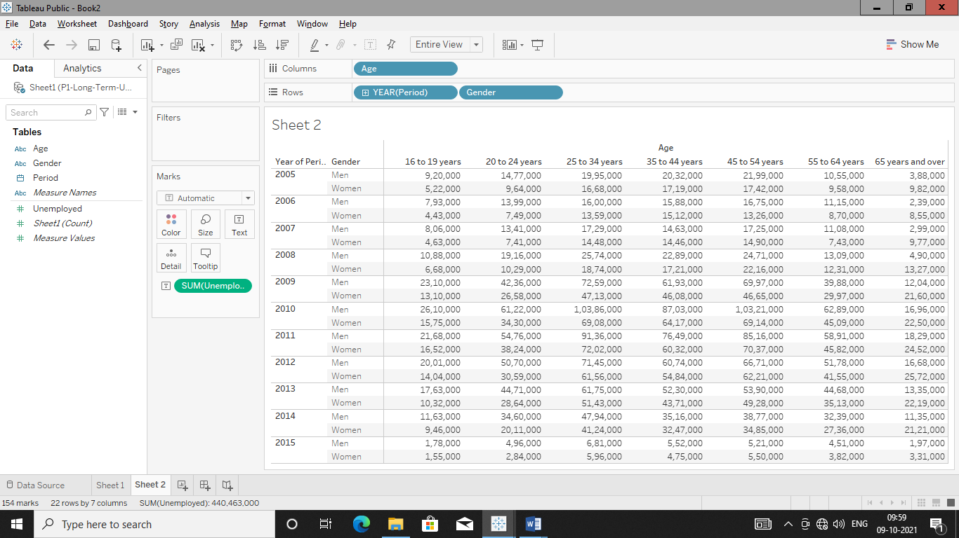

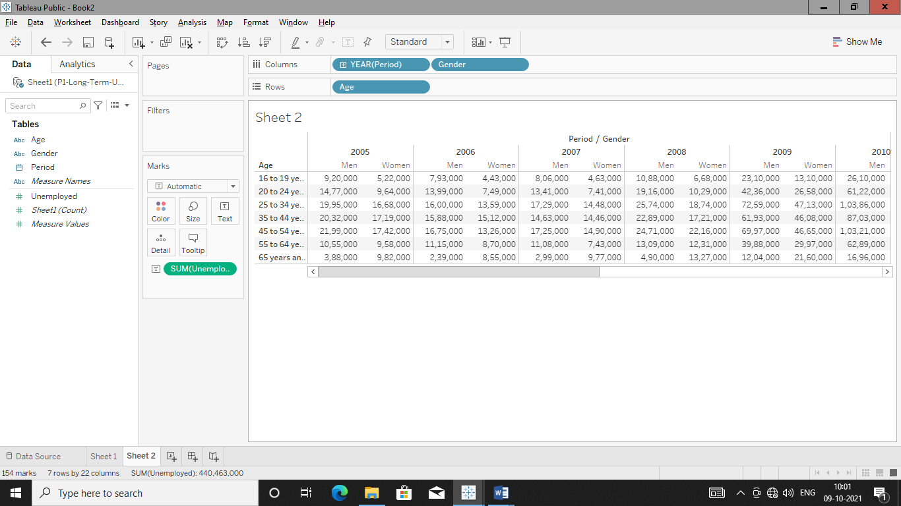

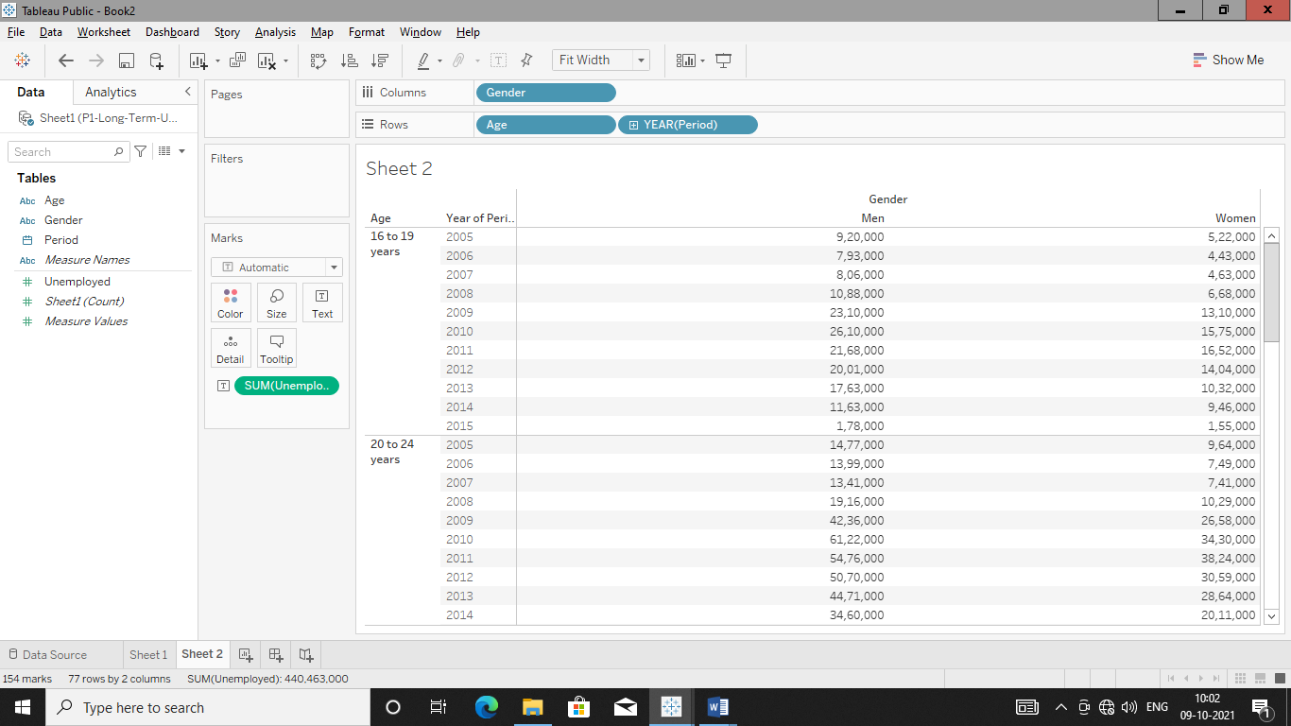

**Show the unemployment details for each month in each year for man & woman using “Shape Chart”.**

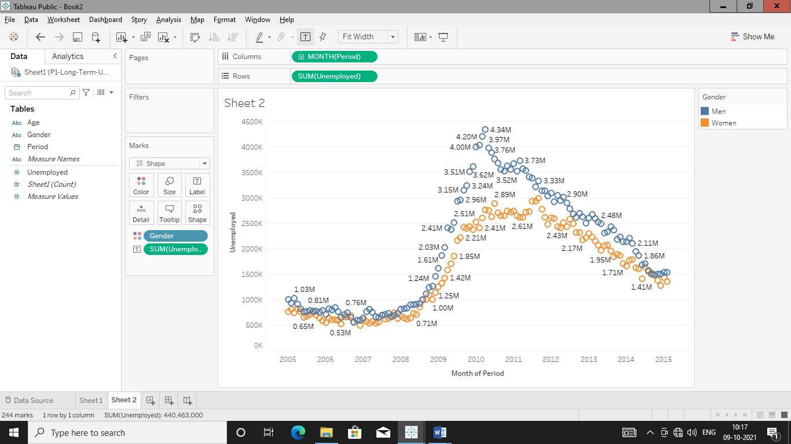

**Find the average unemployment for the same.**

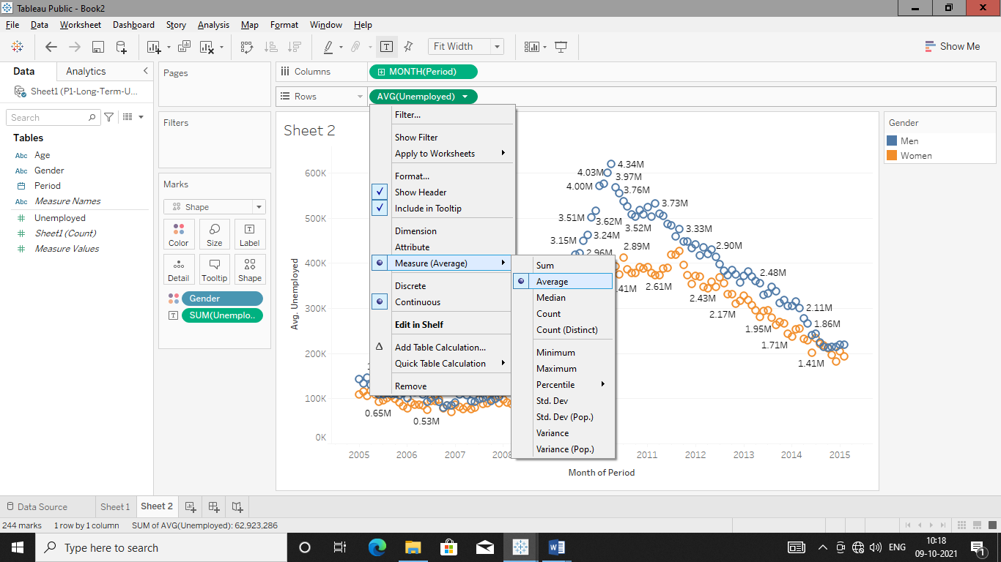

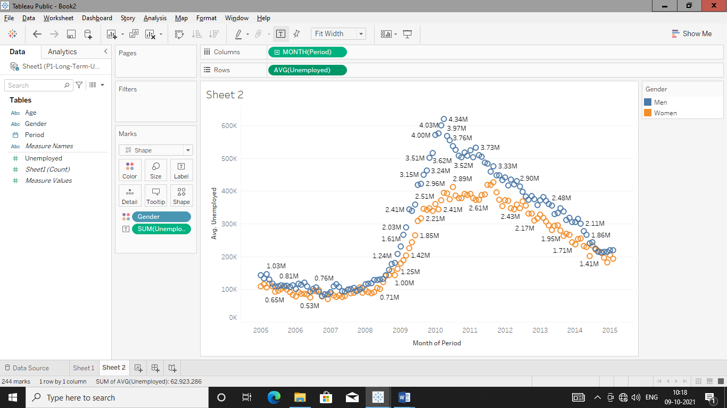

**Add Age group details for the same in Shape Chart.**

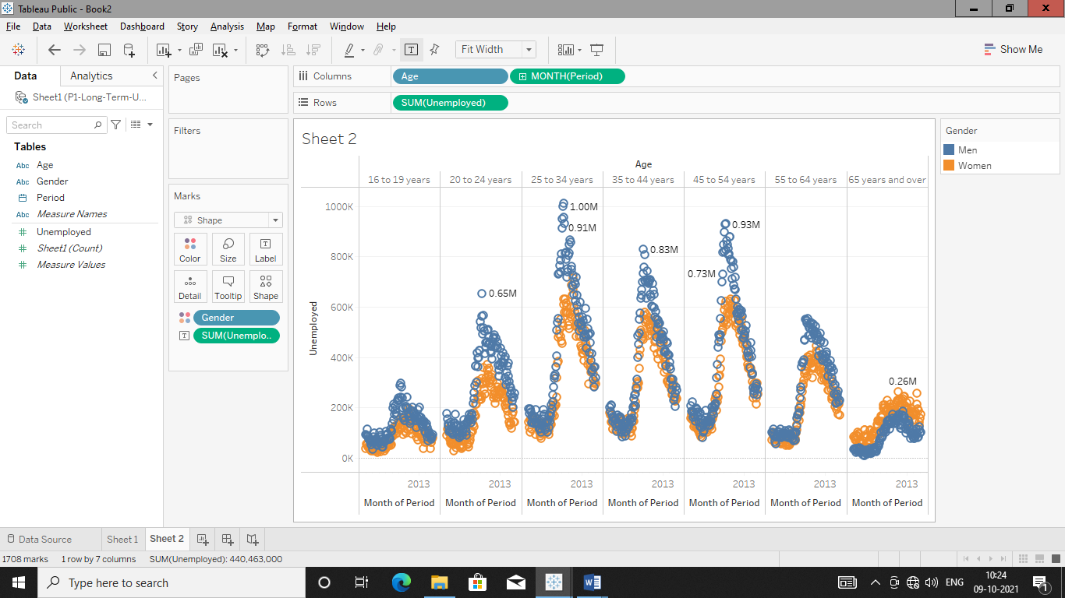

**Make “Area Chart” Of total unemployment for every month with age group labels.**

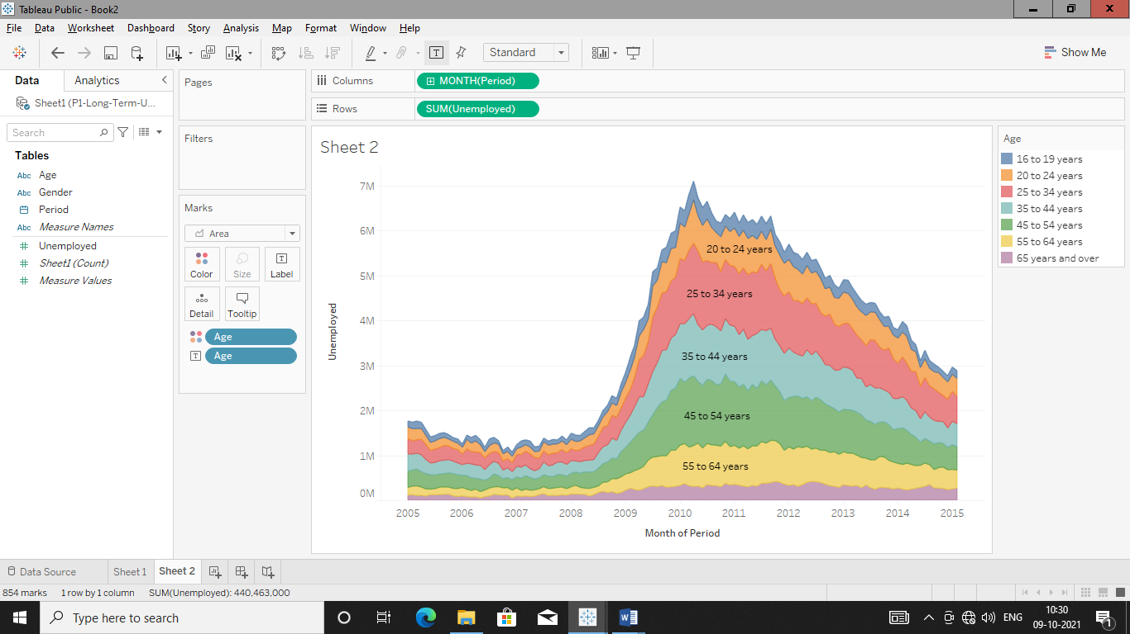

**Filter & Quick Filter:-**

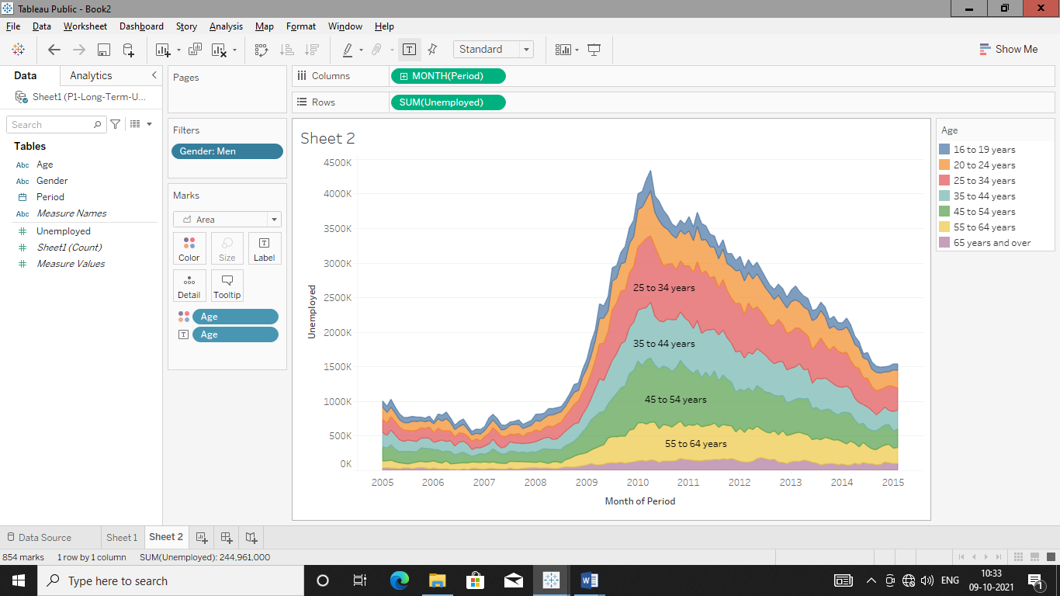

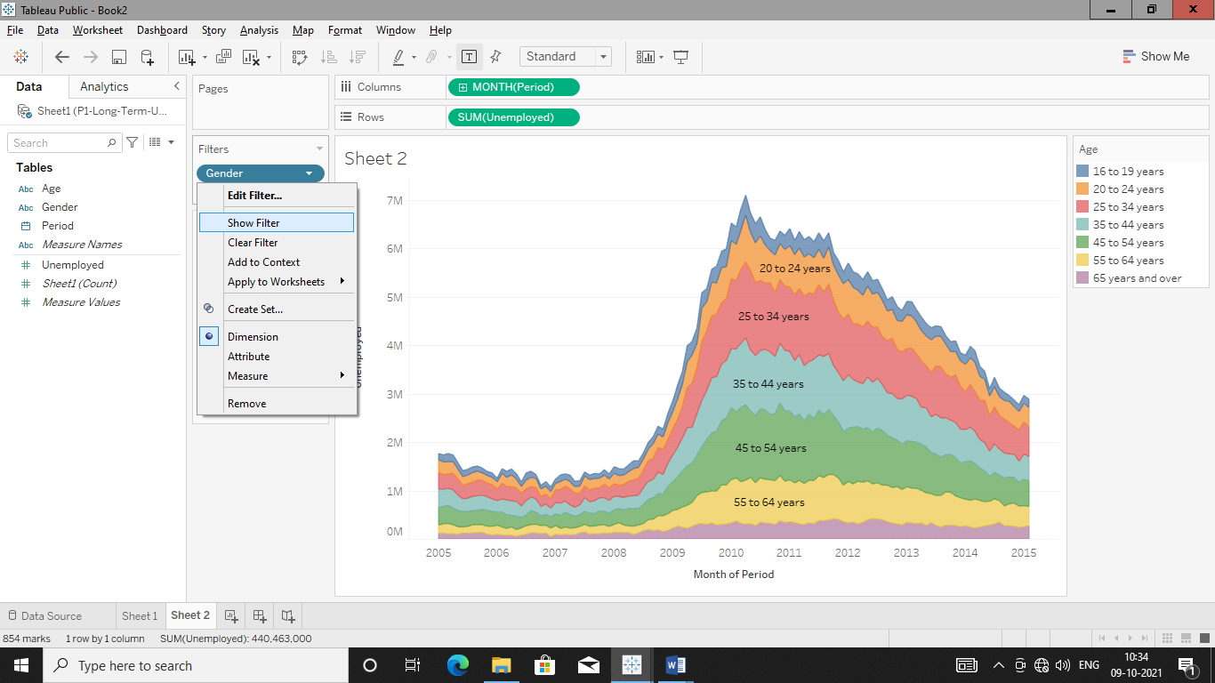

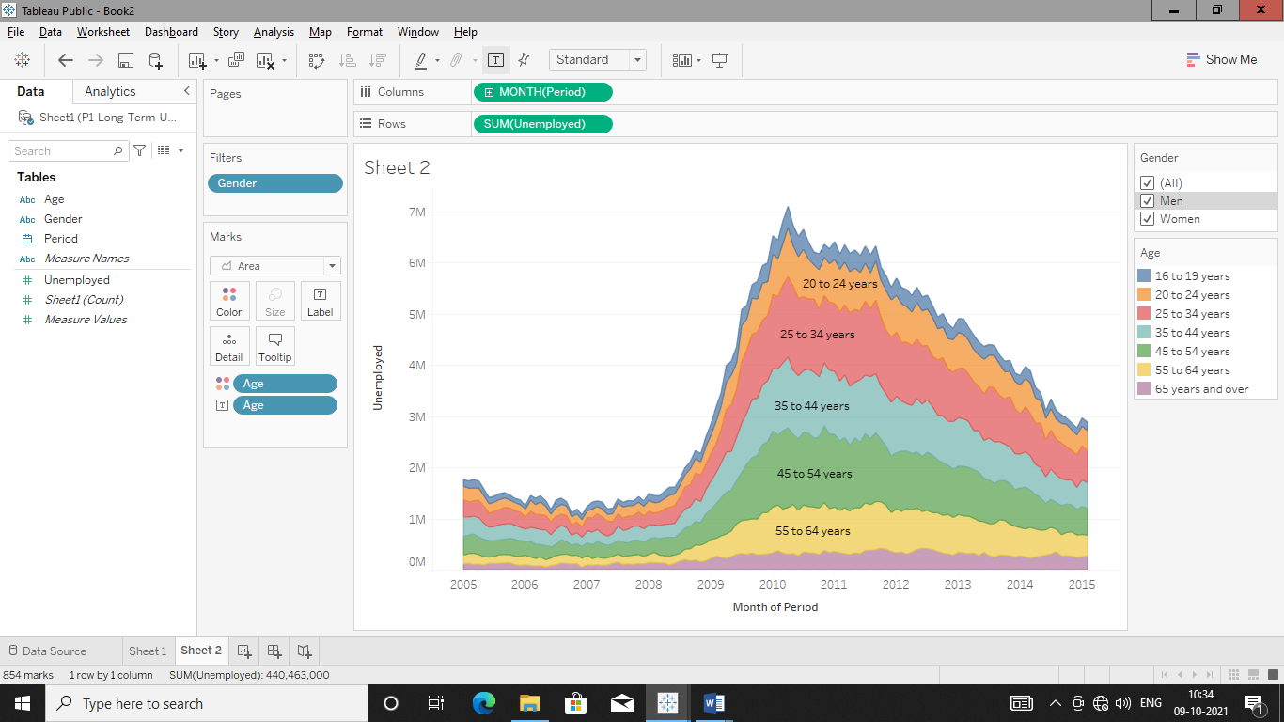

**DAY-03**

**11/10/2021**

**Name**: Harshal Acharya

**Roll No**: 12

**Batch**: B11

**Datasets:** covid_19_data

**Dimensions:**

* Country
* Last Update
* Observation Date

**Measures:**

* Confirmed
* Deaths
* Recovered
* S.No.

**Datasets:** Amazing Mart

**Topics:**

* Create Hierarchy of dimensions
* Revise Filter and calculated fields
* Create Scatter Plots
* Create Dashboards
* Add Interactive Action-Filters
* Add Interactive Action-Highlights

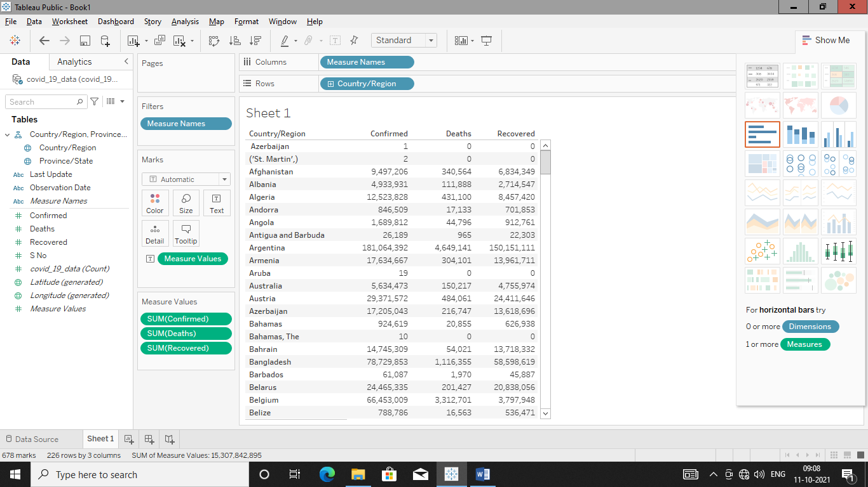

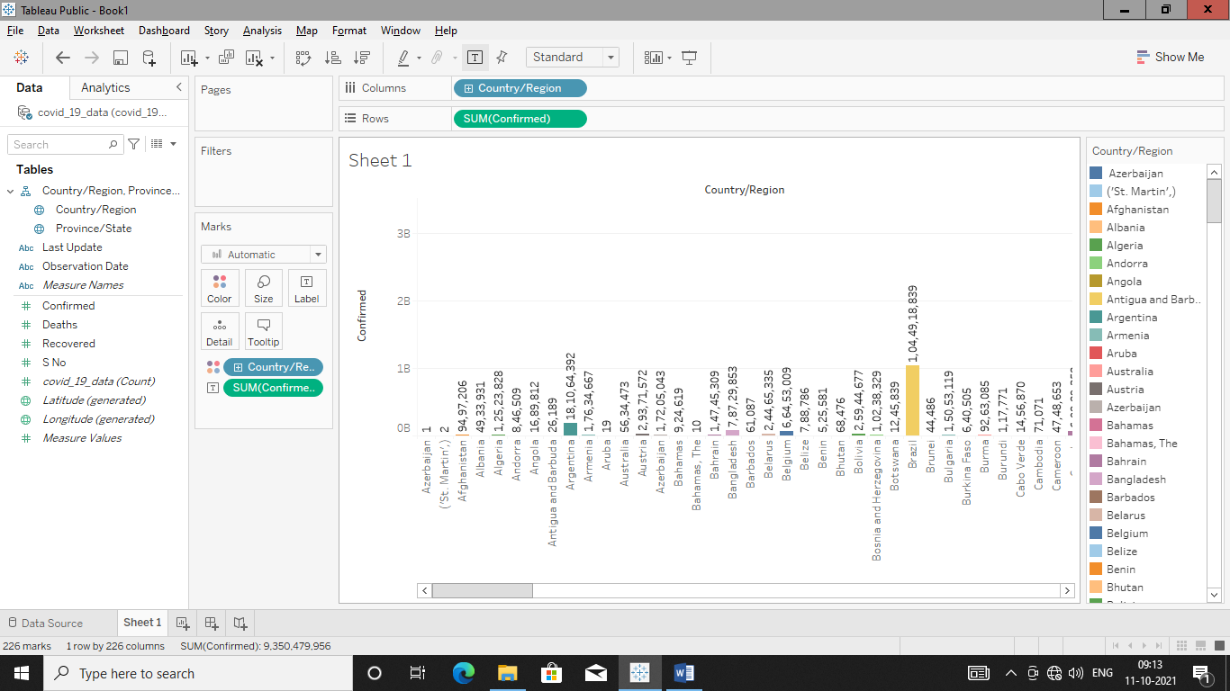

**Nationwise Confirmed,Recovered & Deaths**

Confirmed

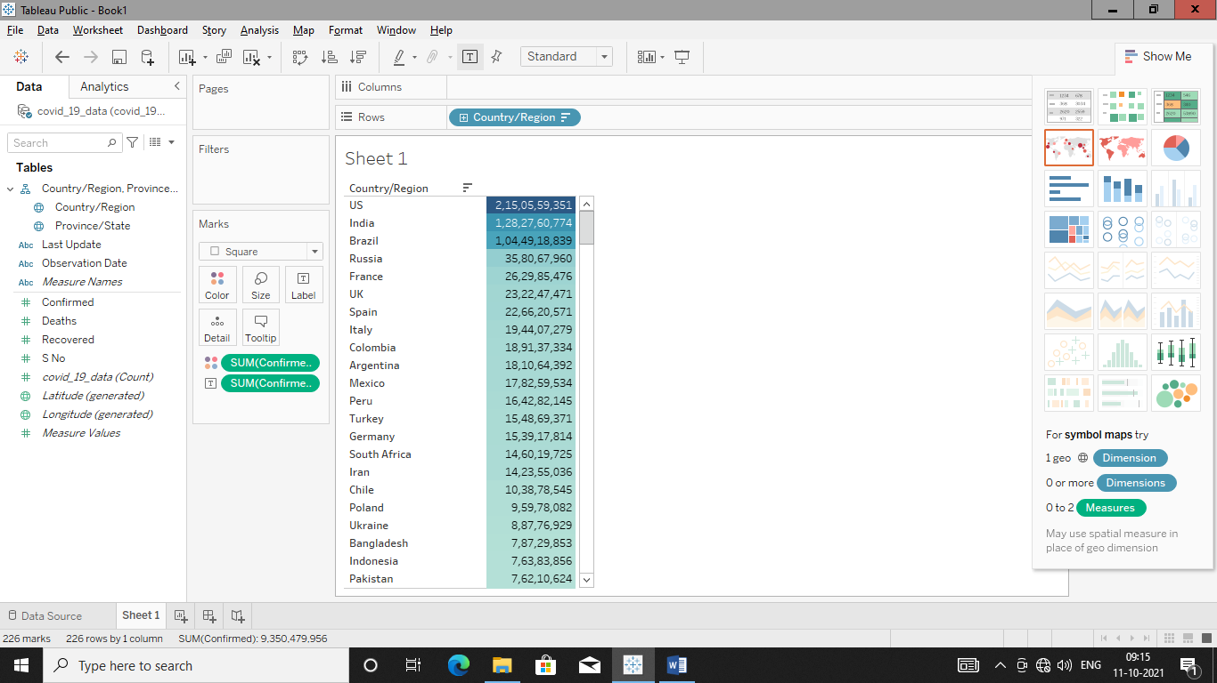

Deaths

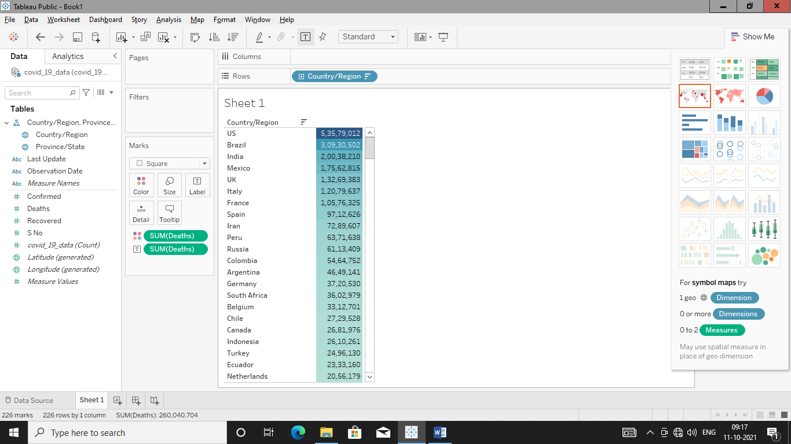

Recovered

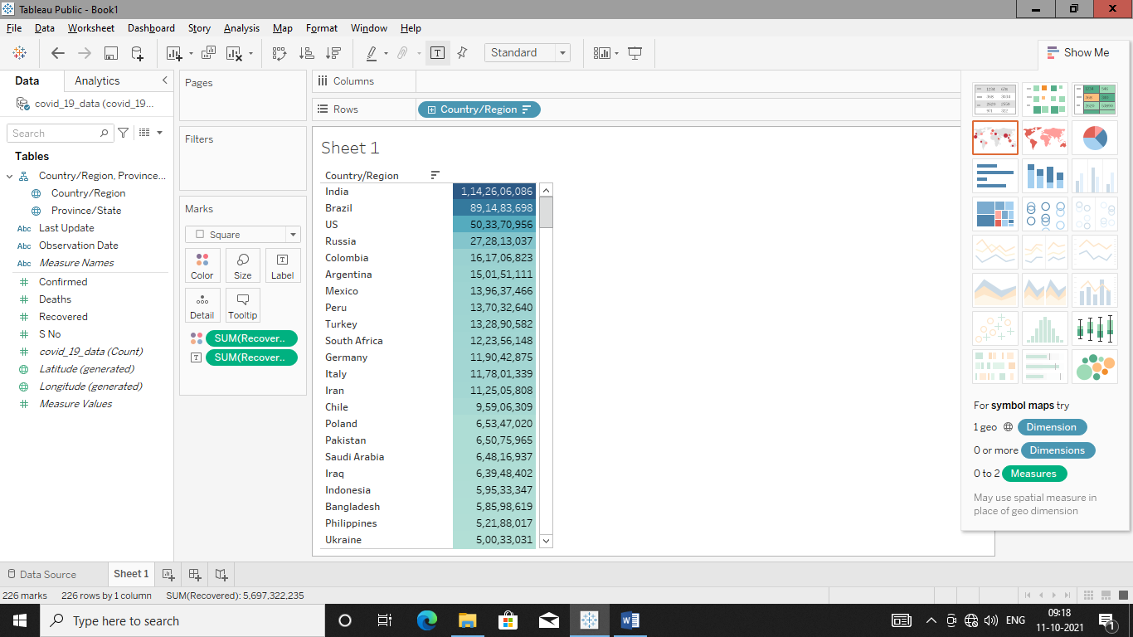

**Indian Statewise Confirmed,Recovered & Deaths**

**Highlight table**

Confirmed

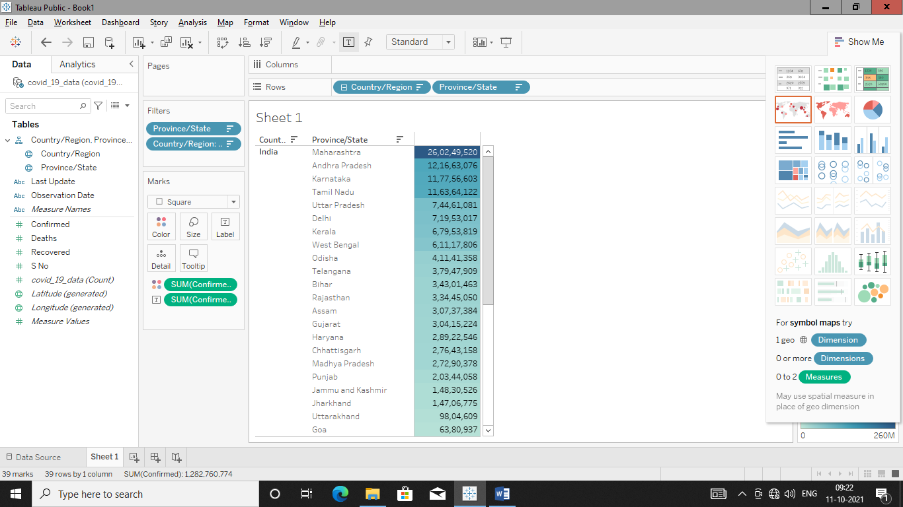

Deaths

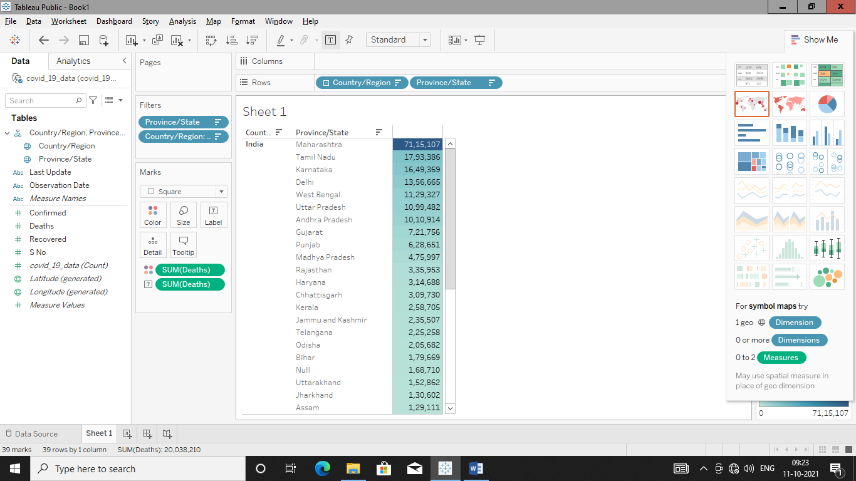

Recovered

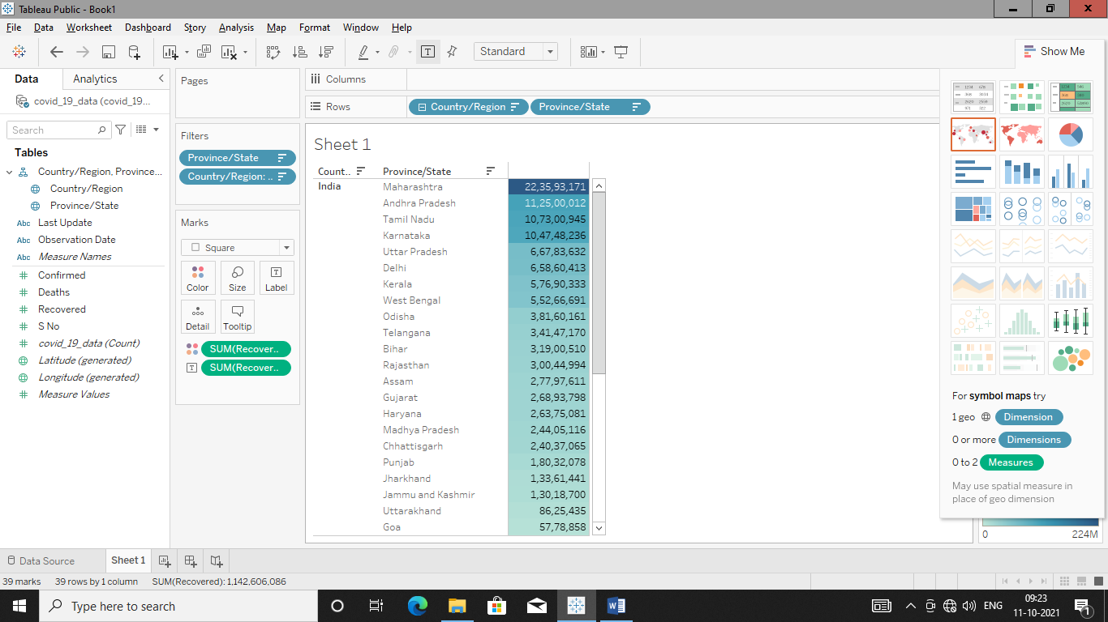

**Stack Bar with label & color formatting**

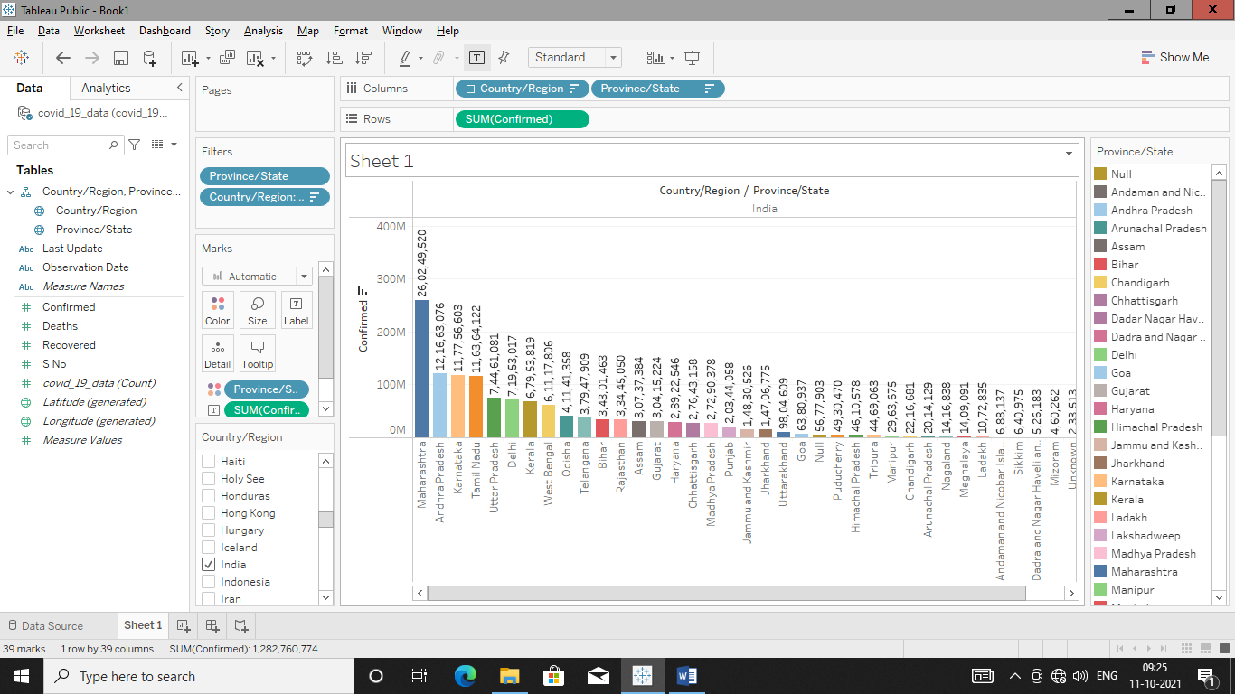

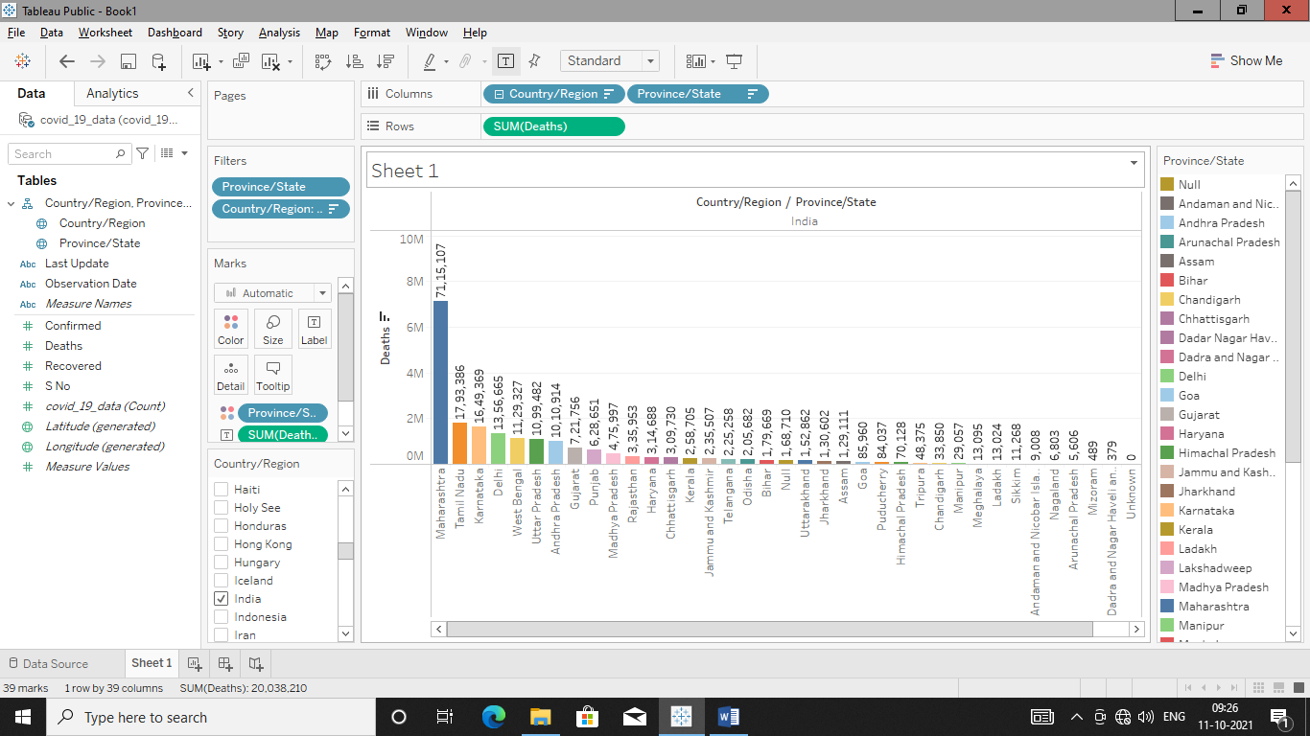

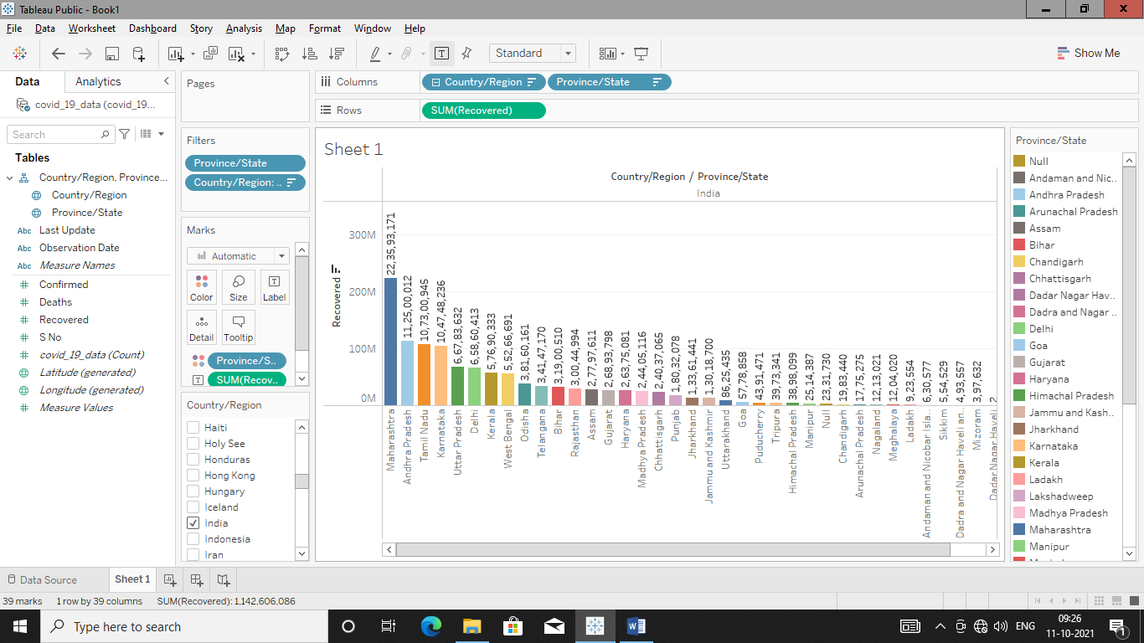

**Pie Charts For Confirmed,Recovered,Deaths**

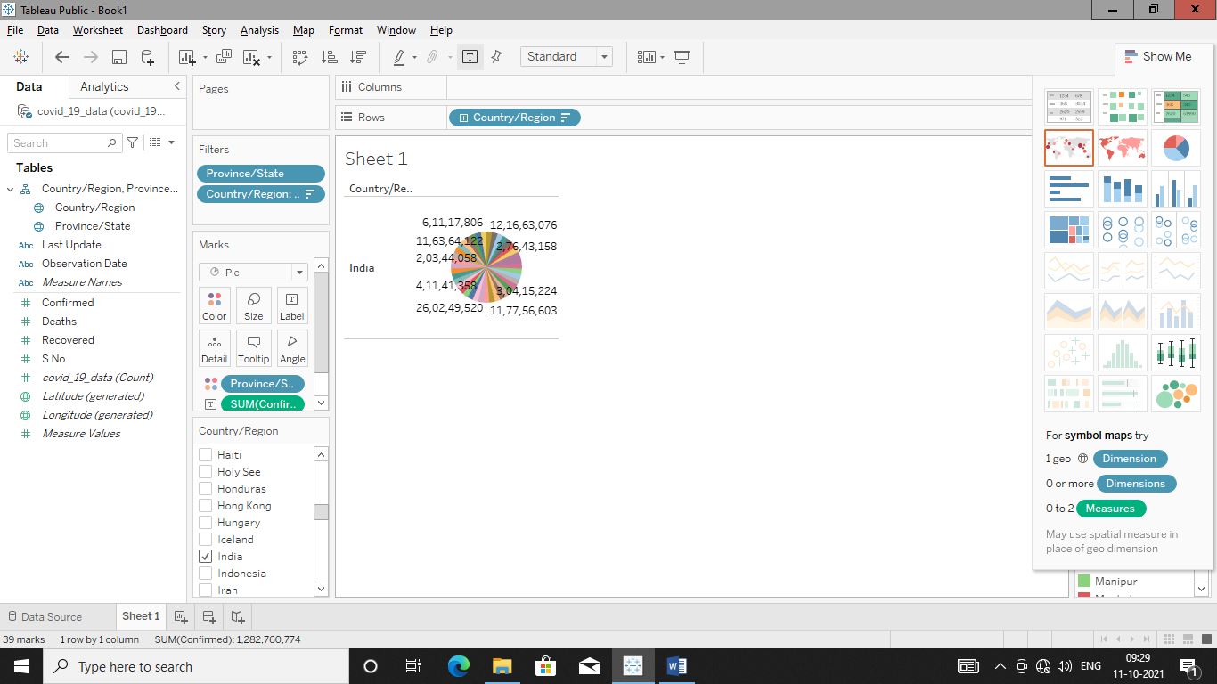

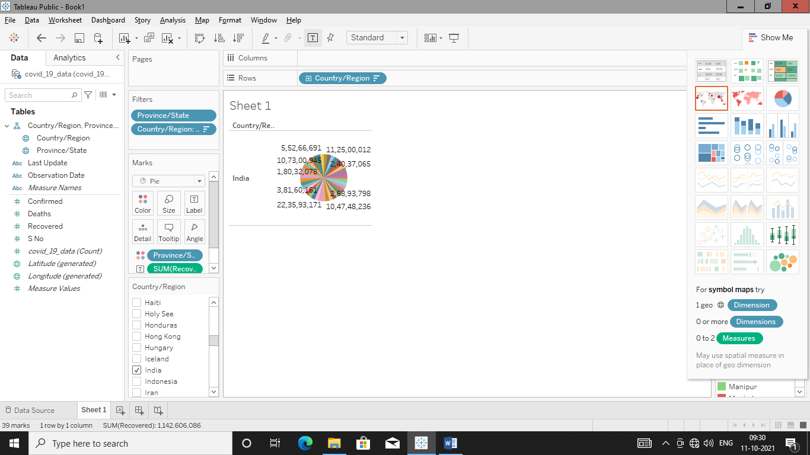

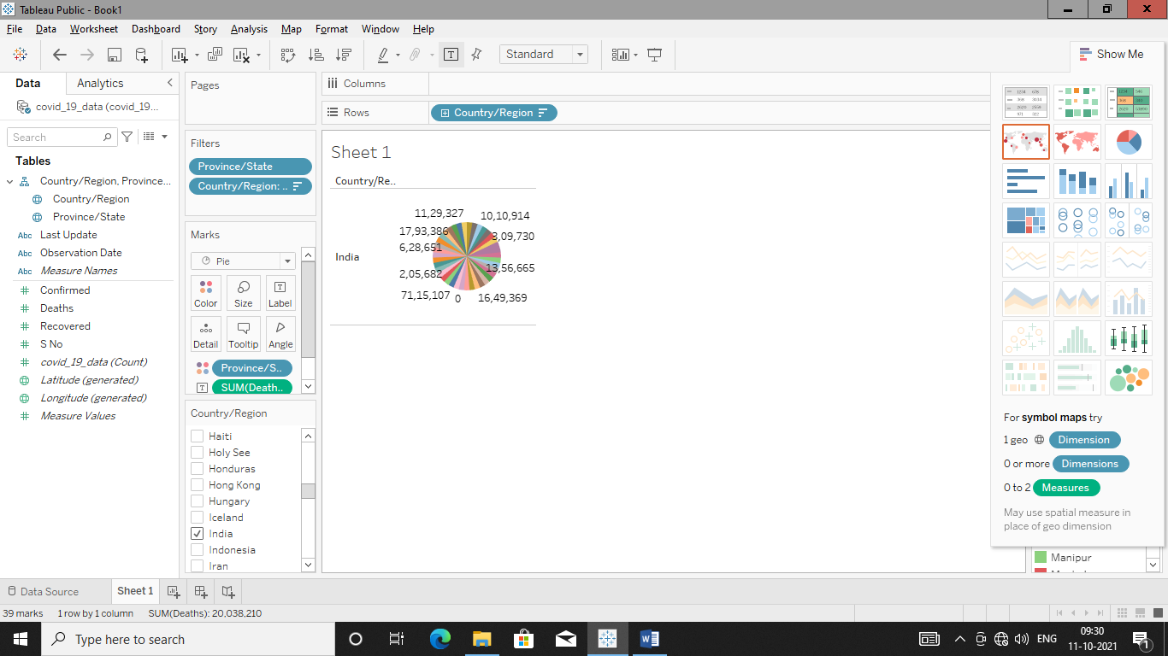

**Create hierarchy of dimension manually**

Here two tables from dataset is joined at logical level to create a hierarchy.

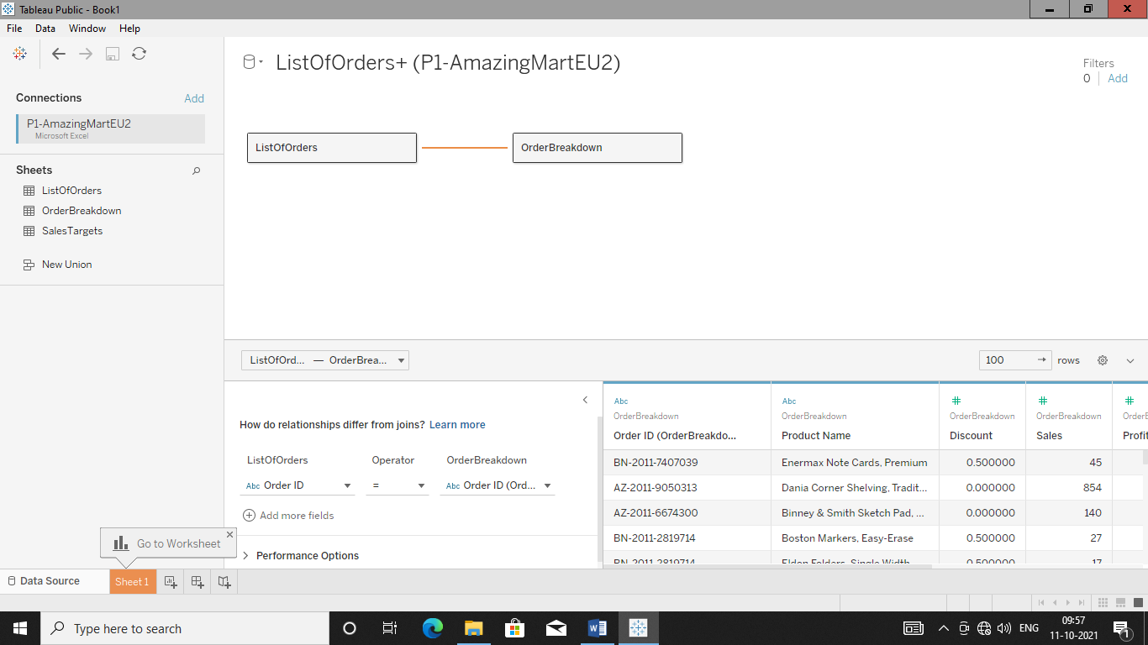

Now if we go to sheet 1 than hierarchy is created own by tableau as shown below

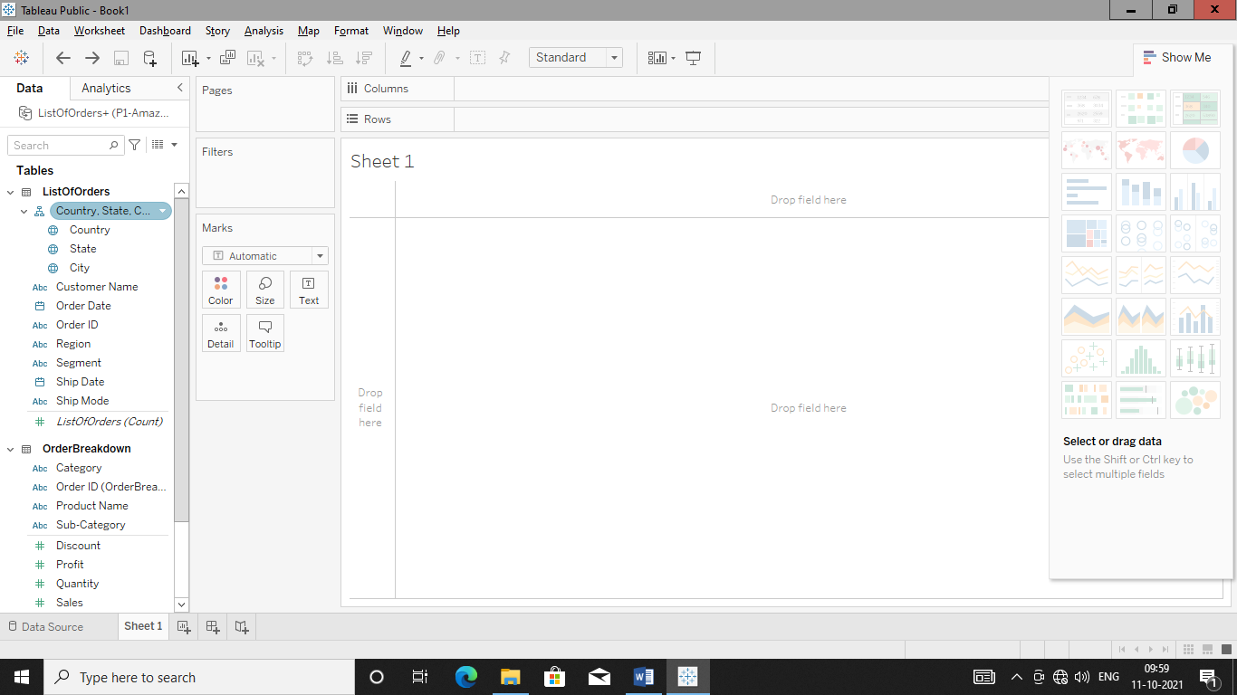So just remove that hierarchy by right clicking it and than create own hierarchy manually.

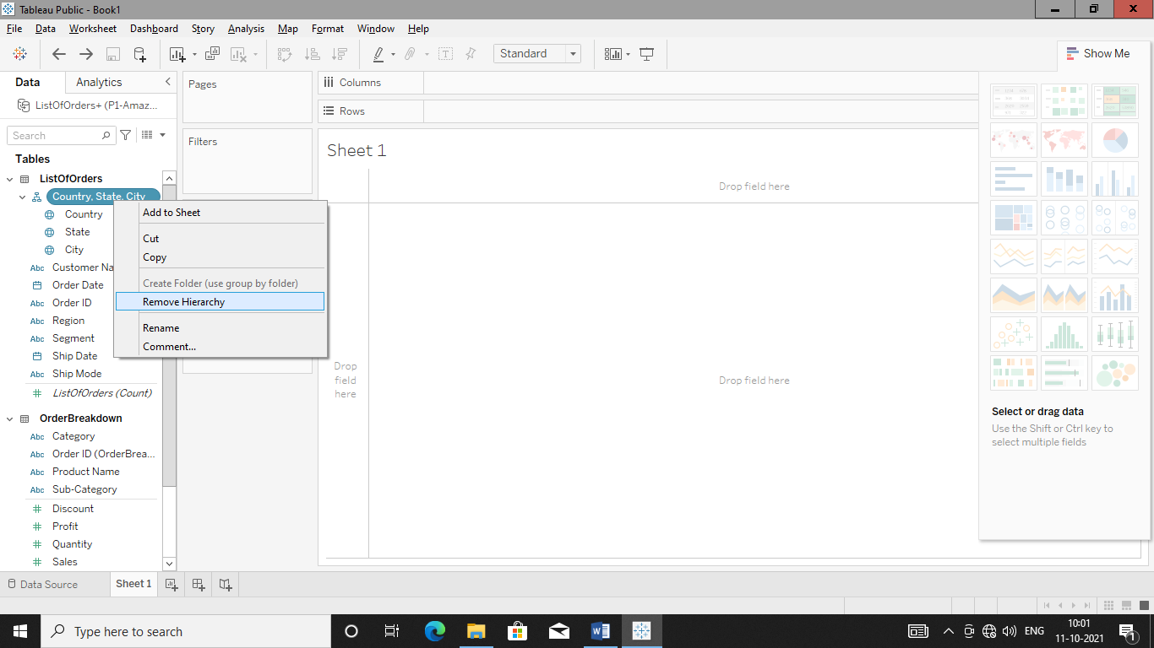

Just Drag and drop two dimensions than tableau will automatically ask to give new name to that hierarchy.

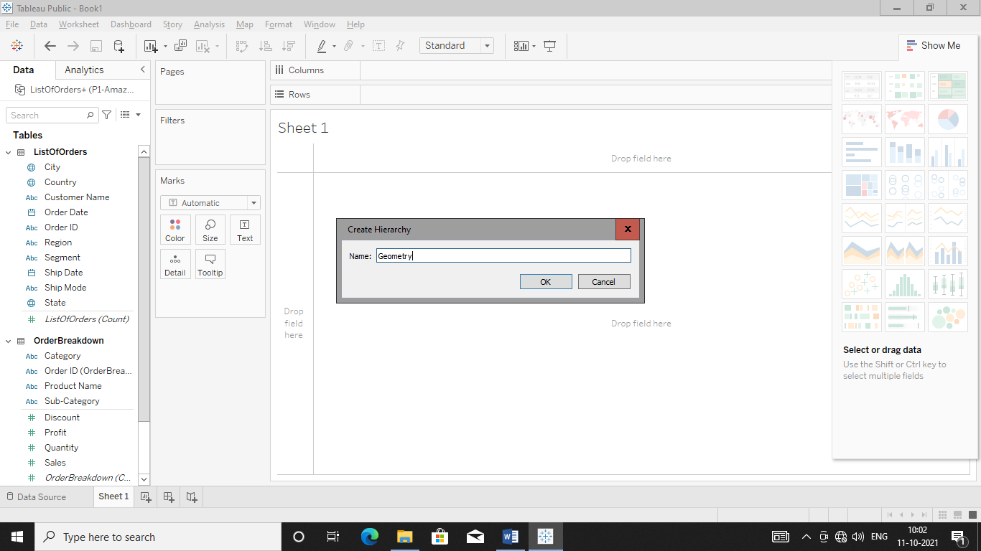

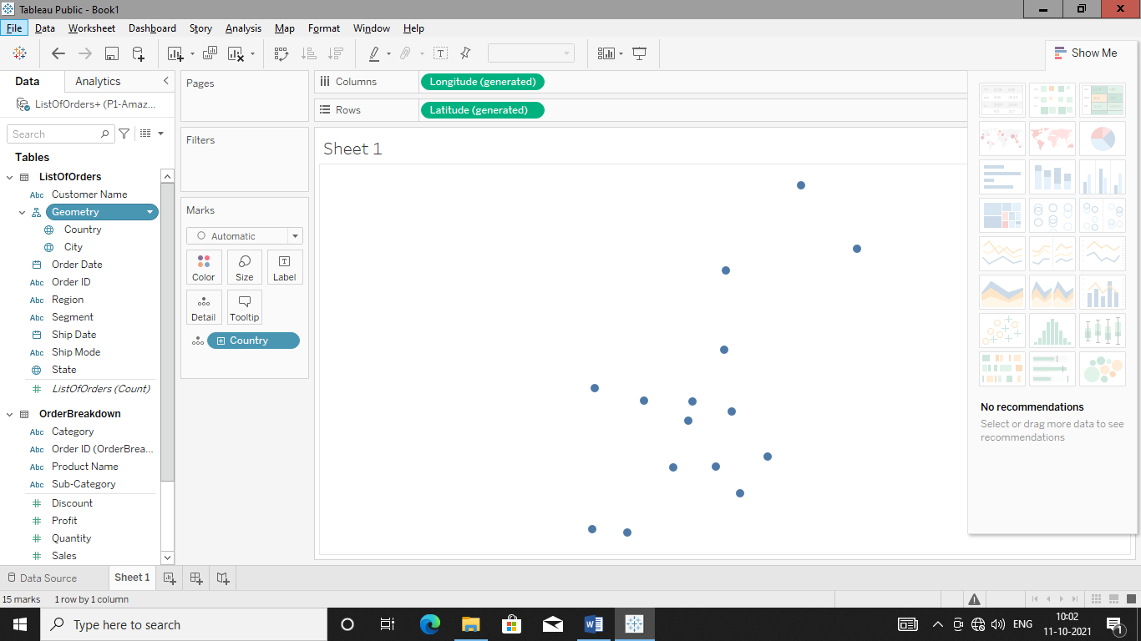

Drag and drop state between country and city to complete a hierarchy

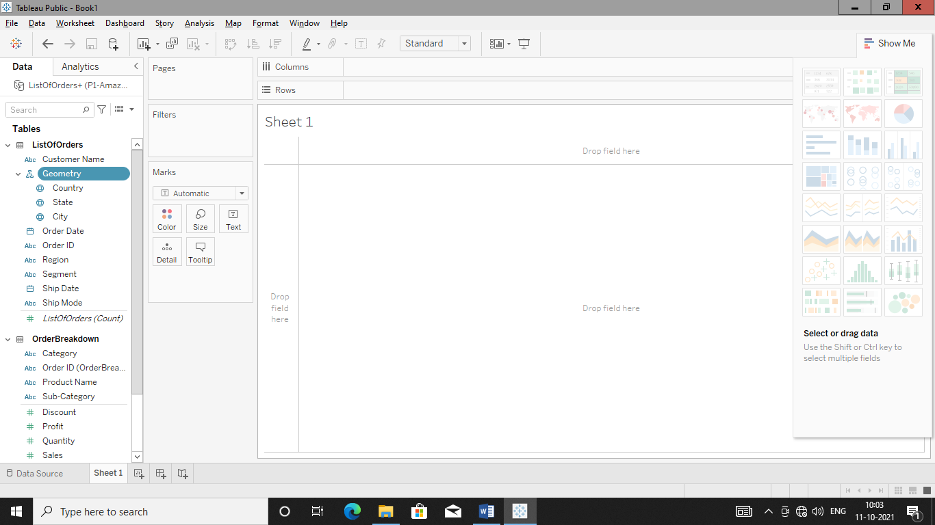

Plot country map by double clicking it

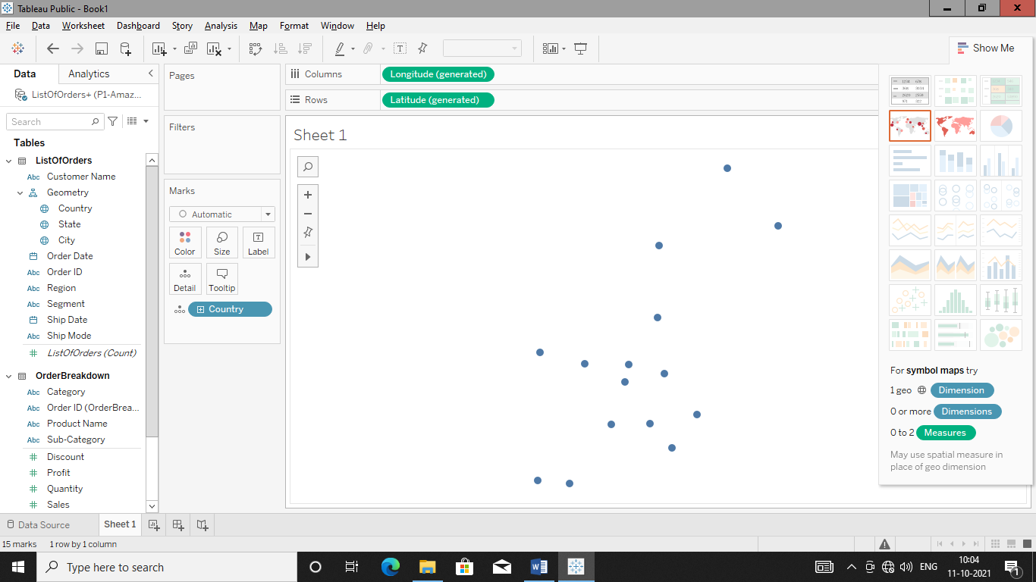

As well as plot state also

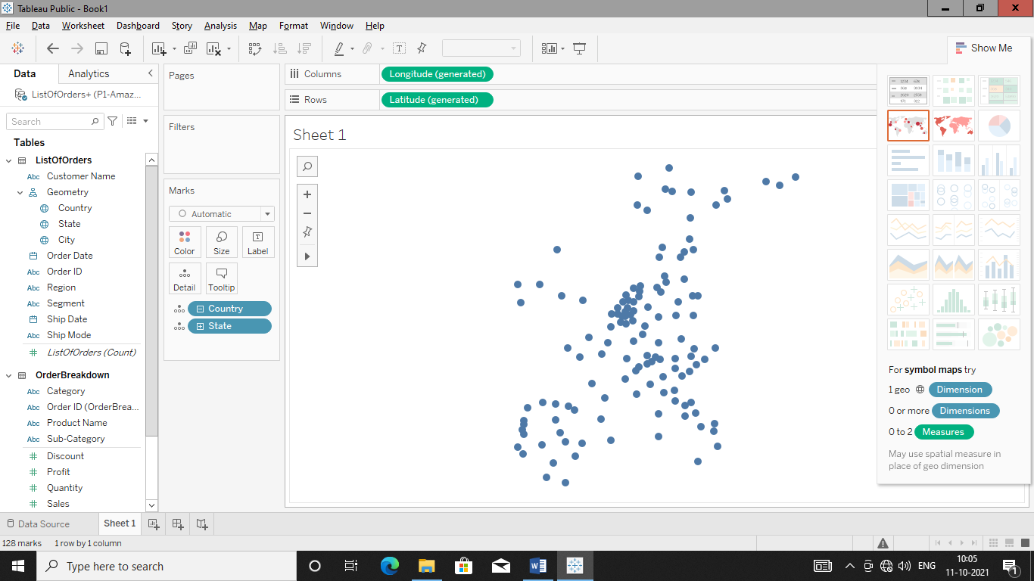

Apply color filter to country.

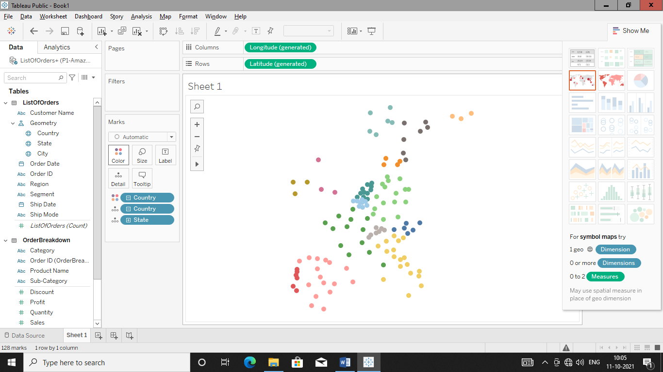

Add state name as labels.

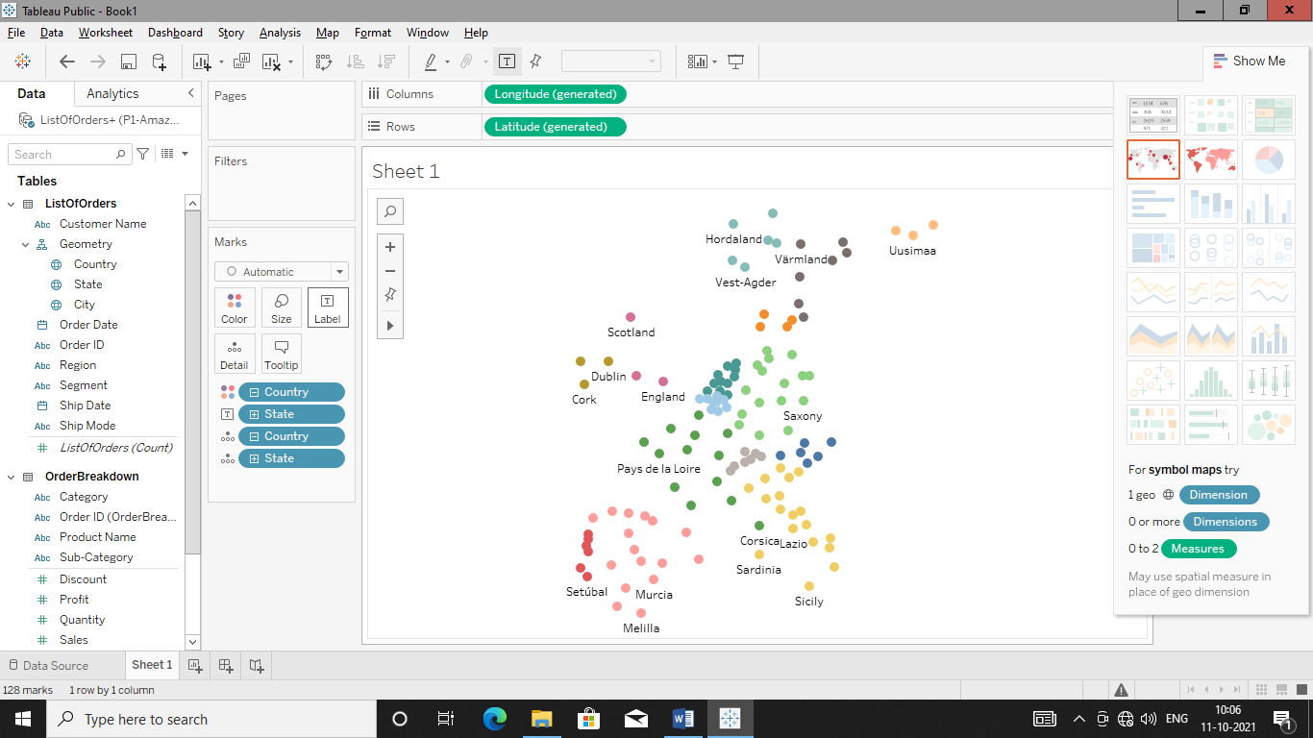

**Q. Plot order details of year 2011(do create filter with slider)**

Add order date to filter for getting this information

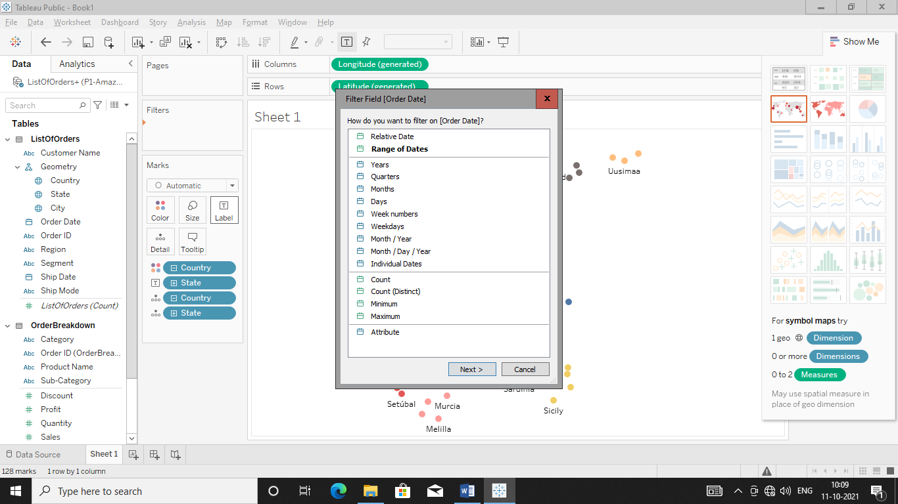Select Years as we want of year 2011

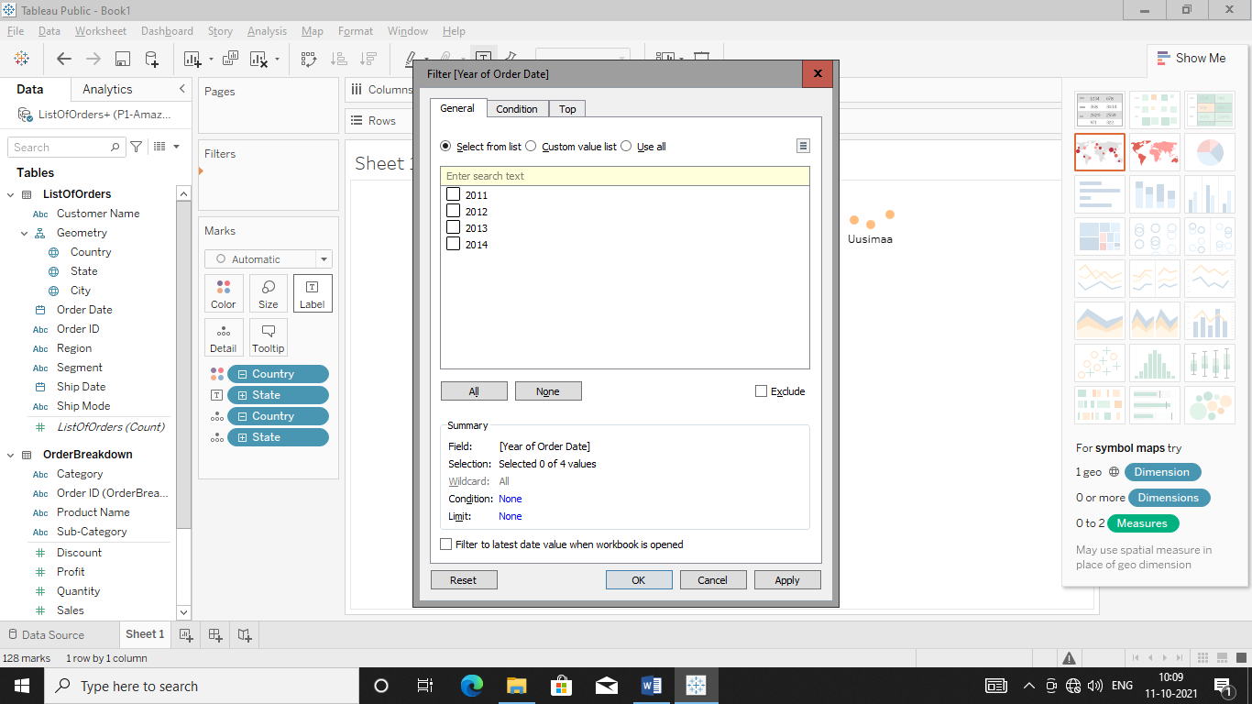

Select 2011 in above diagram

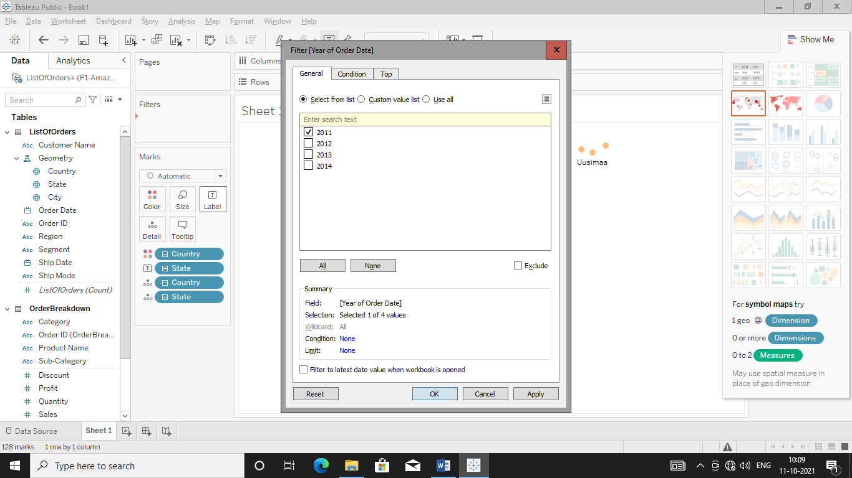Hit Apply in order to get output

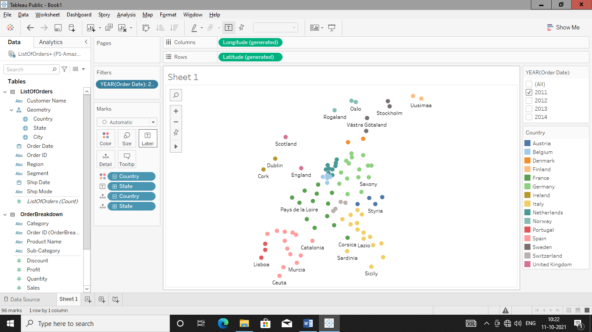  
Remove all option from filter box

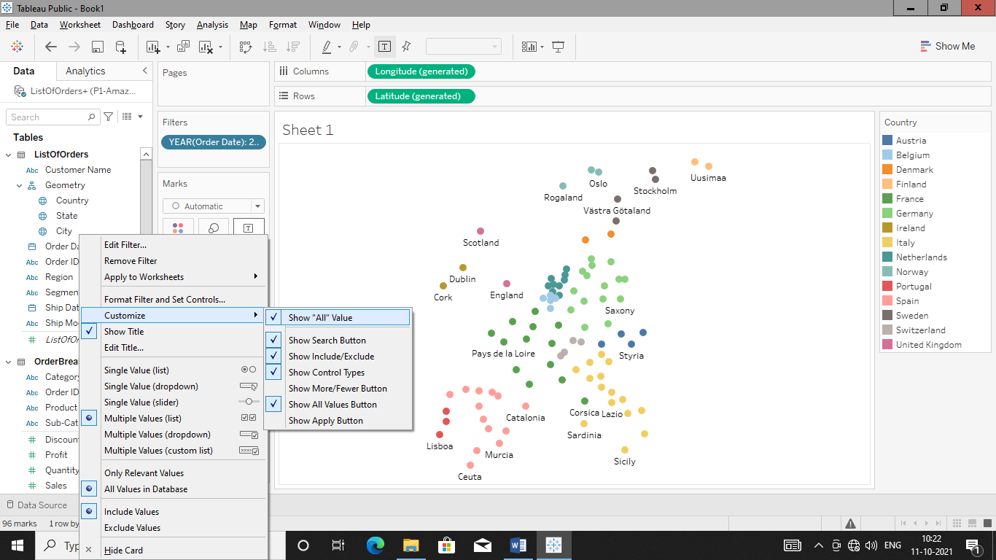

Hit Show All Value to remove it

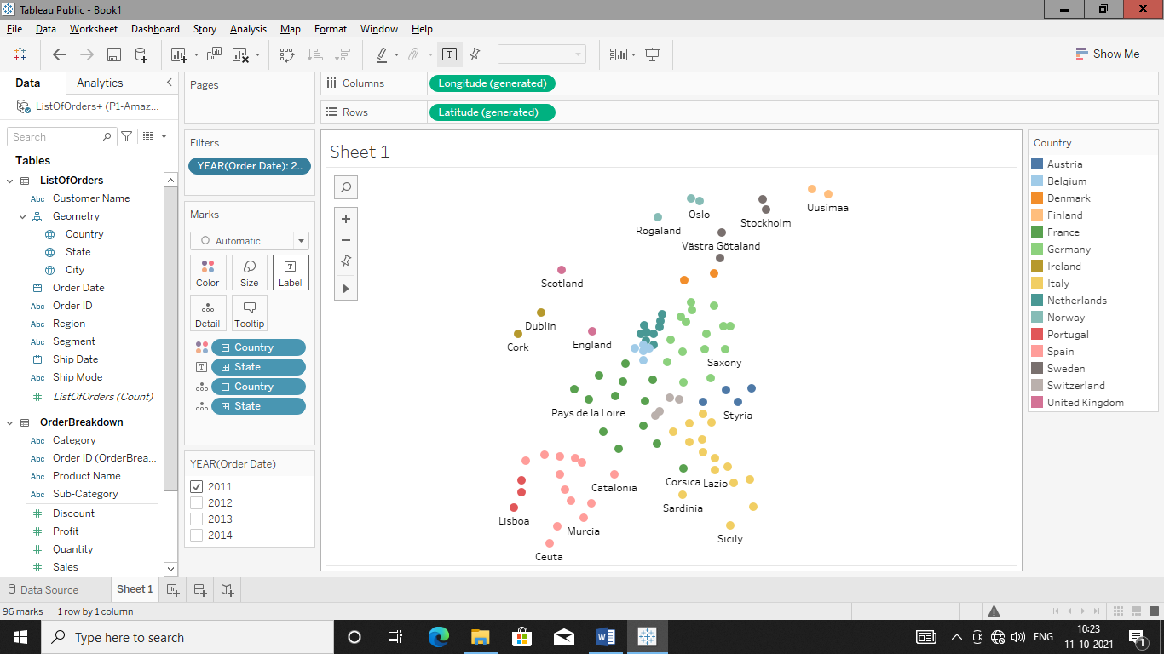

Make Filter as Slider

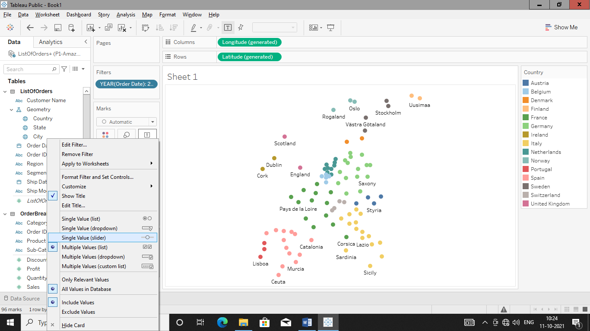

Hit single valued (Slider) to transform filter box in to slider

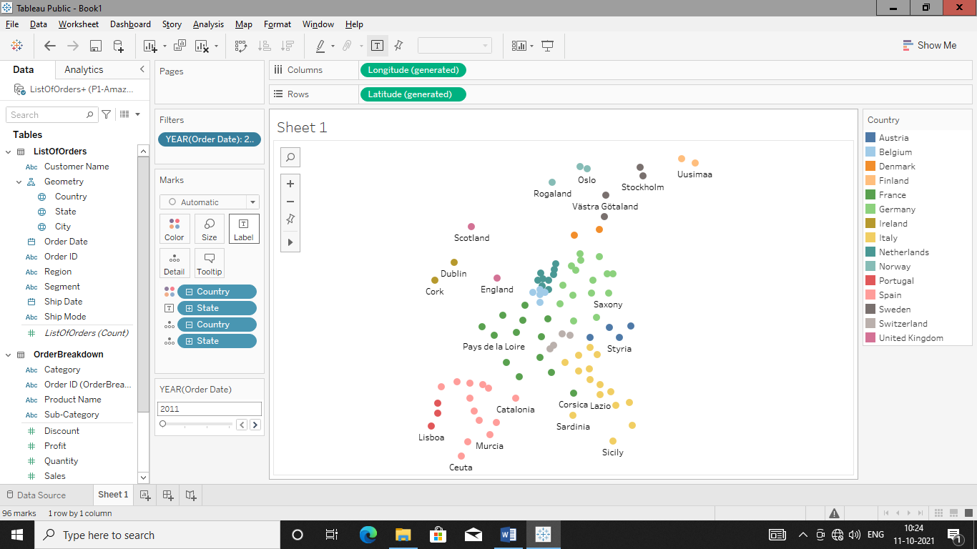

Add Sales to Size box to manipulate map bubble size according to state

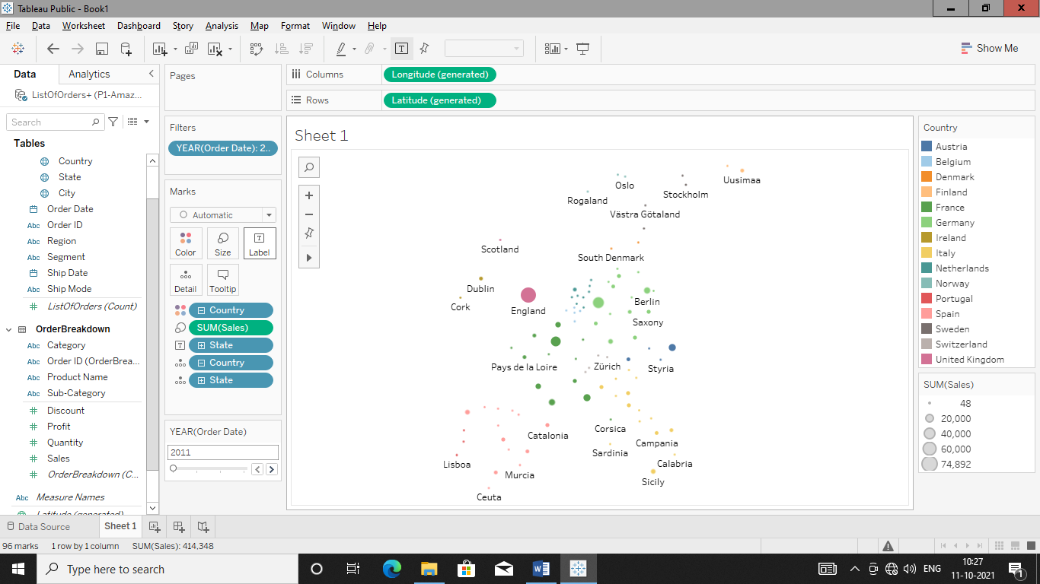

Create calculated field profit margin by right clicking profit as shown above

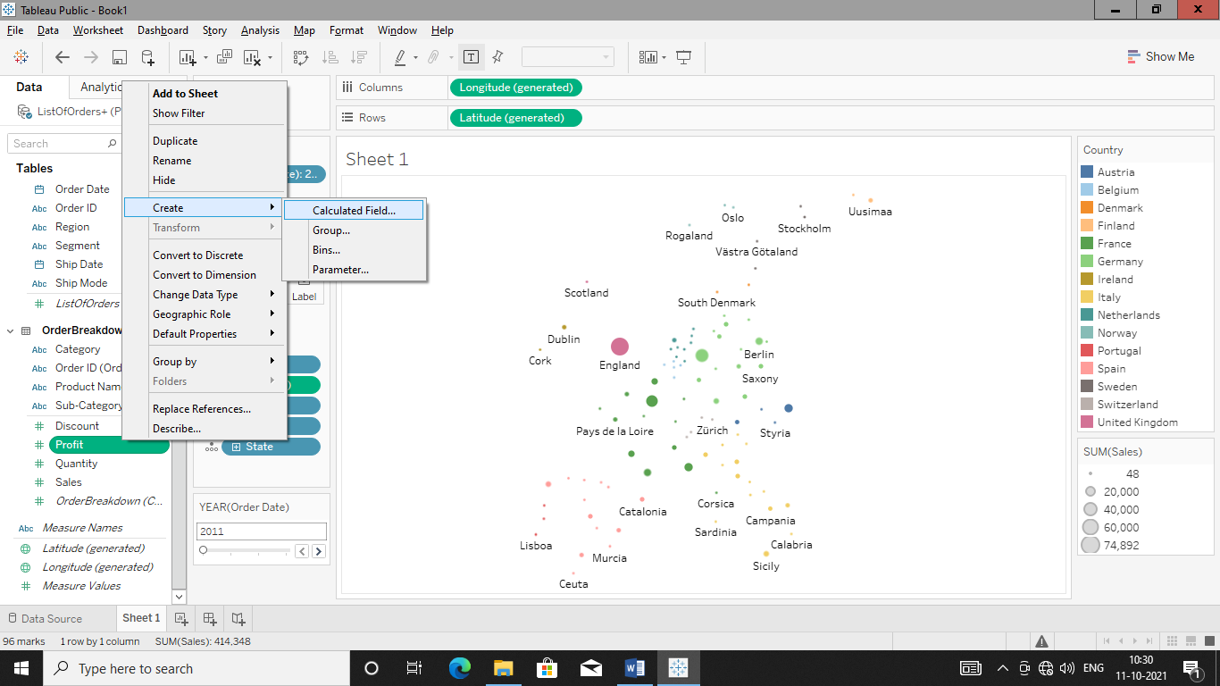

Calculate profit margin and make calculated field

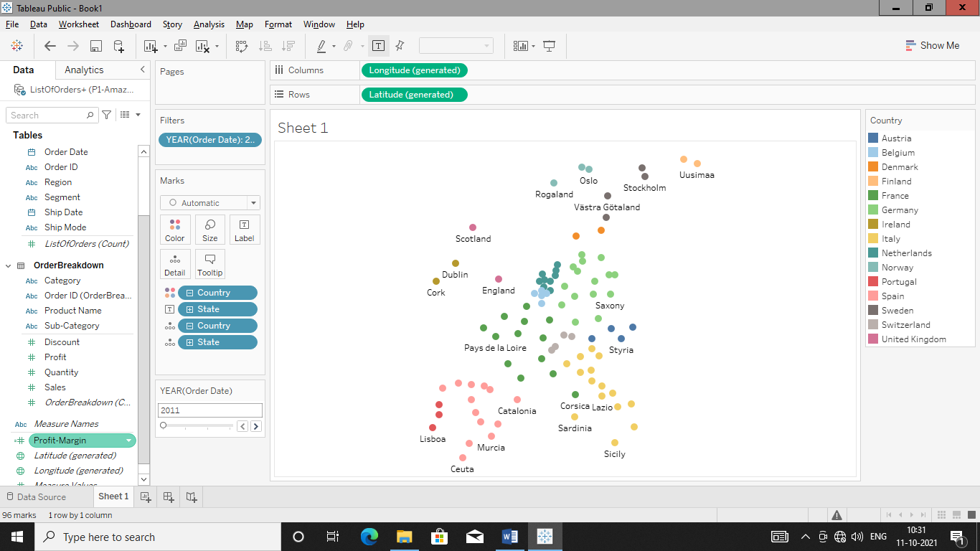

Add profit margin to size tab to get map

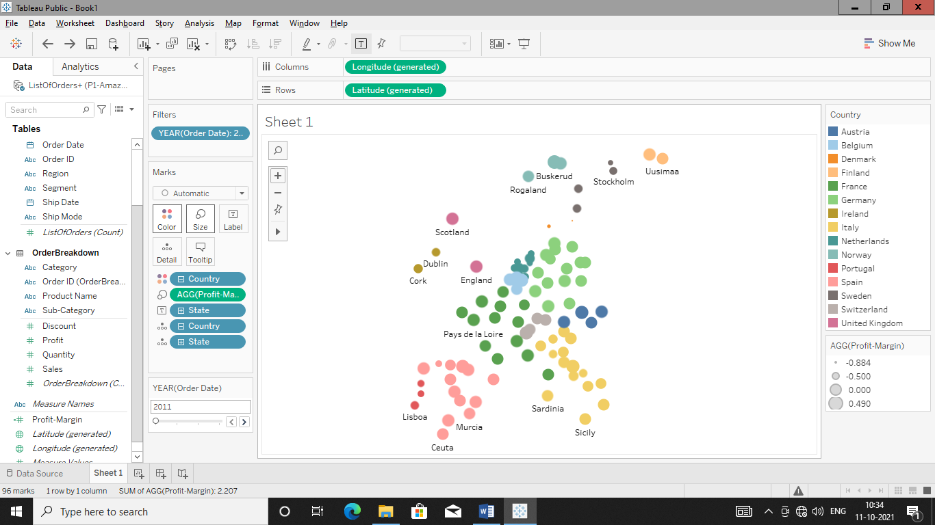

Add profit margin to colour tab to get details of profit margin state wise in map

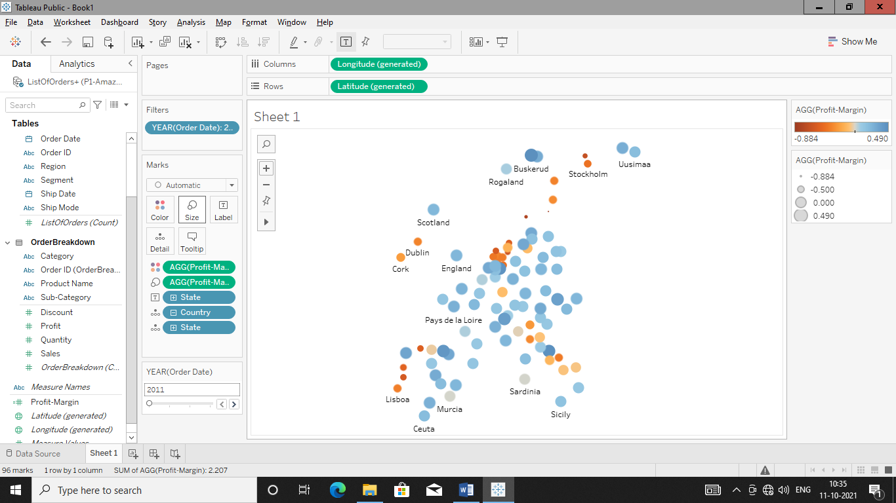

Change color filter to blue-red

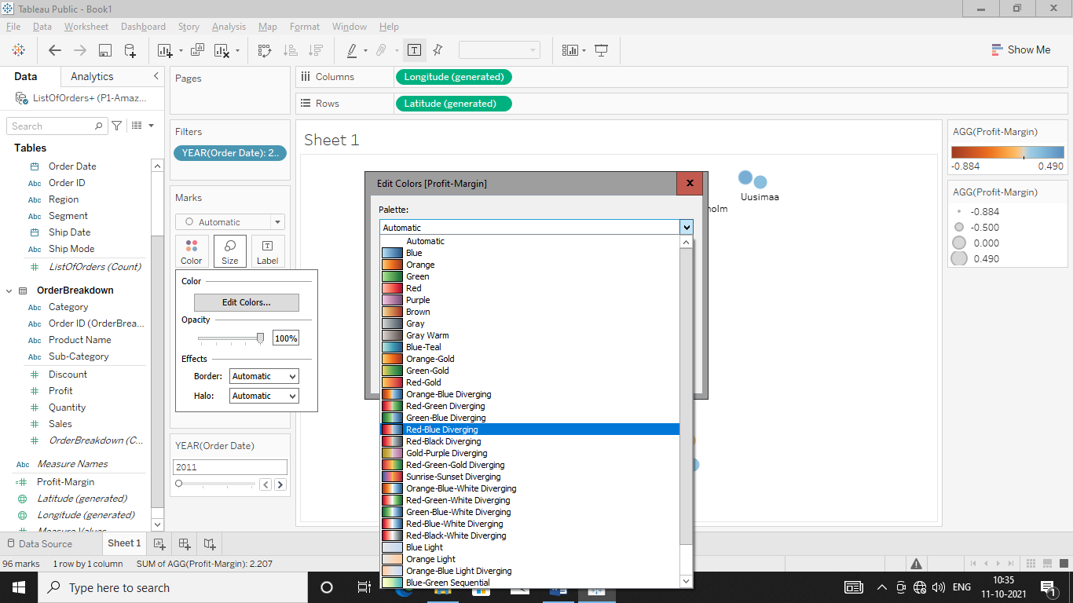

Click on advance

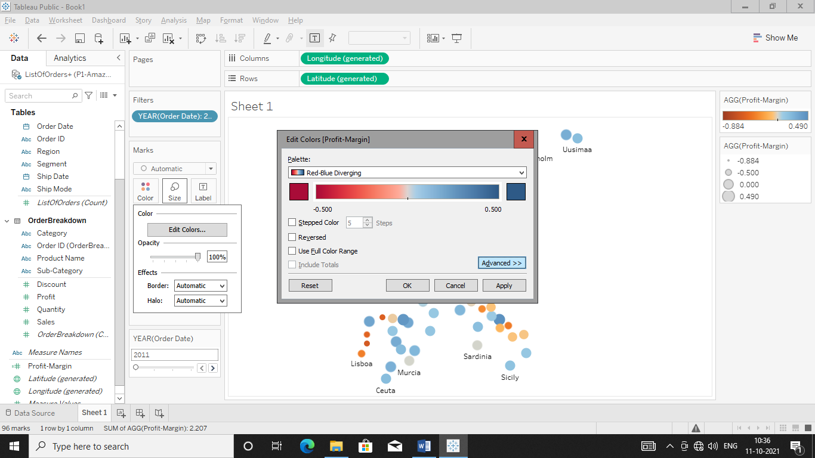

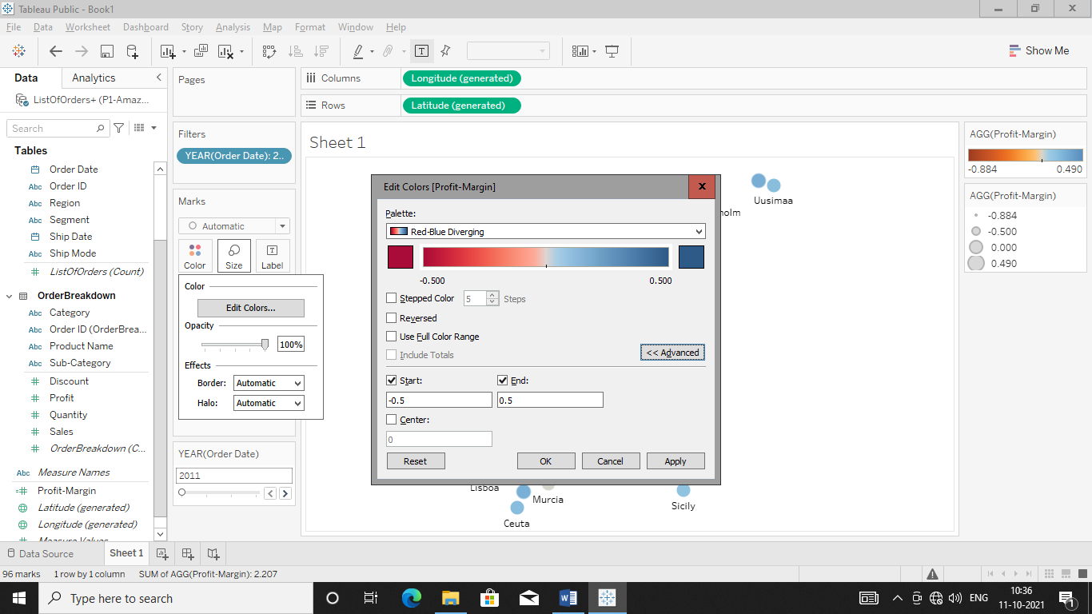

Change Start to -0.5 and End to 0.5 and hit Apply and cliuck ok to get respective output

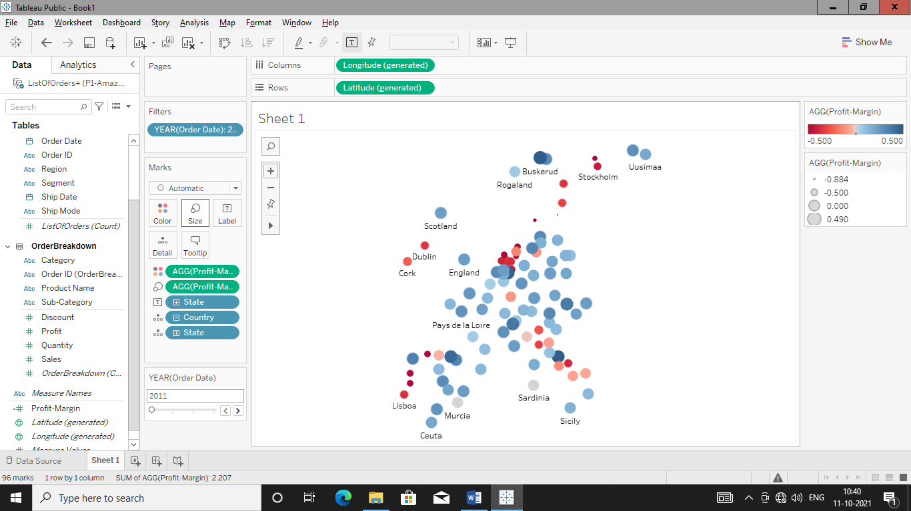

Remove profit margin from size to get clear map

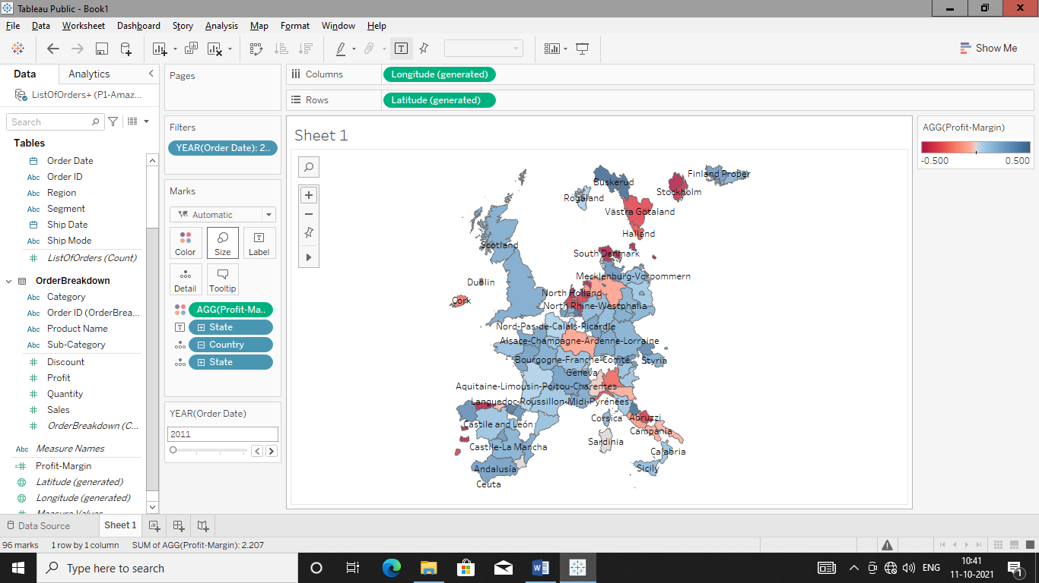

Create Scatter Plot between profit and Sales

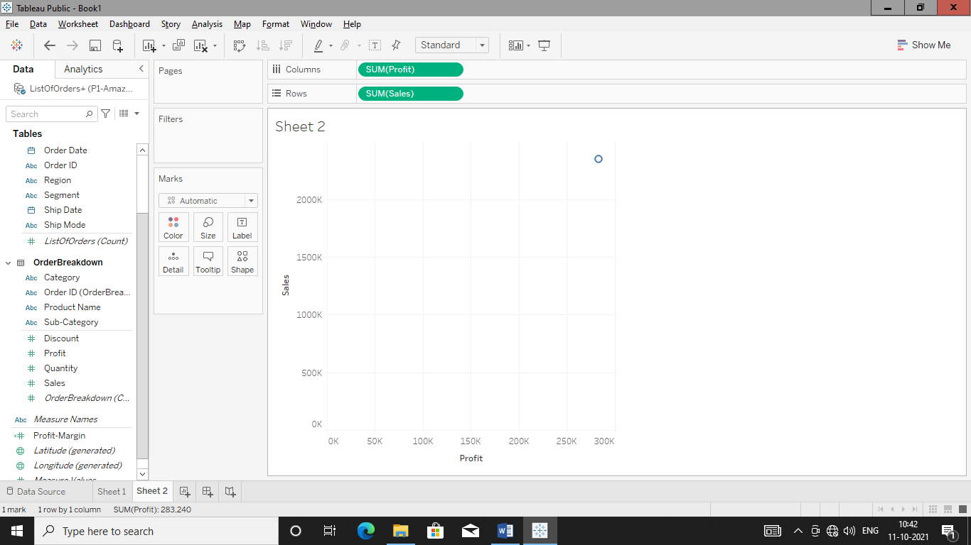

Add Customer name to details as we want scatter diagram of profit & sale for specific customers.

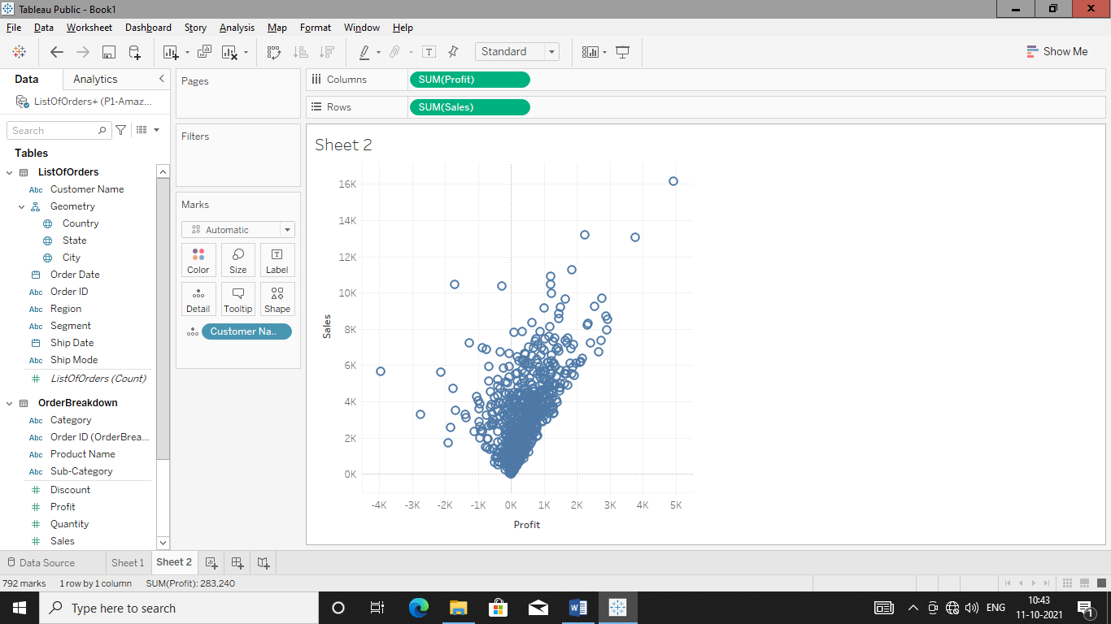

Add Country to Color to get scatter diagram of profit-sales of customers with country colours

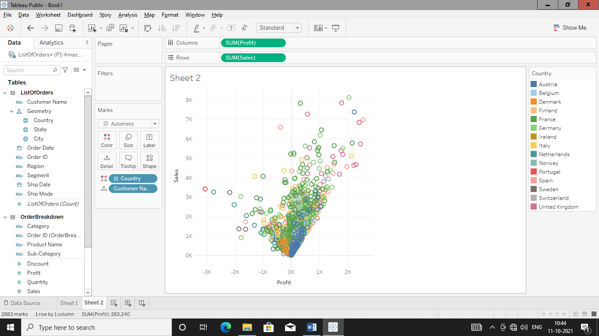

Add profit margin to colour tab to get scatter diagram of specific customer with colour code

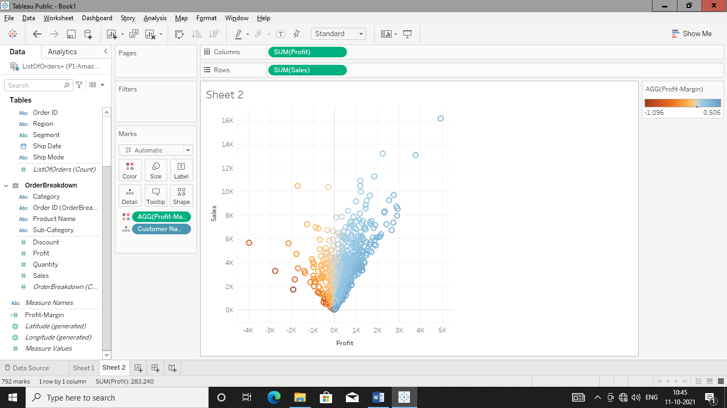

Add Order date to filter tab and filter scatter diagram year wise in order to get graph year wise with customer name and profit margin colour.

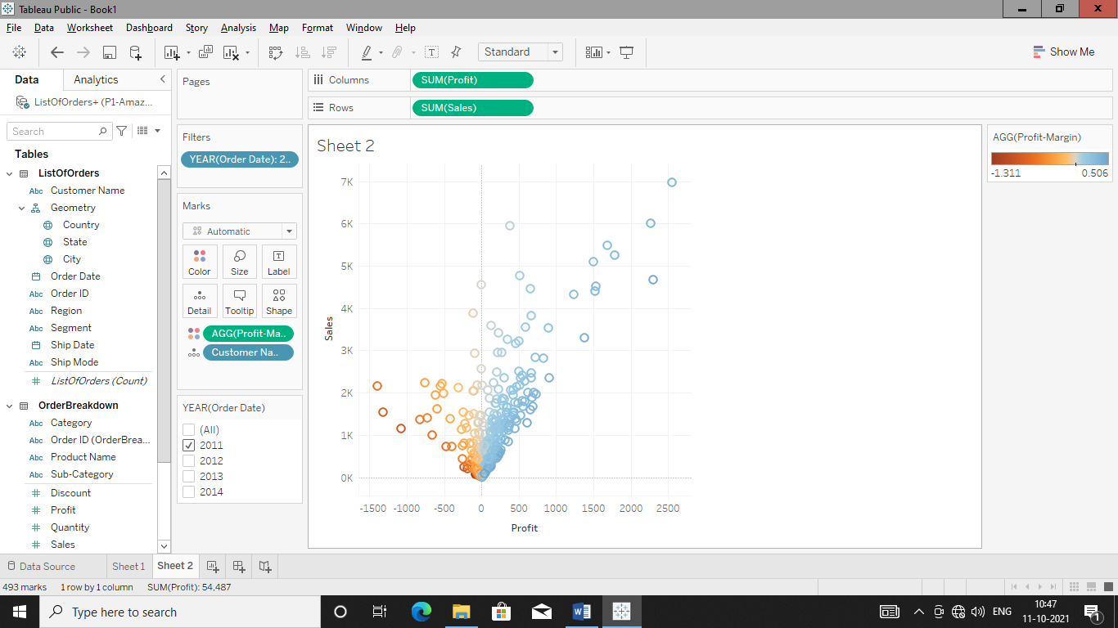

Create dashboard and drop sheets

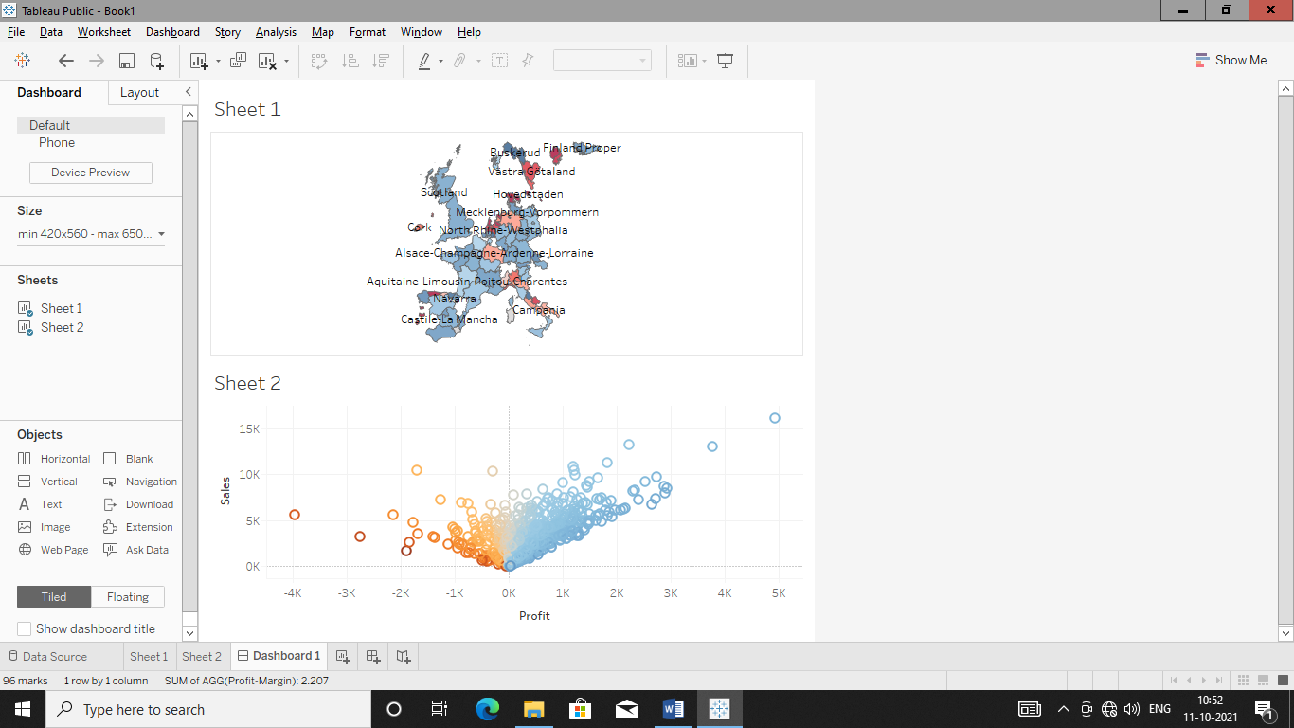

**DAY-04**

**12/10/2021**

**Name**: Harshal Acharya

**Roll No**: 12

**Batch**: B11

**Datasets:** covid_19_data

**Dimensions:**

* Country
* Last Update
* Observation Date

**Measures:**

* Confirmed
* Deaths
* Recovered
* S.No.

**Datasets:** Amazing Mart

**Topics:**

* Create Dashboards
* Add Interactive Action-Filters
* Add Interactive Action-Highlights

**Create Dashboards**

Amazing Mart:

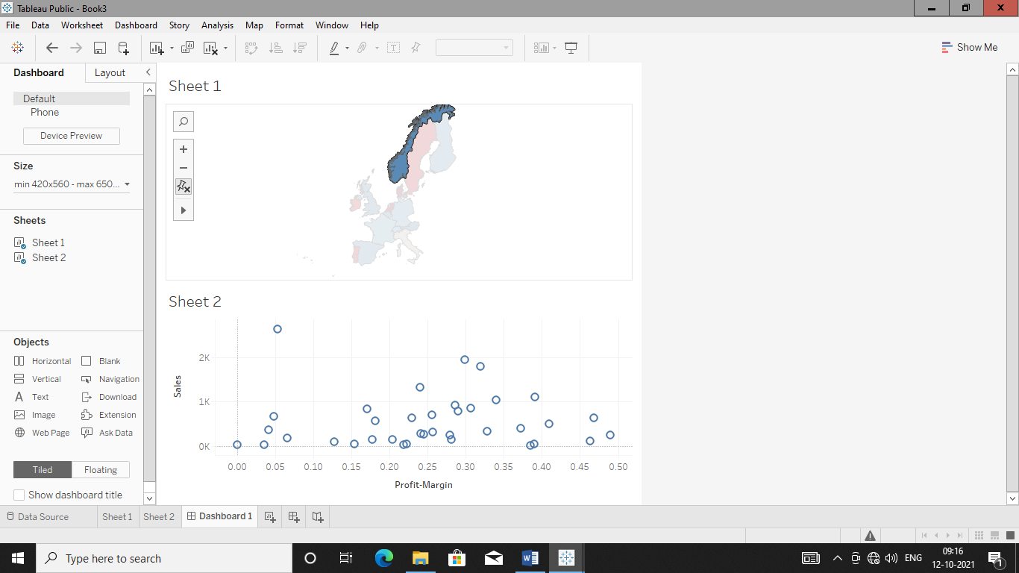

Covid-19:

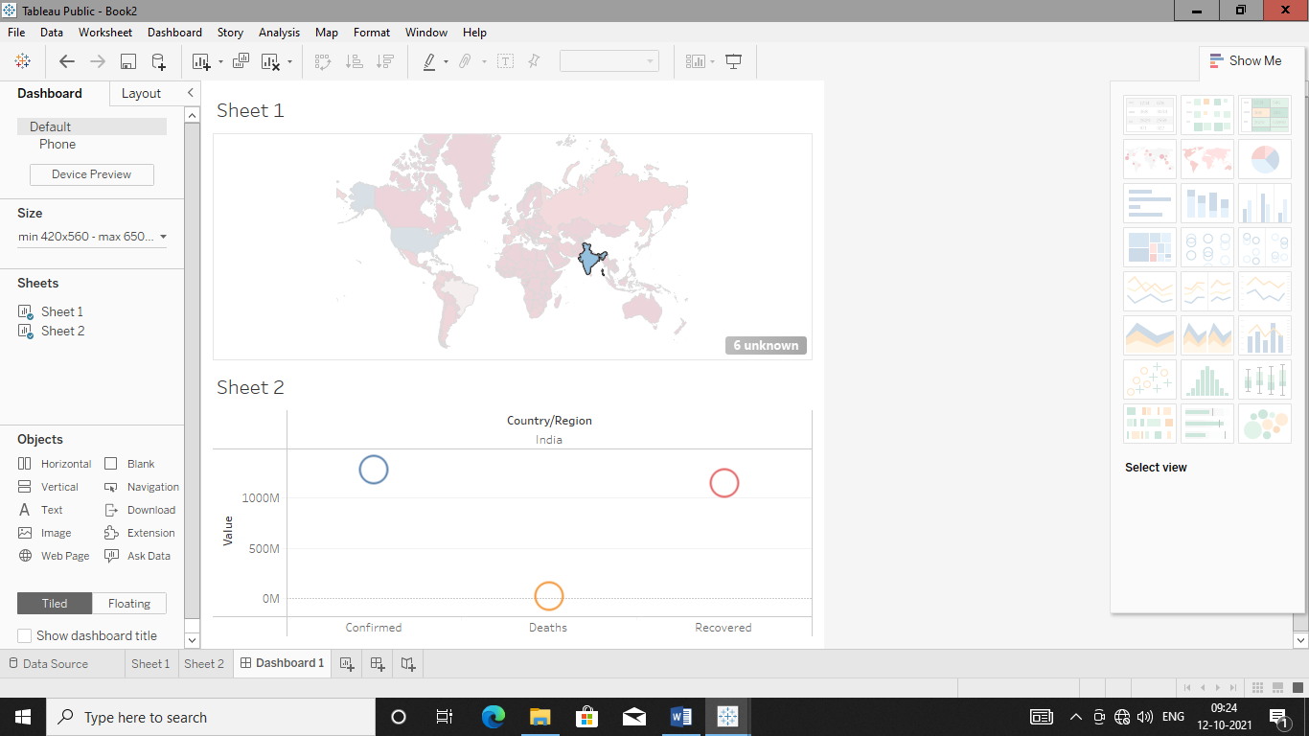

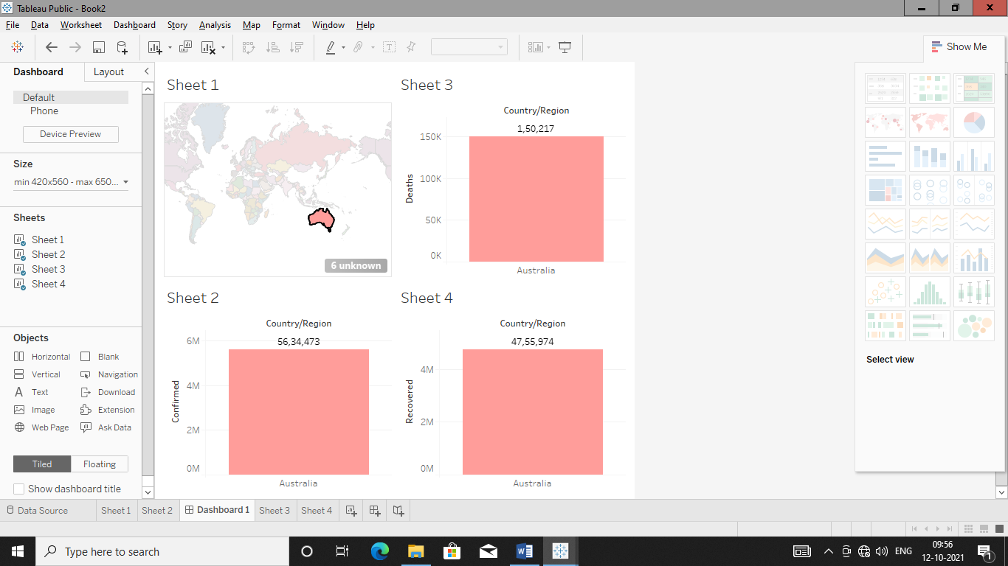

Office Supplies:

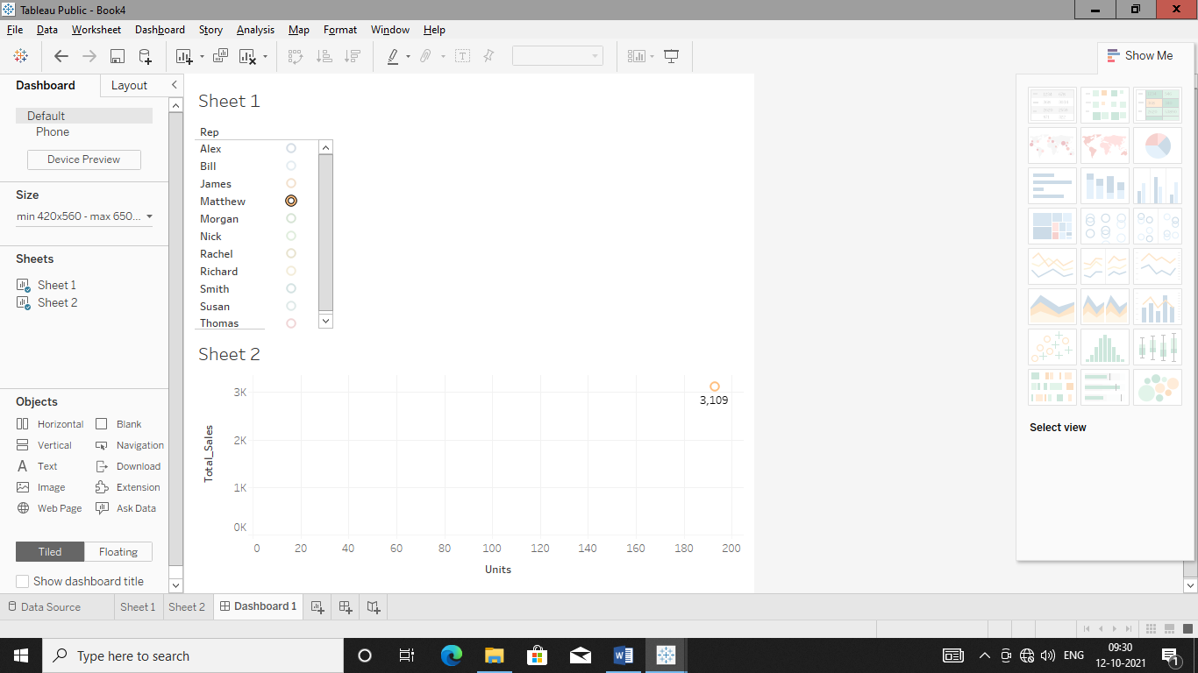

Add Action Filter

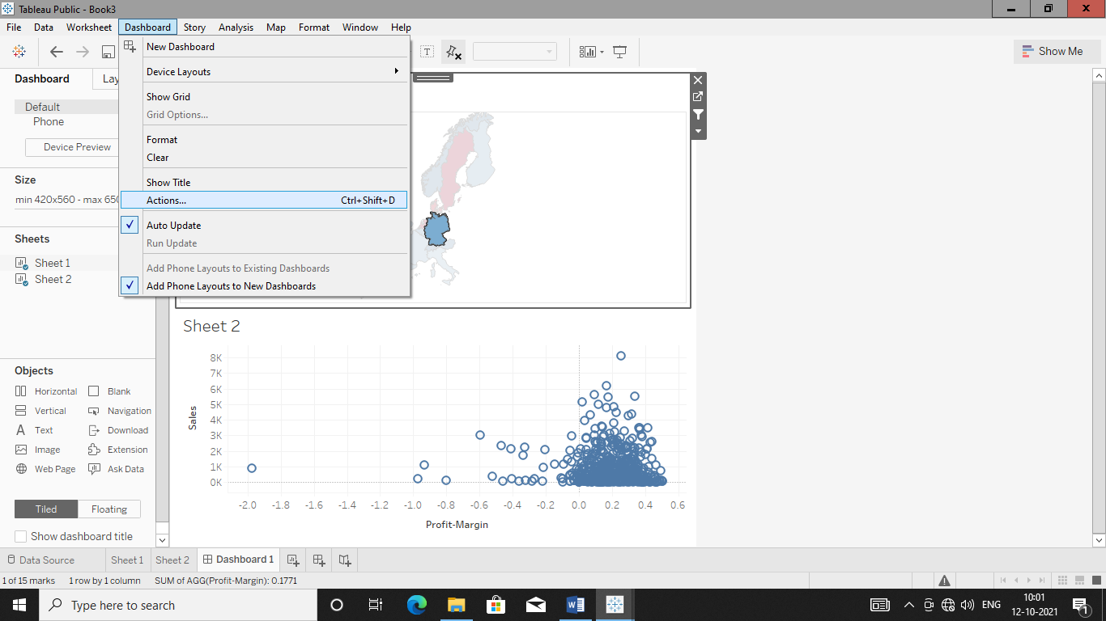

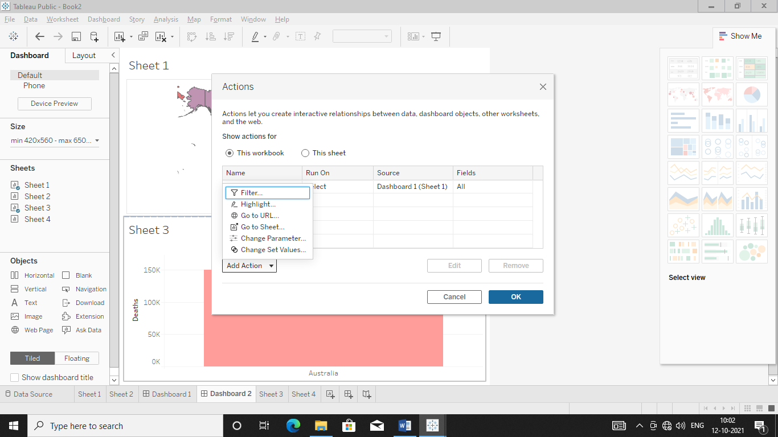

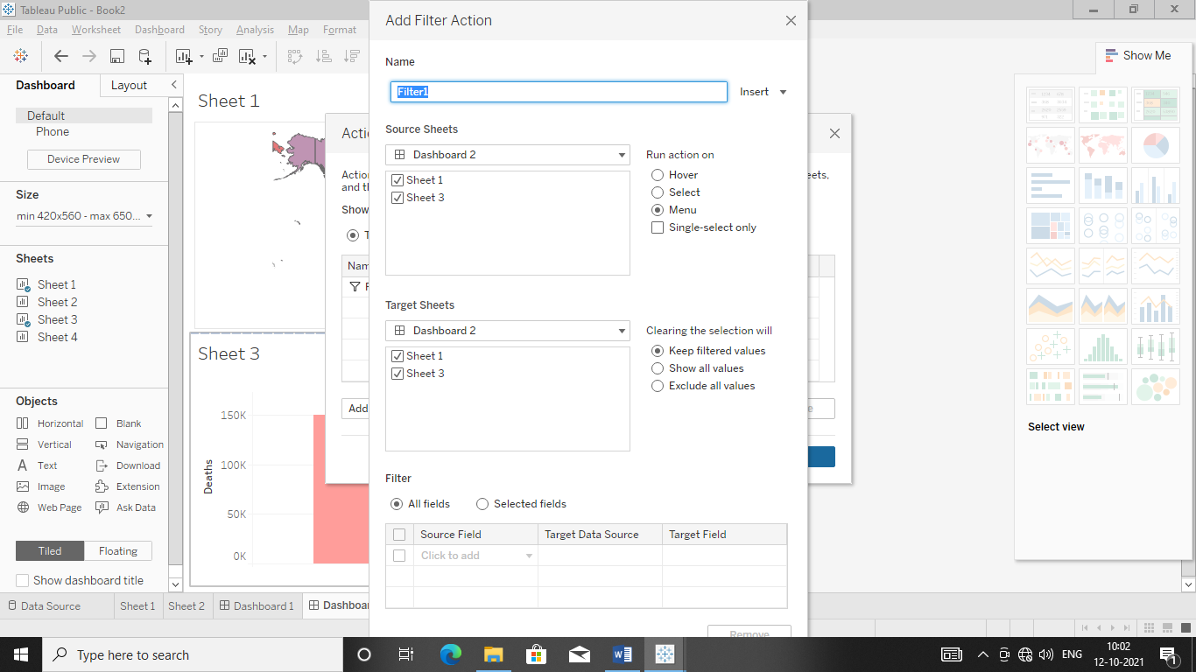

Add Action Highlighter

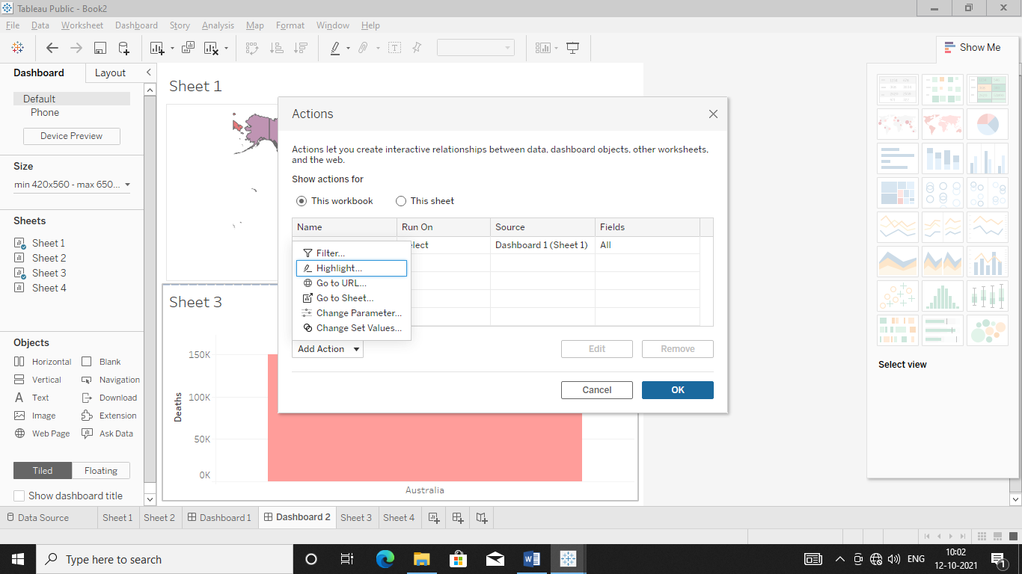

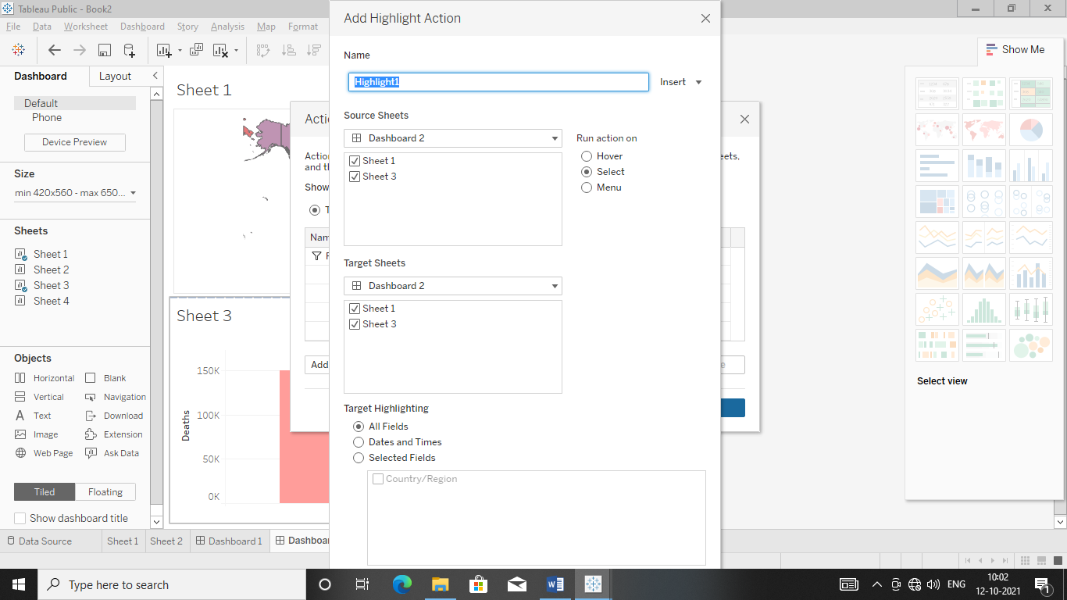

**Dataset:** Netflix

**Make Dashboard With Five Questions:**

Sheet 1:

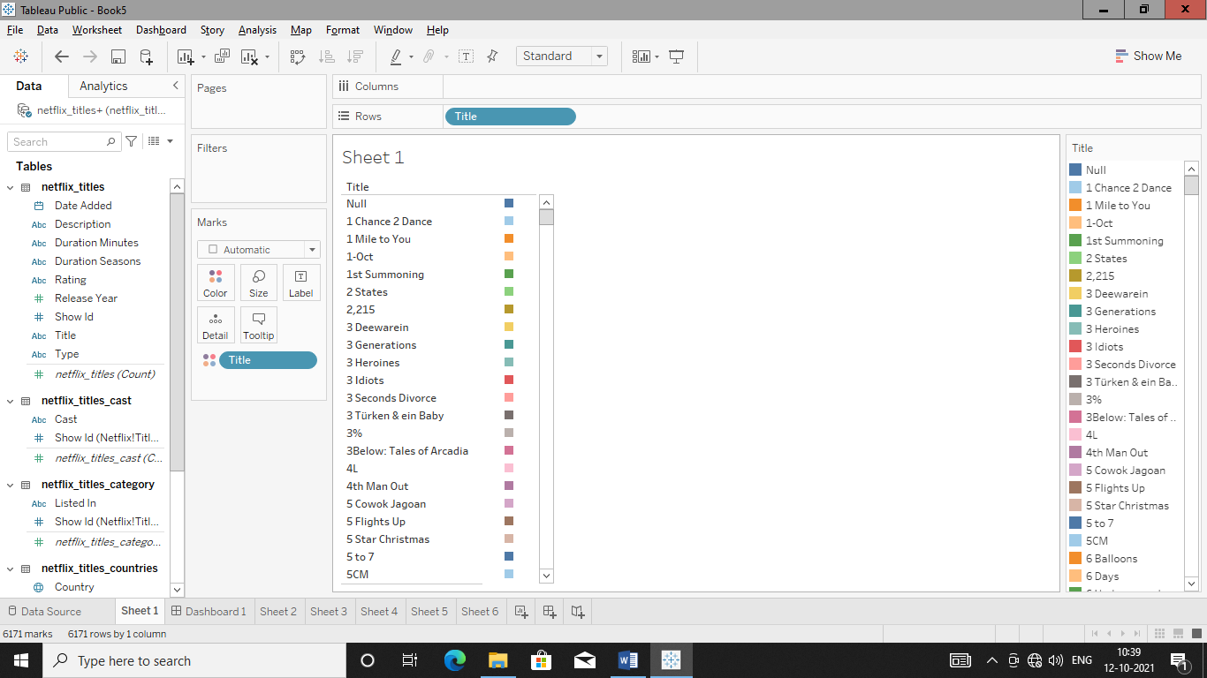

Sheet 2:

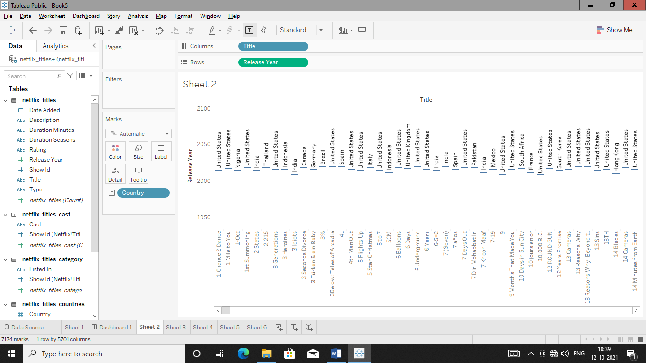

Sheet 3:

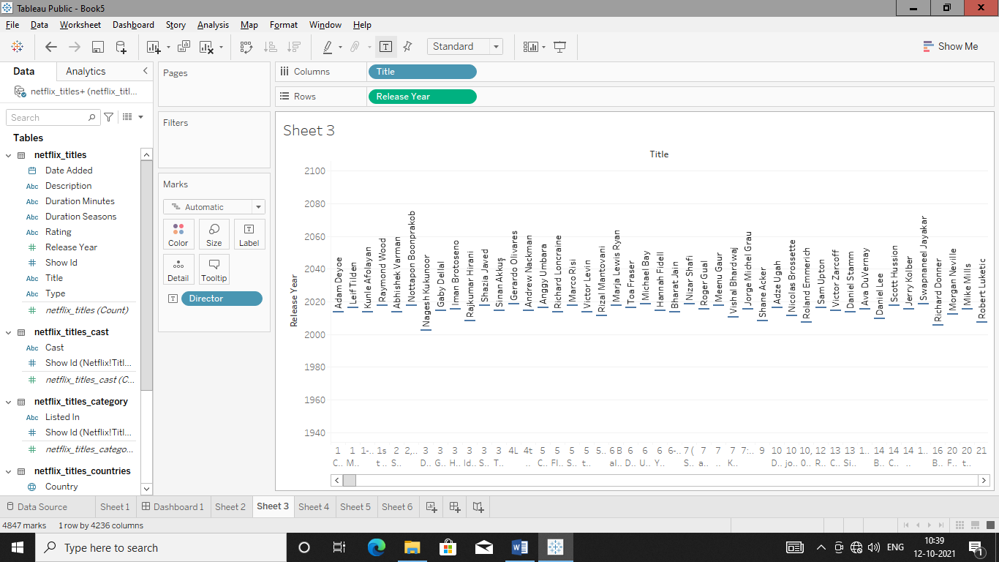

Sheet 4:

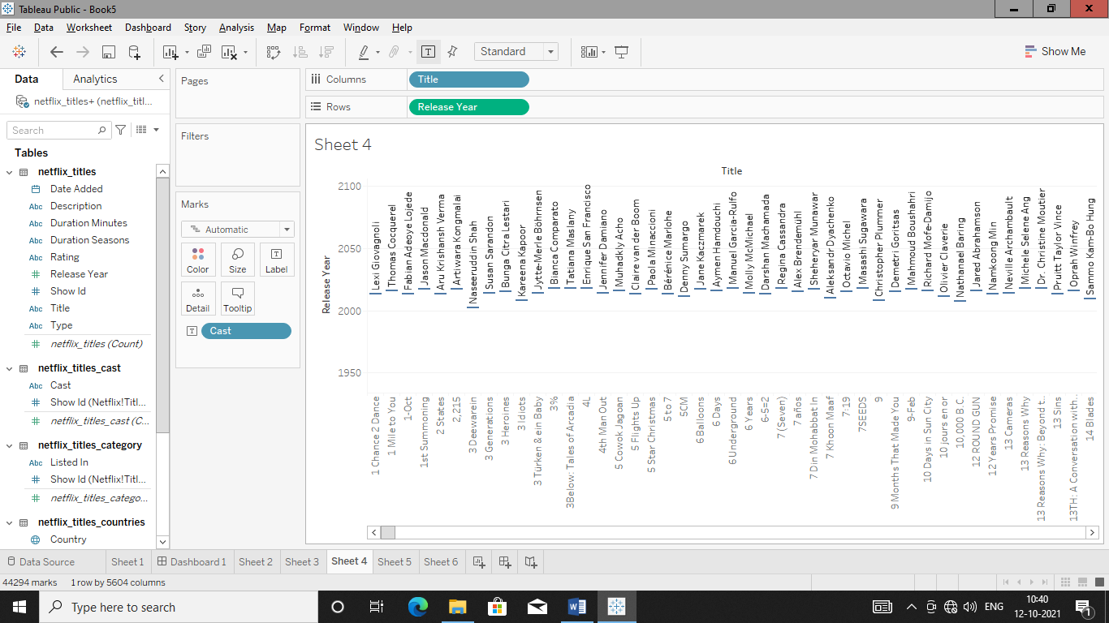

Sheet 5:

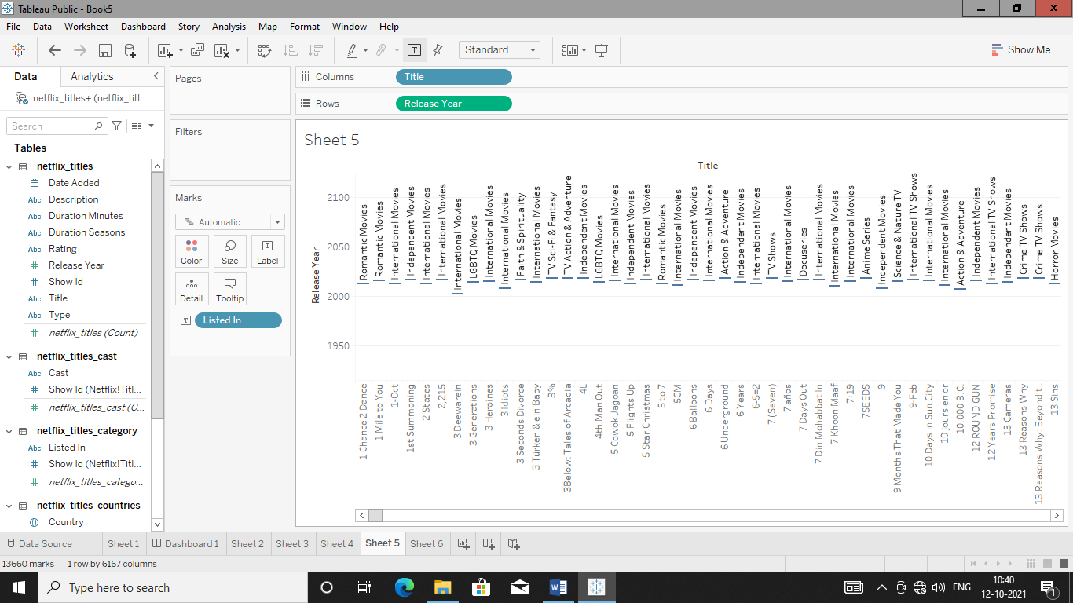

Sheet 6:

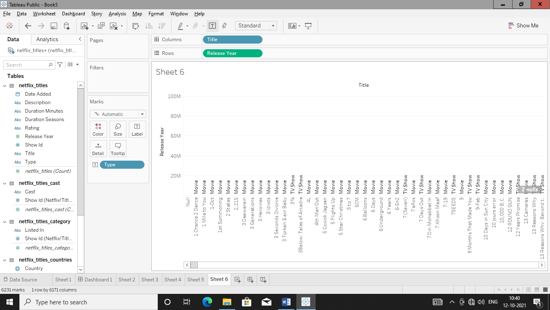

Dashboard:

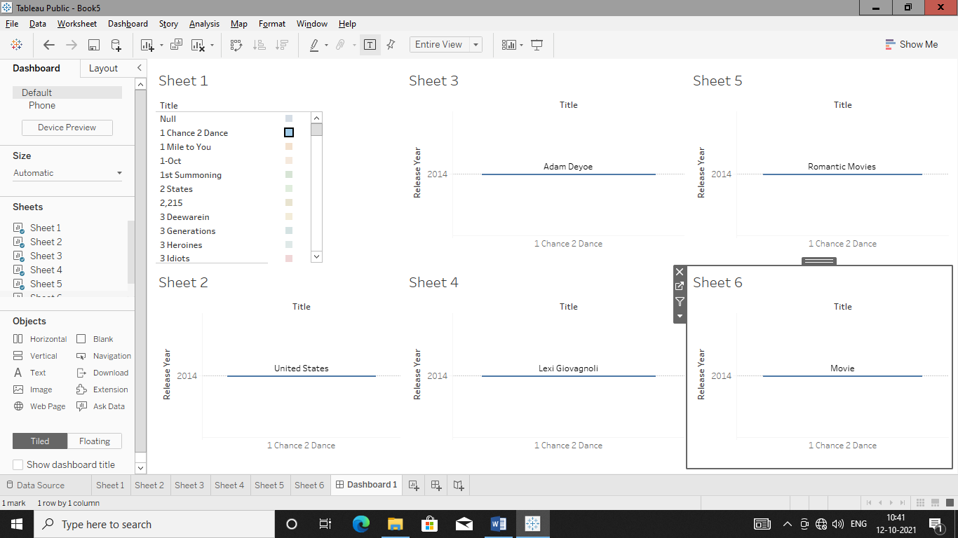

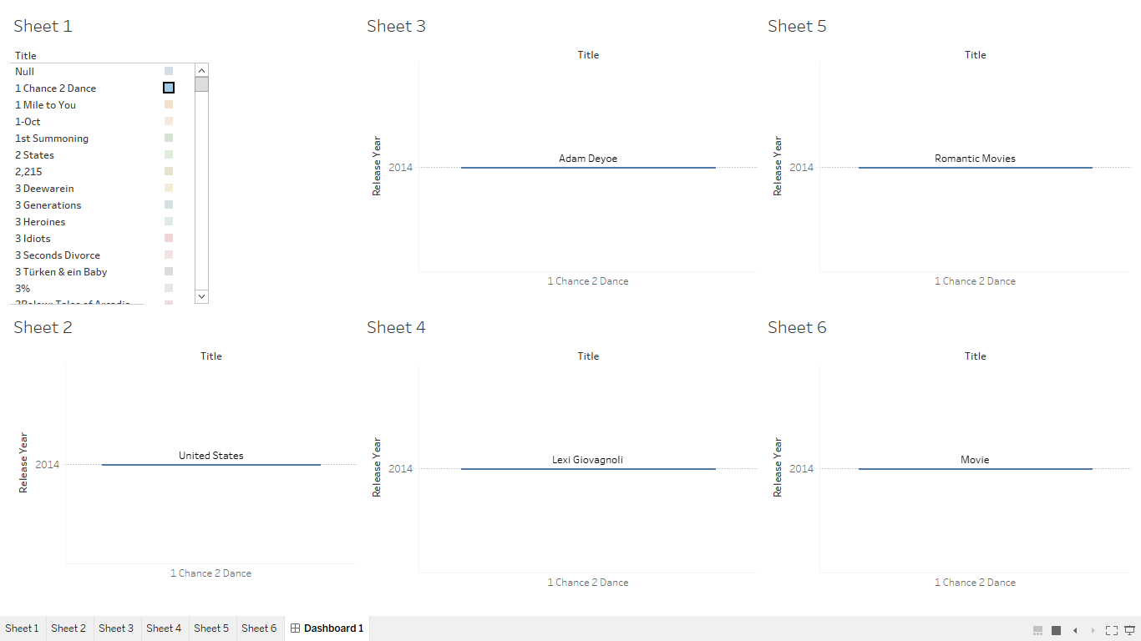

**DAY-05**

**13/10/2021**

**Name**: Harshal Acharya

**Roll No**: 12

**Batch**: B11

**Datasets:** Amazing Mart EU

**Topics:**

Data Joining & Data Blending

**Data Joining:**

**Joining Of Tables-**

Add Dataset and then drag and drop one table to that side.

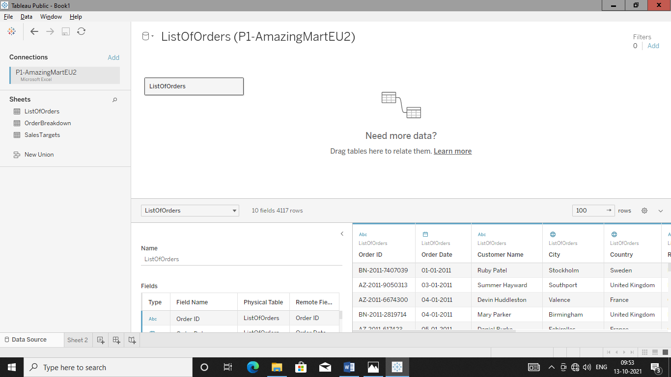

Double click on ListofOrders to go in physical level to make join.

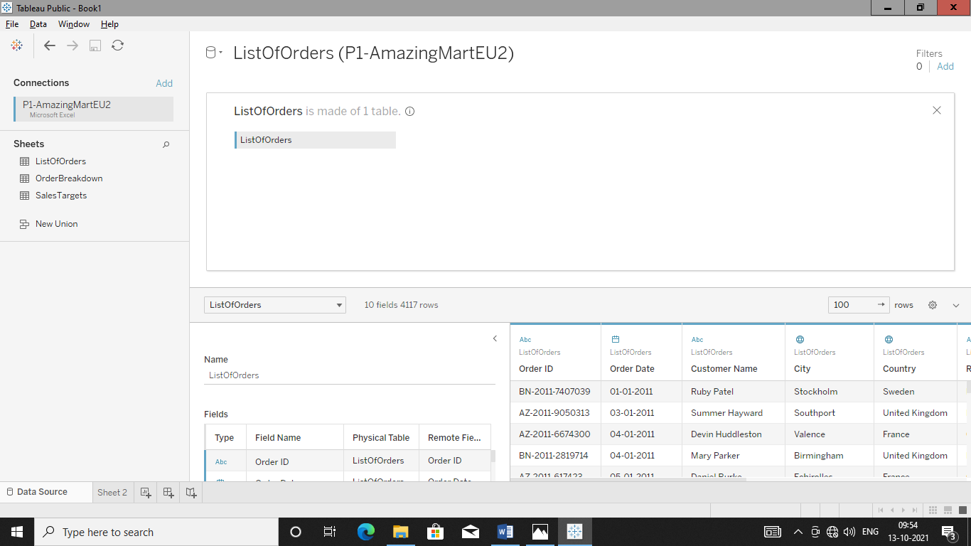

Drag & Drop another table to which join is to be formed.

Here tableau will automatically form join with respect to data source.

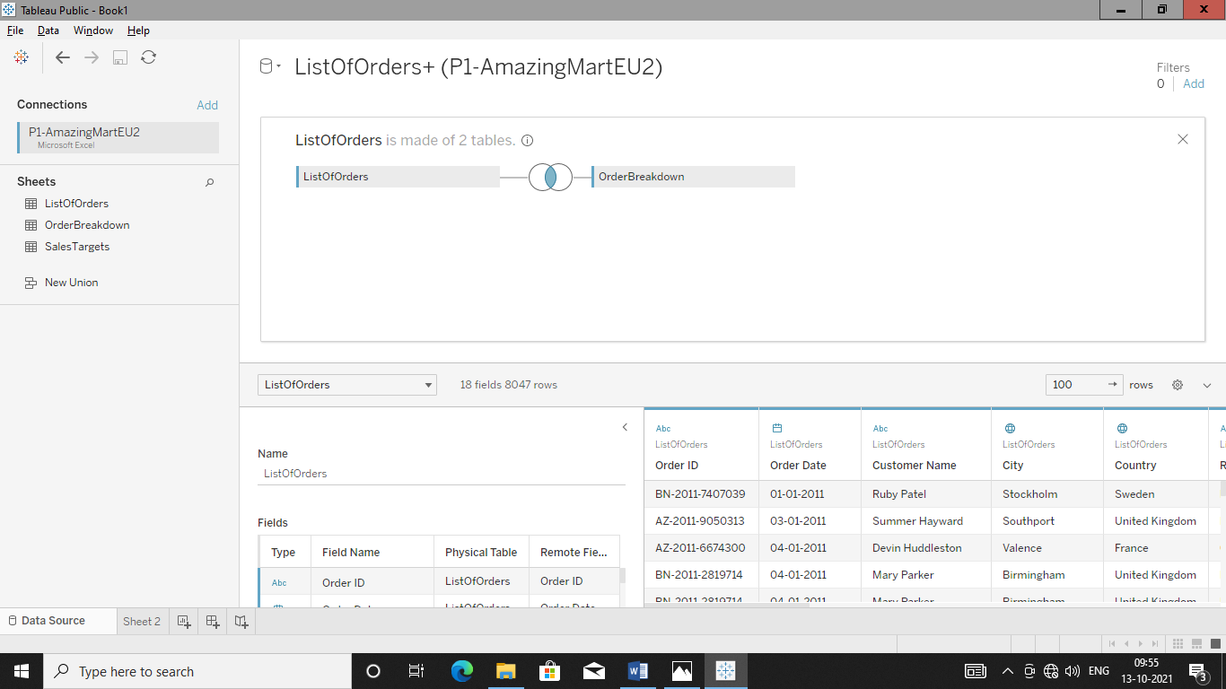

Now we want to work with all three table so now again connect to data source and drag and drop third table to use it which secondary table.

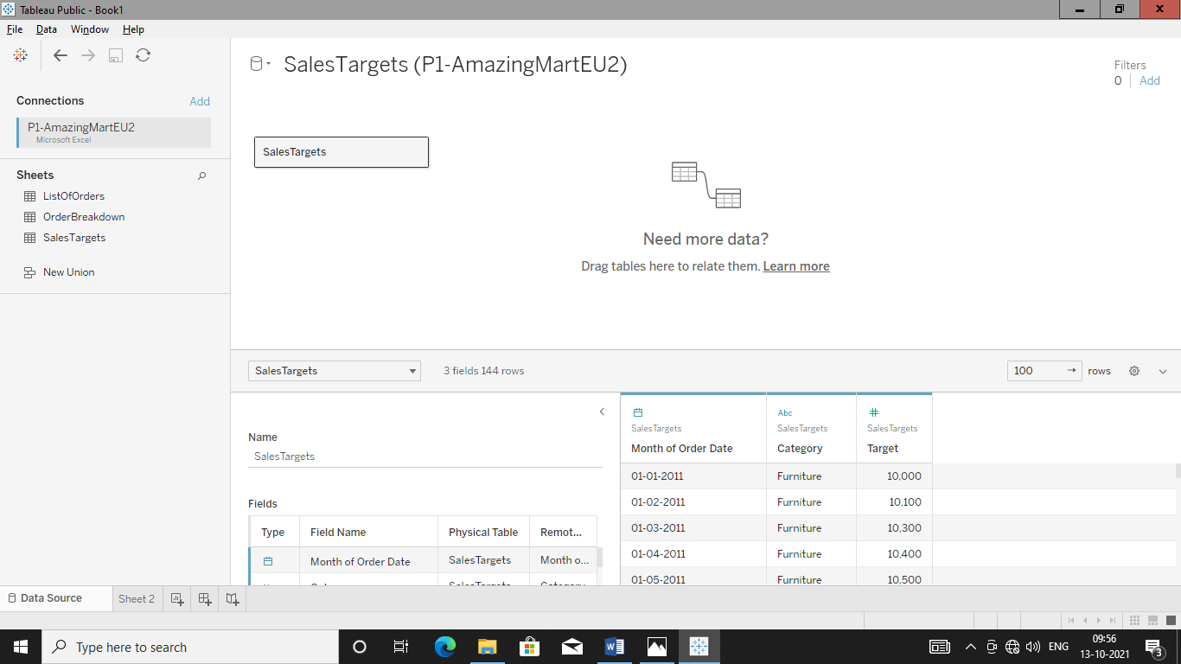

Go in sheet to see all data which came in two table form i.e. primary & secondary.

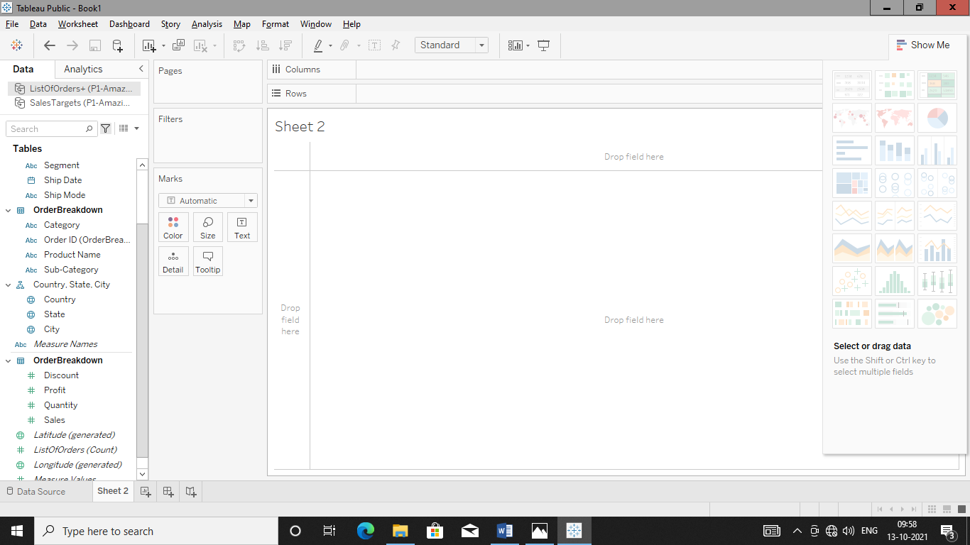

**Q.** Find total sales and Target for each ‘Category’ (for each month of a year).

For this make plot between month wise sales line chart in order to get information about sales category wise.

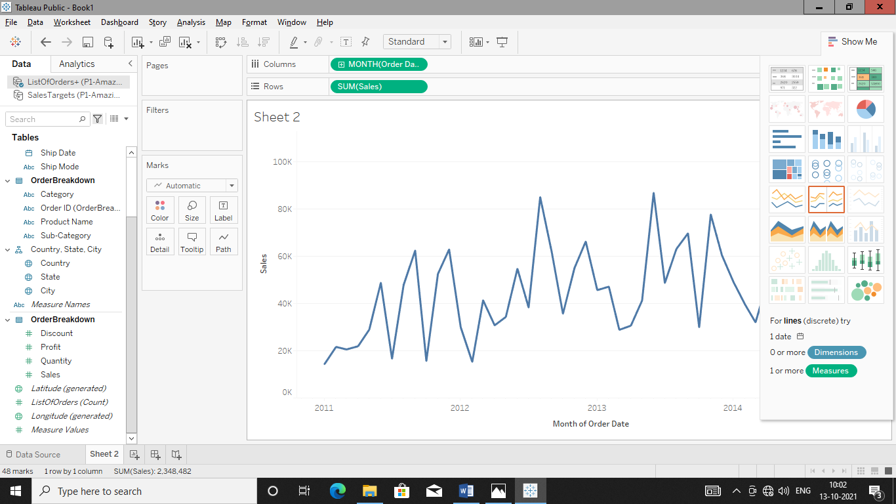

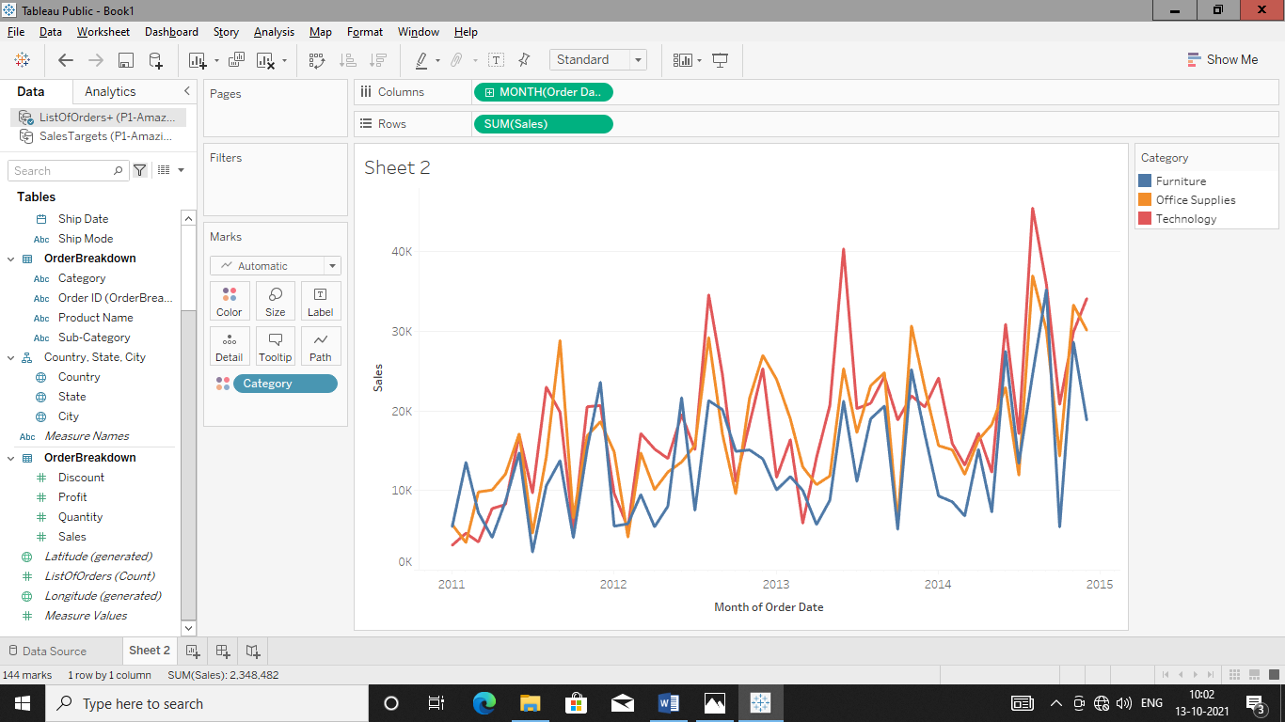

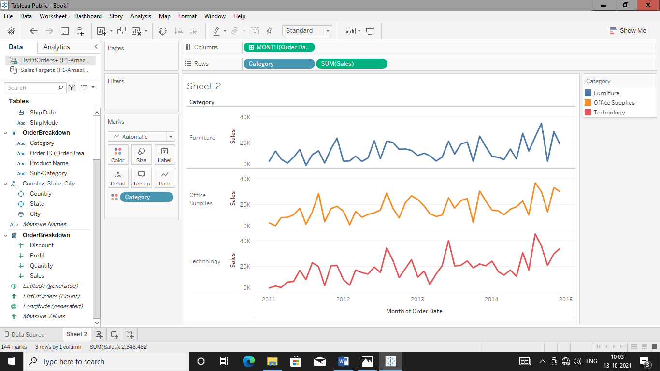

Add target in order to analyse sales in each month of year .

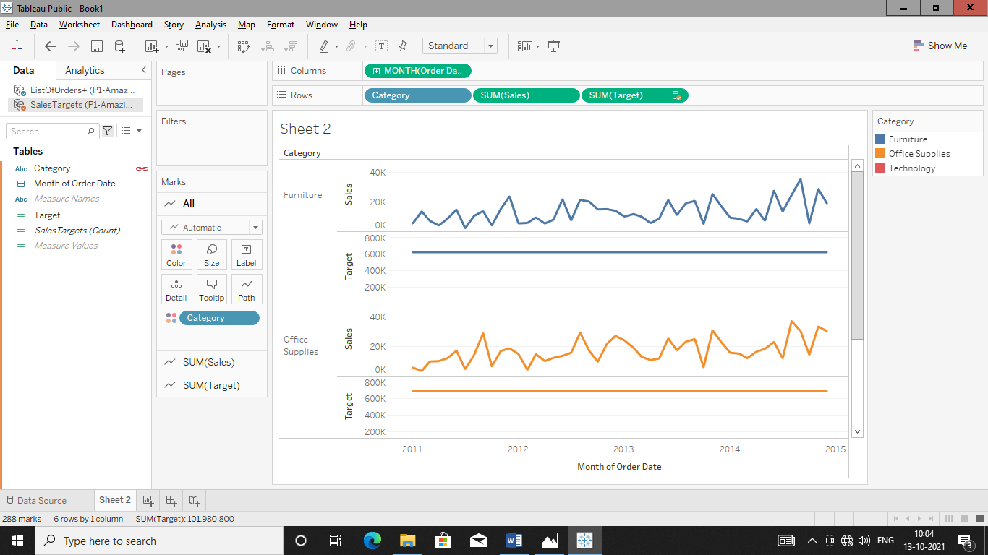

Now chart is not appropriate of target as its one line or aggregated chart so blend the data to get exact analysis.

**Blending The Table:**

Blend “targets” in sales table to match with ‘Month’ of ‘order date’ in ‘ListofOrder+Orderbreakdown’ table.

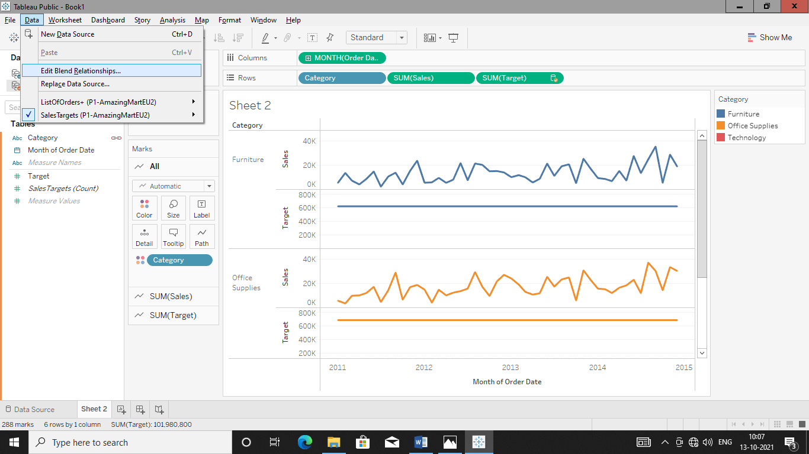

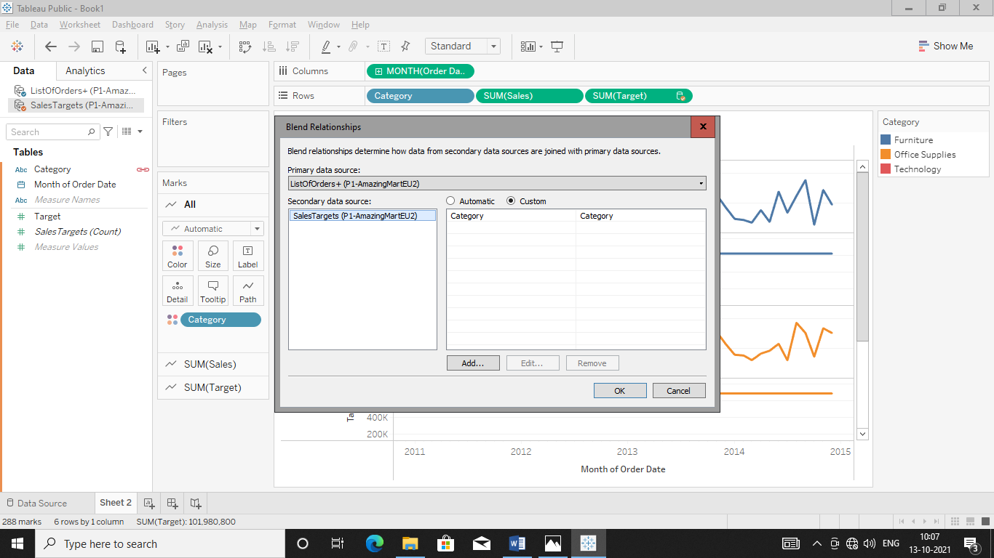

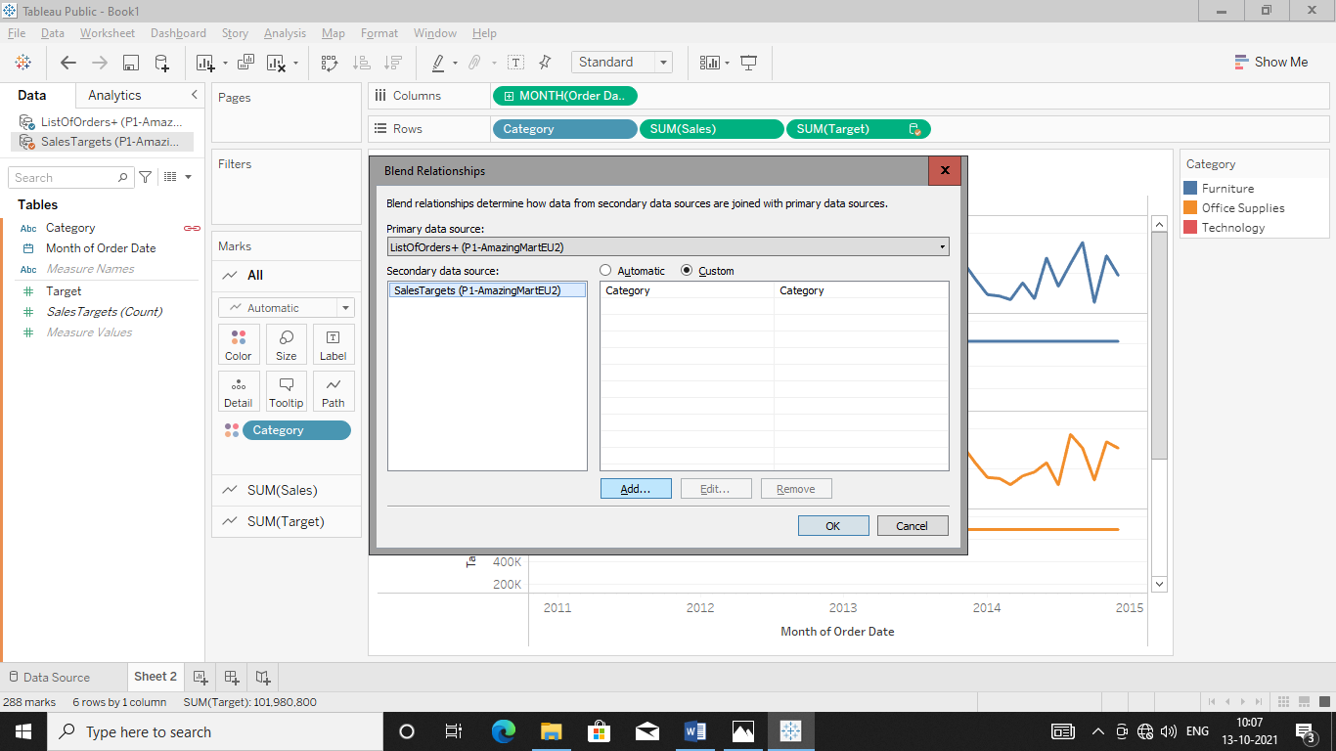

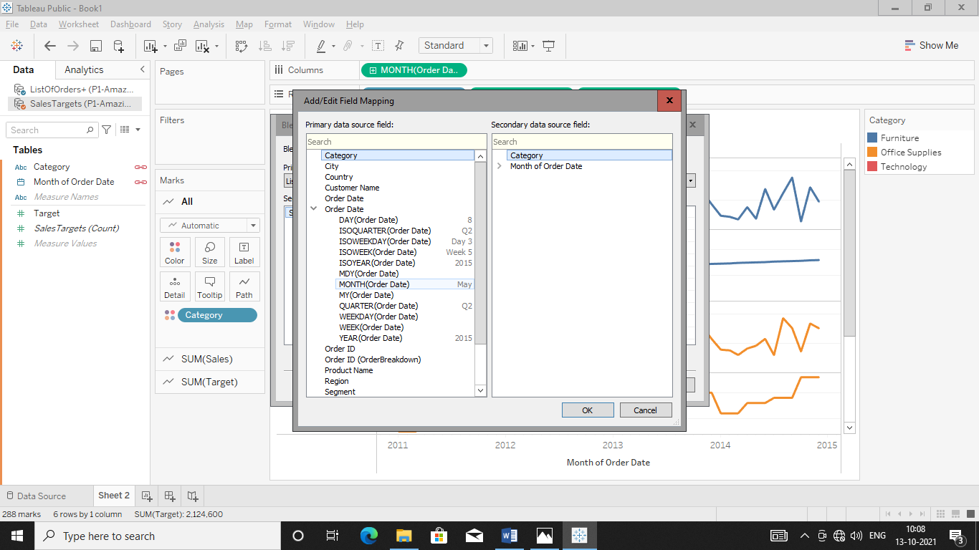

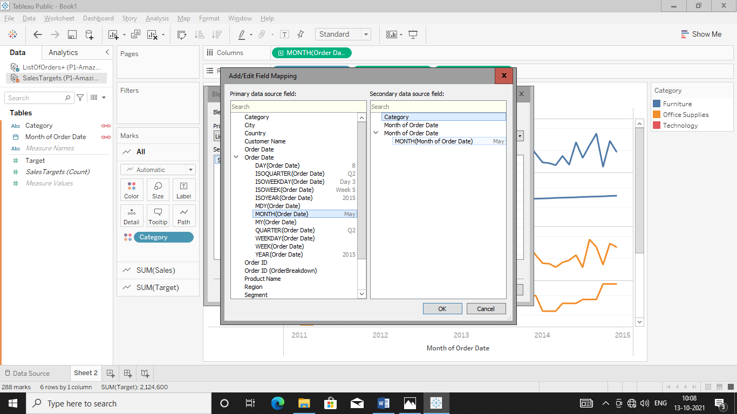

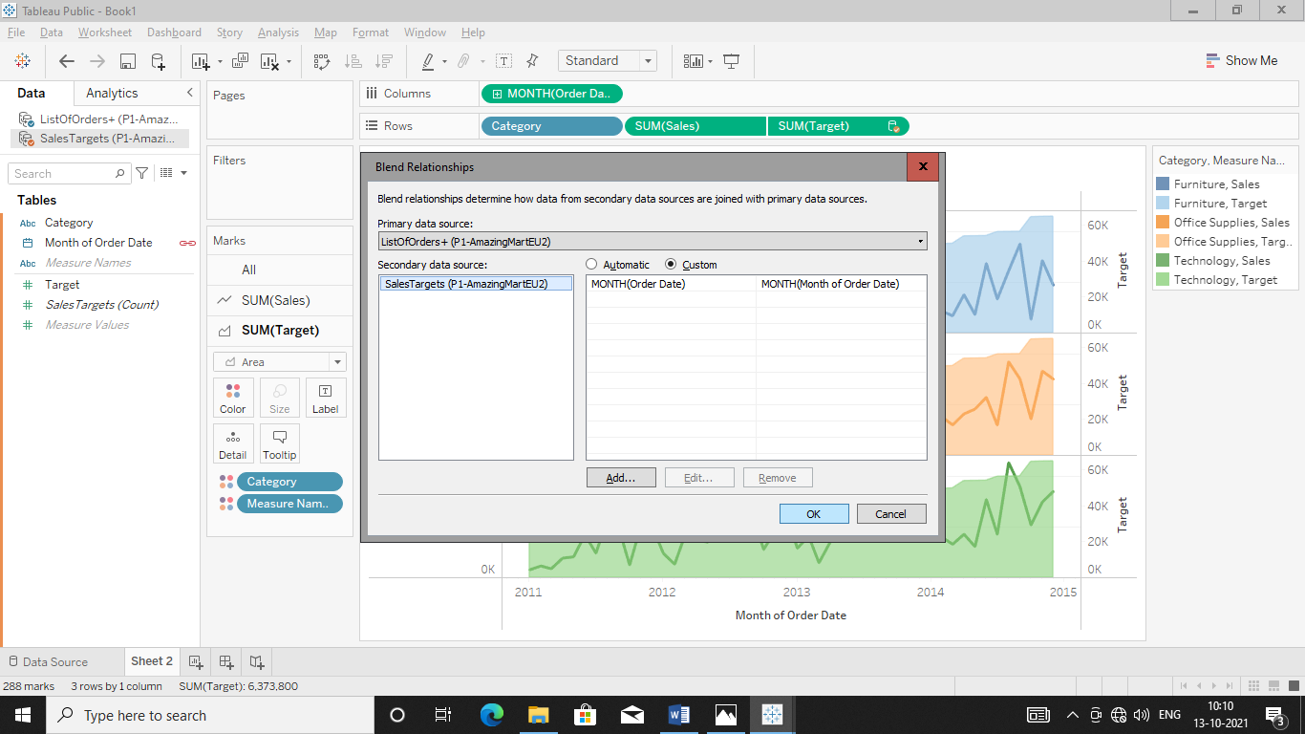 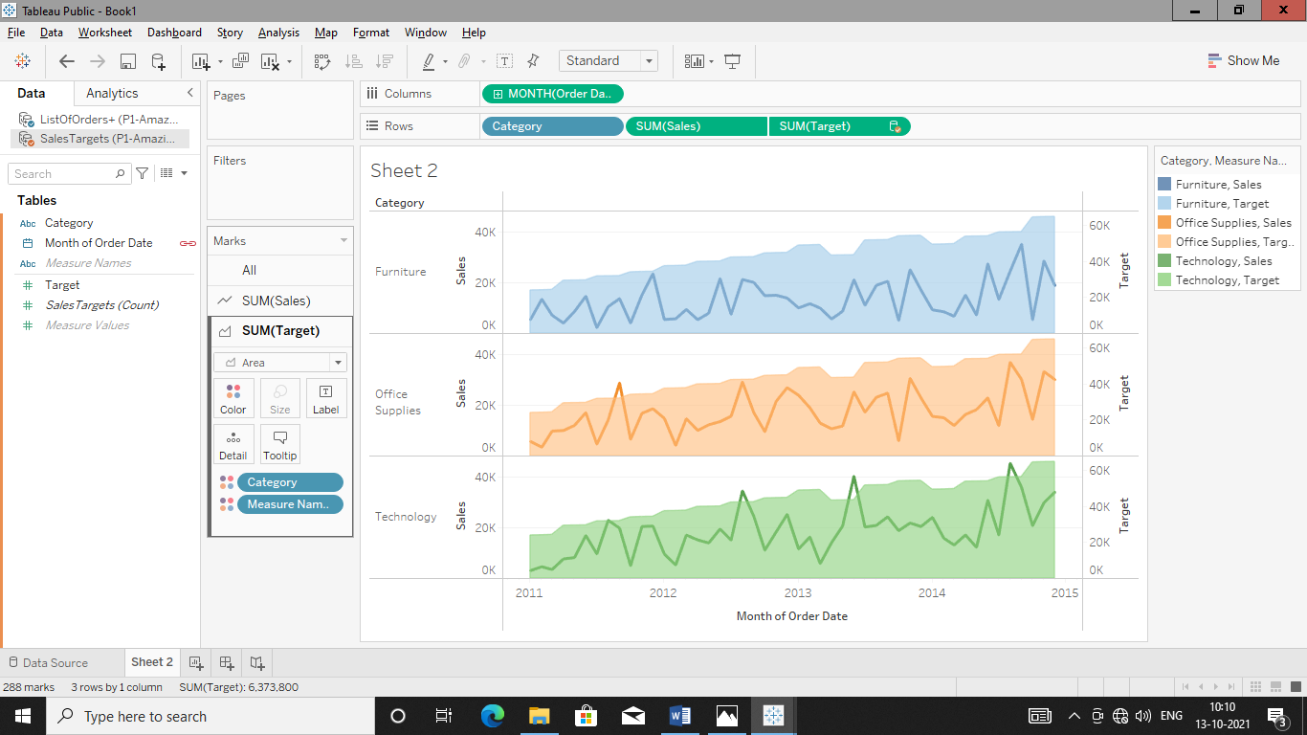

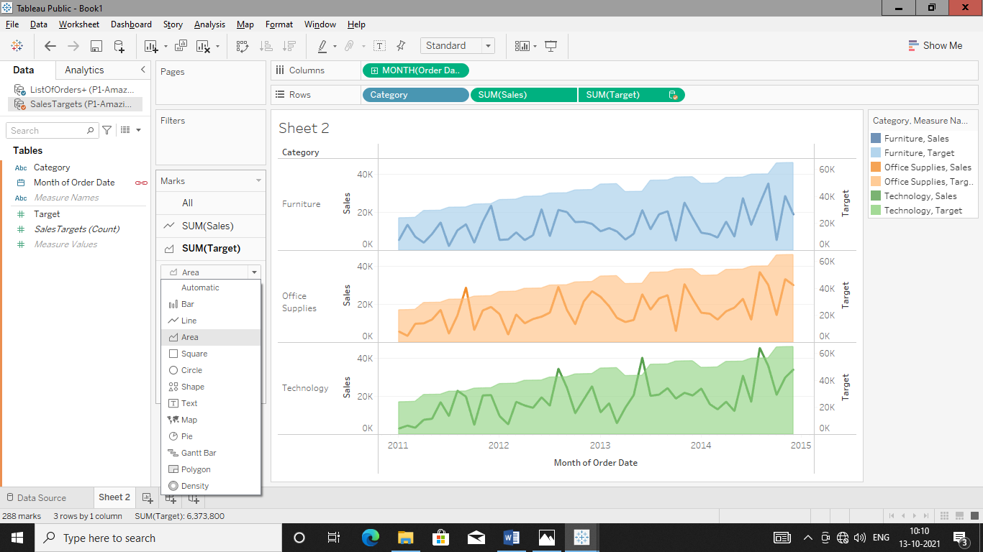

Add Dual Axis in graph in order to get perfectly analyse graph.

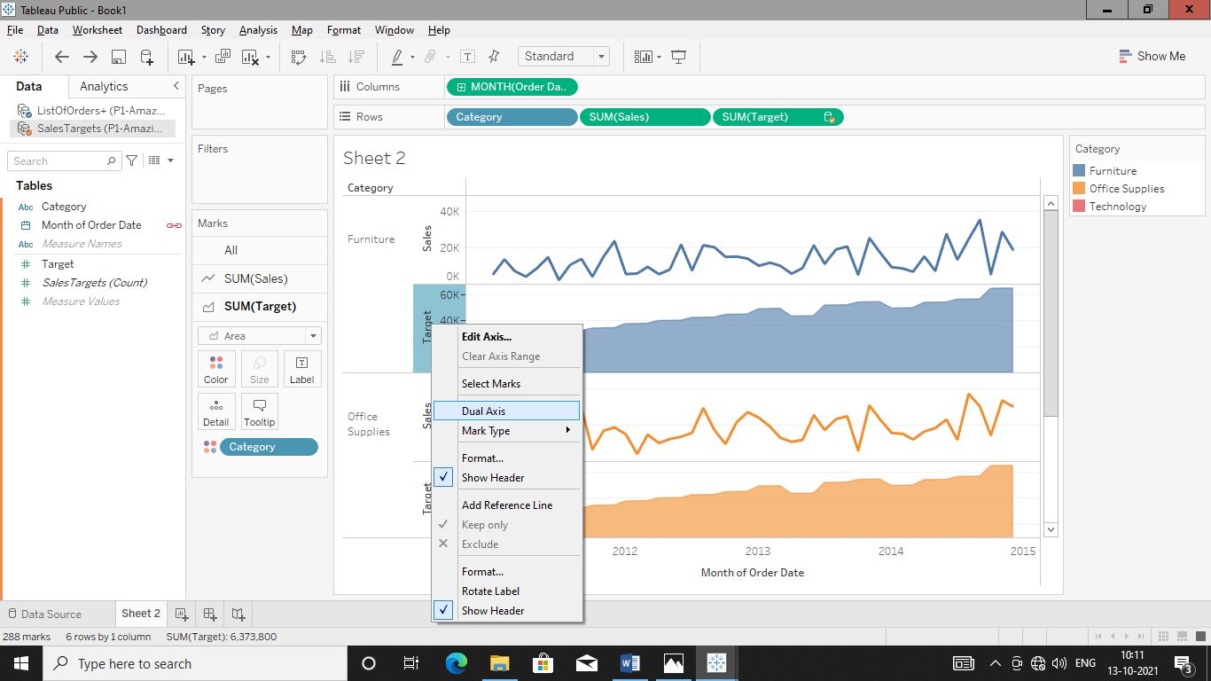

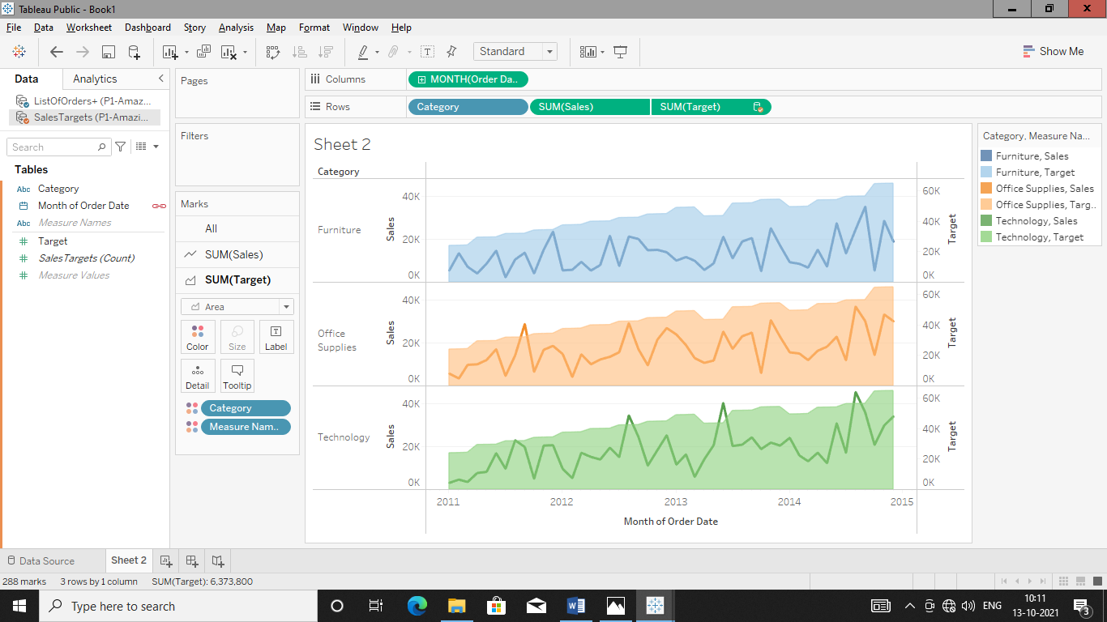

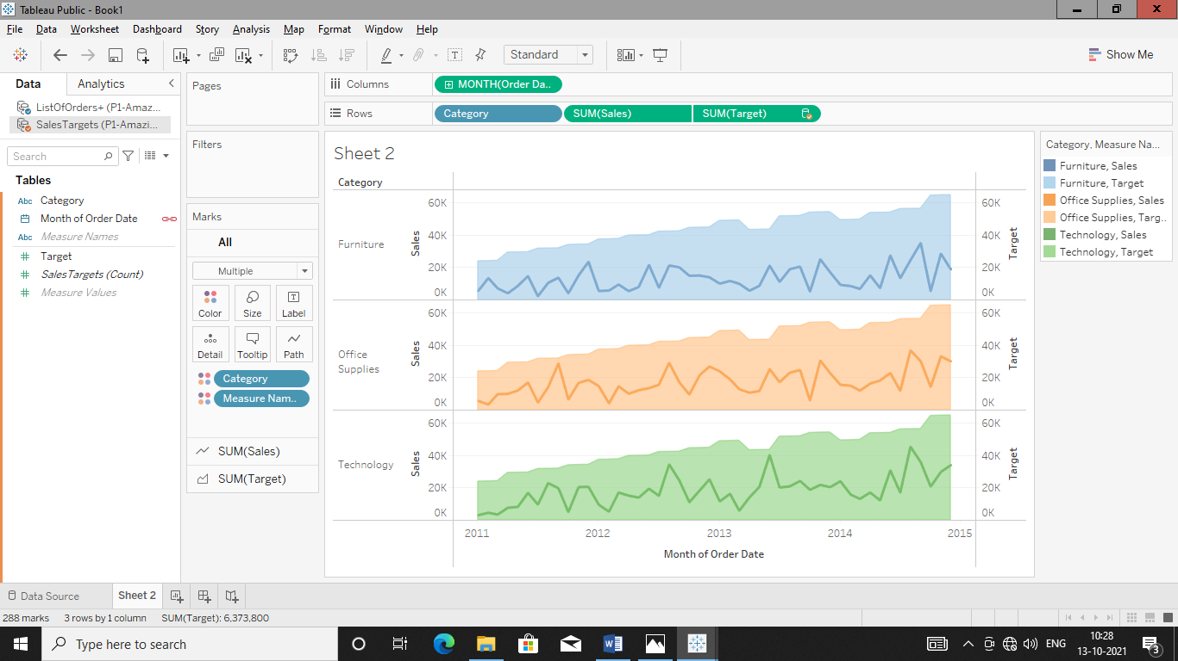

**DAY-06**

**14/10/2021**

**Name**: Harshal Acharya

**Roll No**: 12

**Batch**: B11

**Datasets:** UK Bank Customer

**Topics:**

Set Geographical Location

Creating table calculation in percentage

Create bins and distribution

**Set Geographical Location**

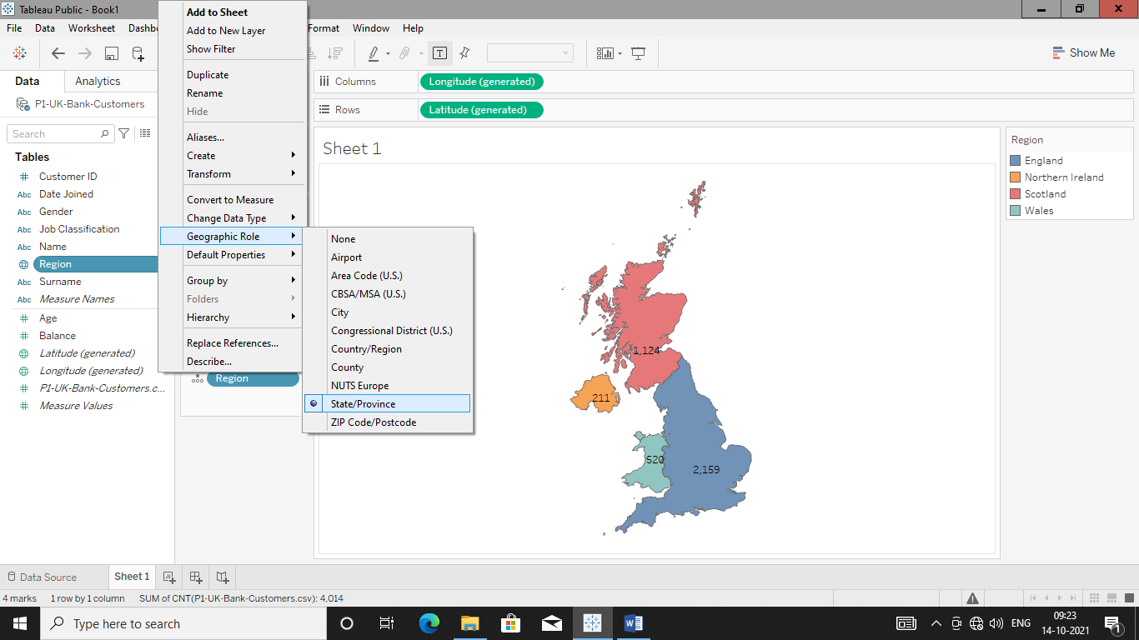

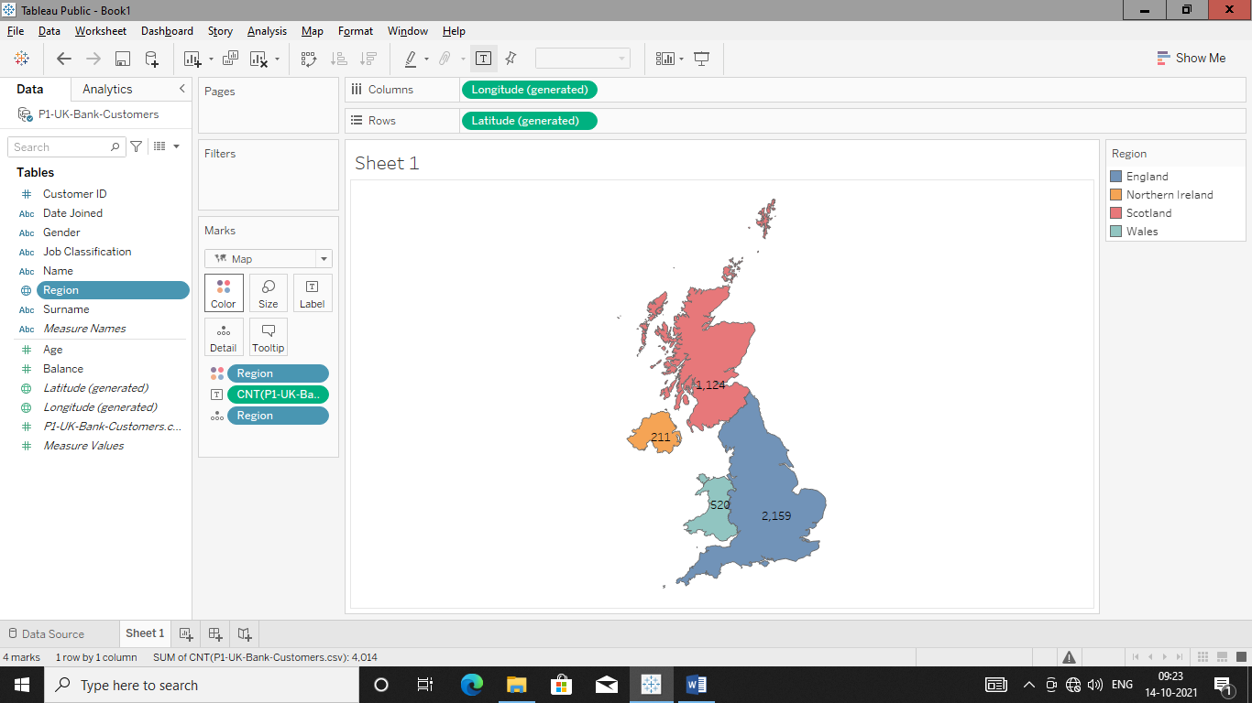

Pie chart gender wise customers in percentage%

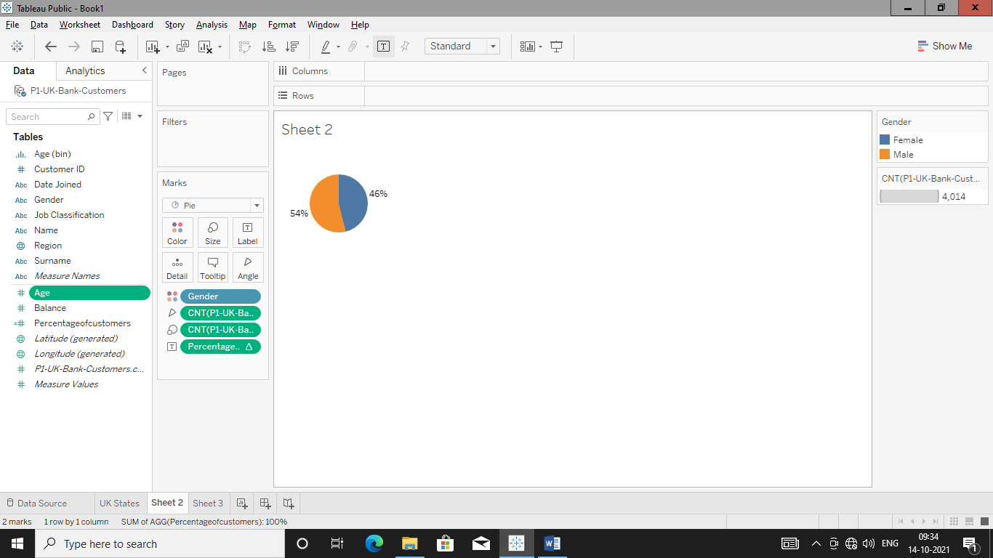

Creating bins & Distributions

Age(Bins)

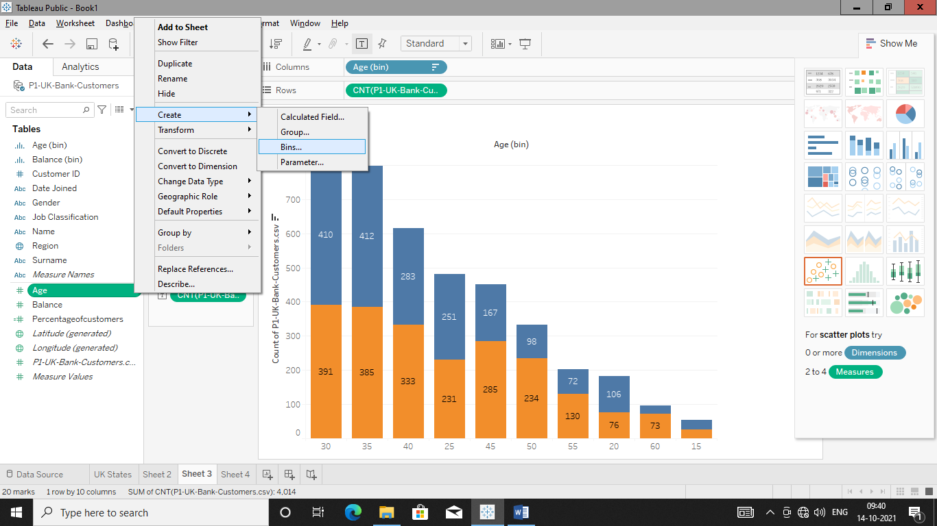

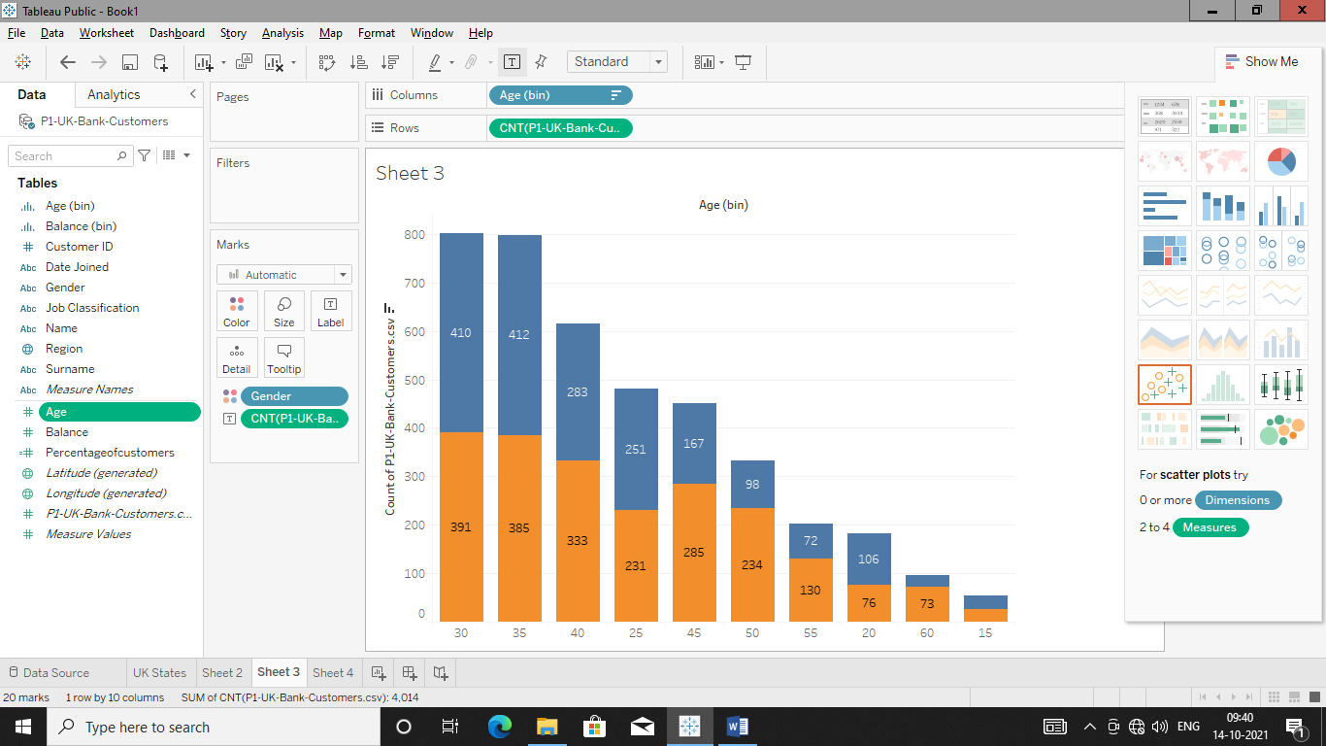

Create Parameters

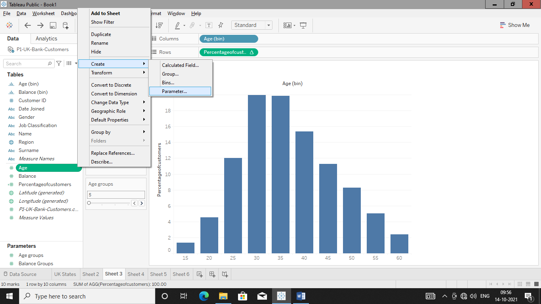

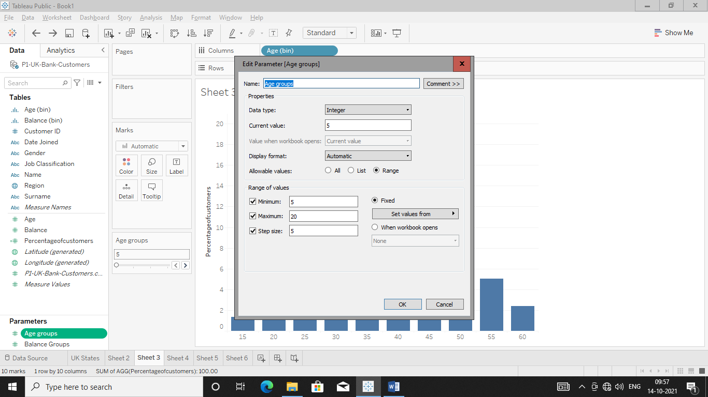

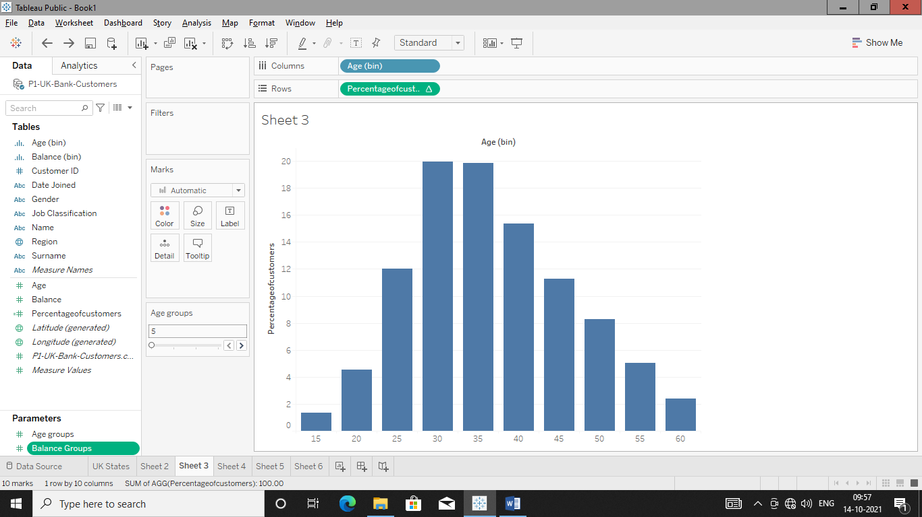

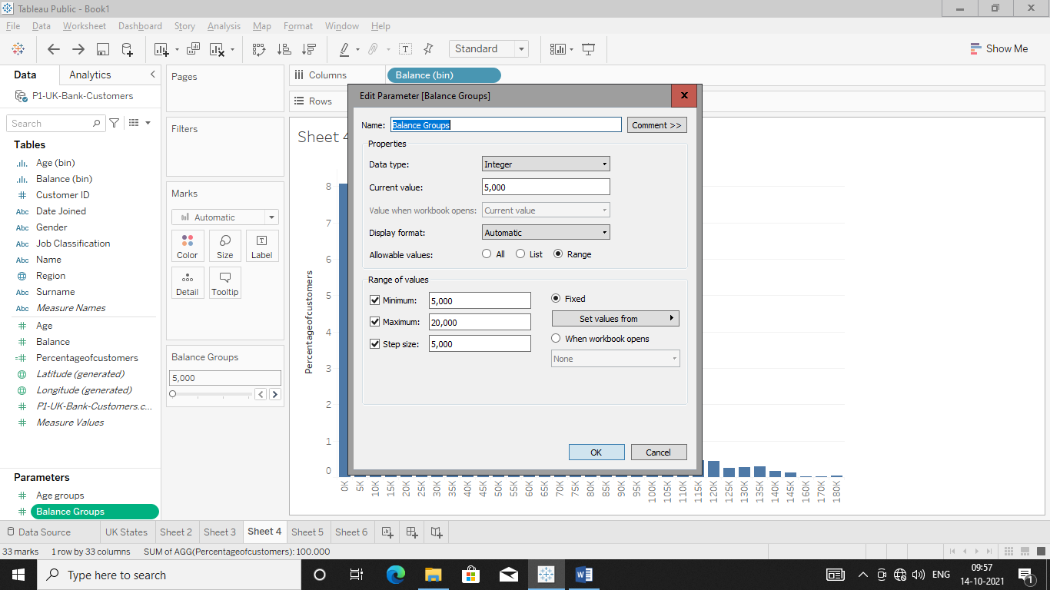

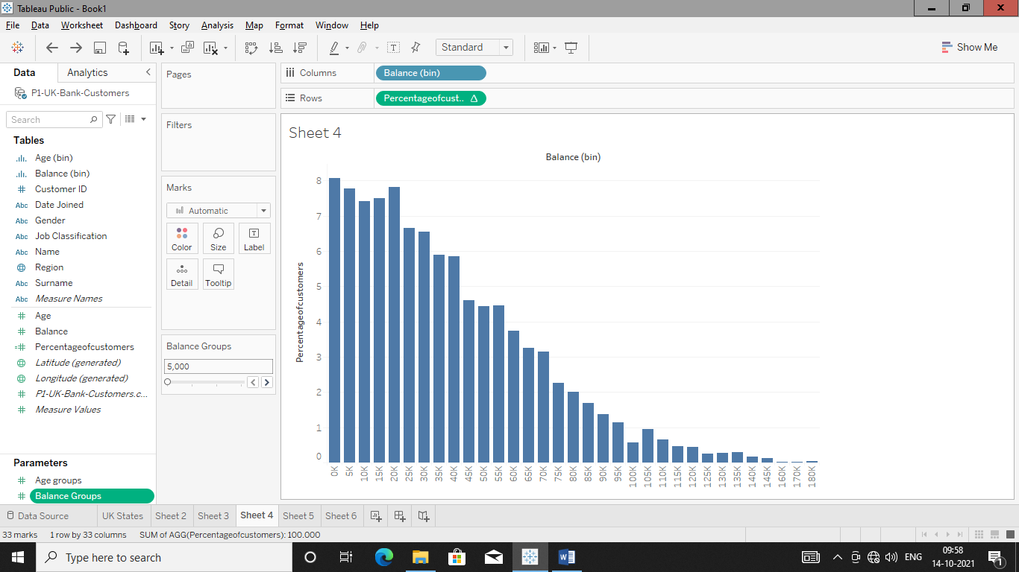

Create Tree Map for Job Classification

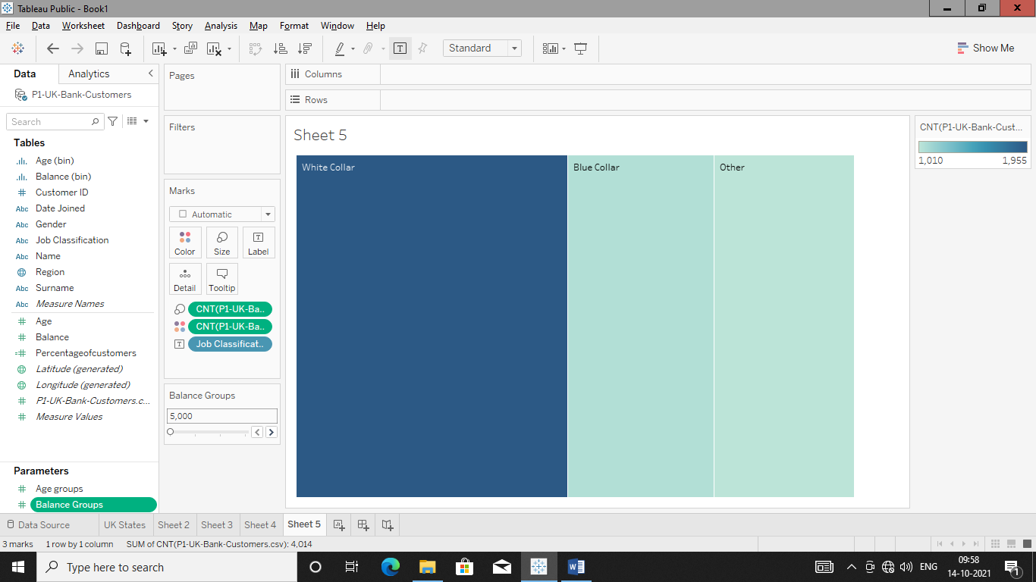

Sheets:

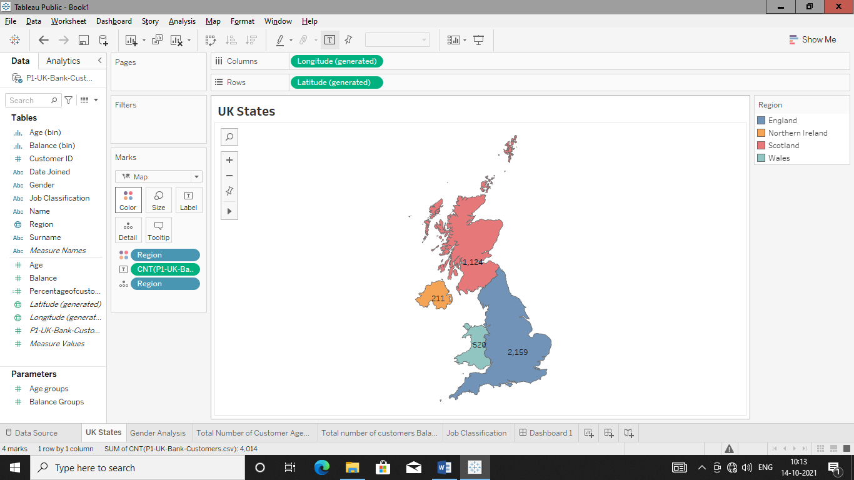

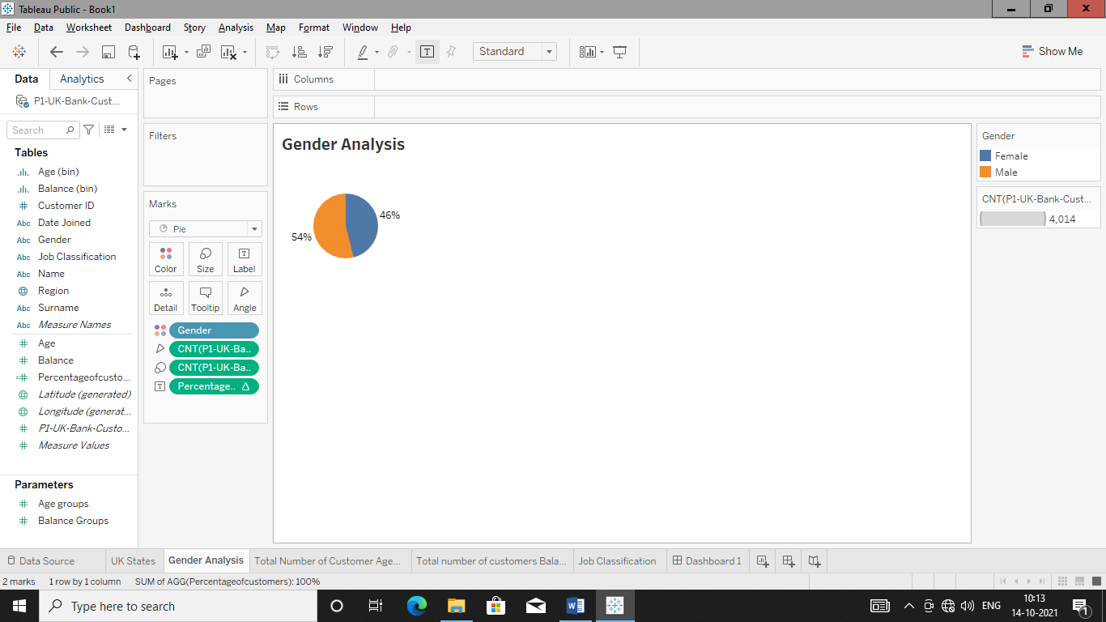

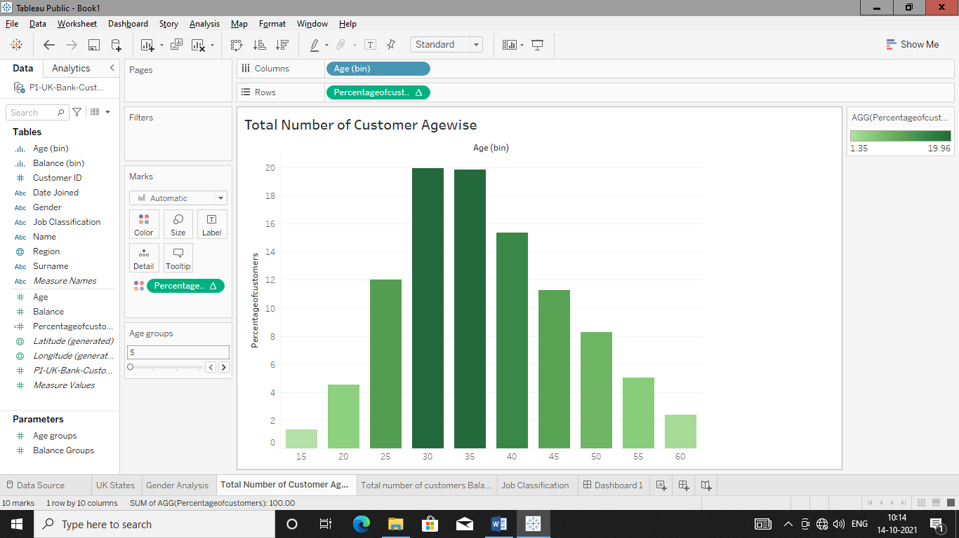

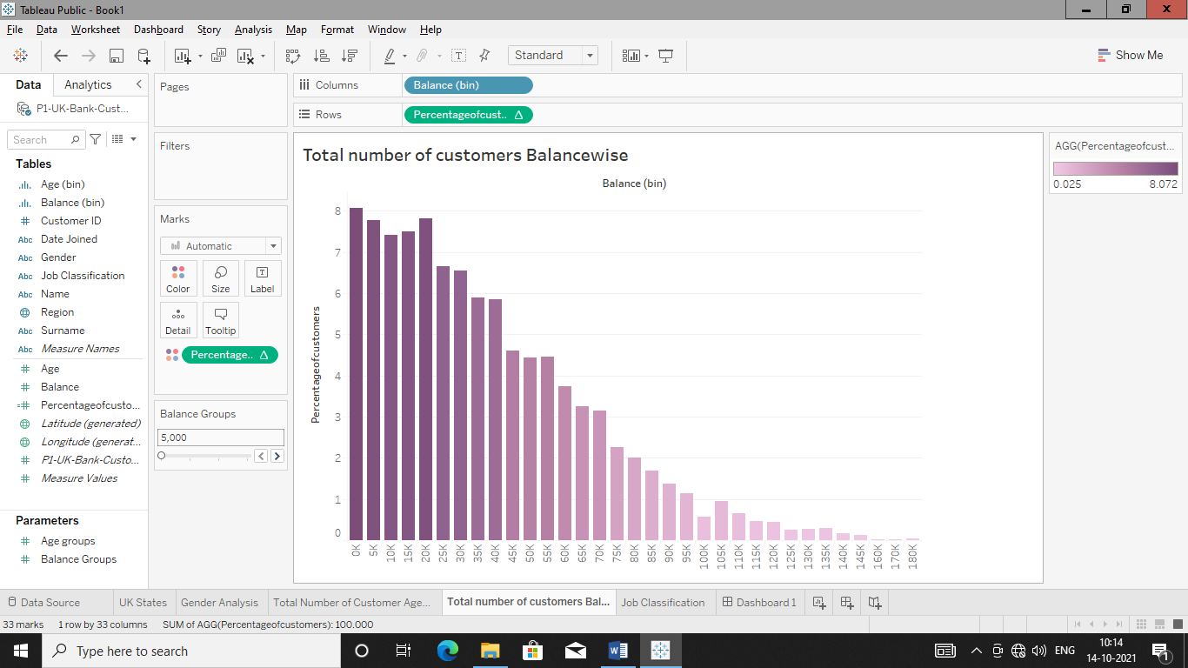

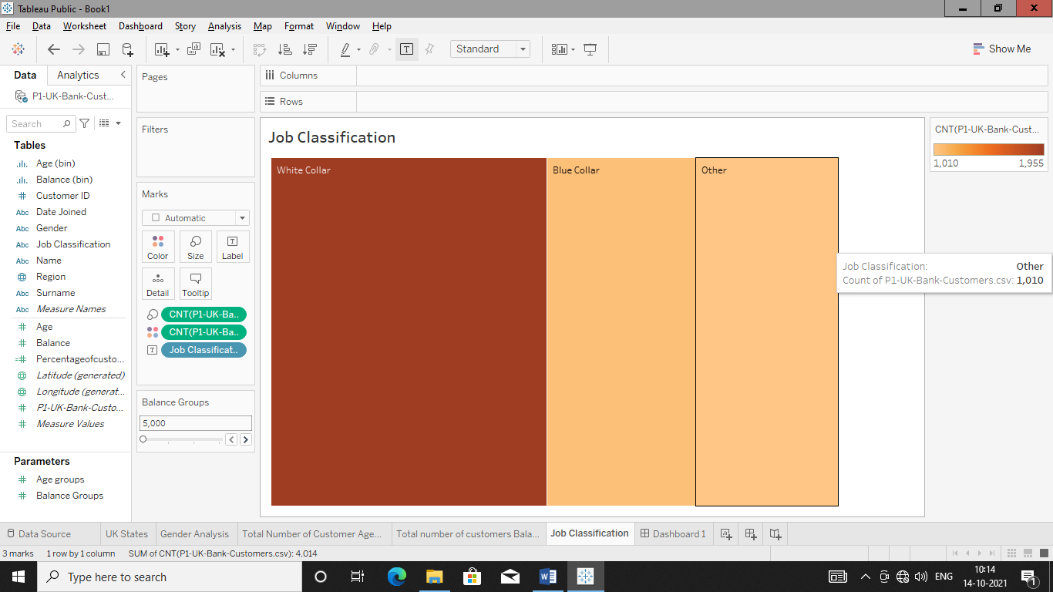

Dashboards

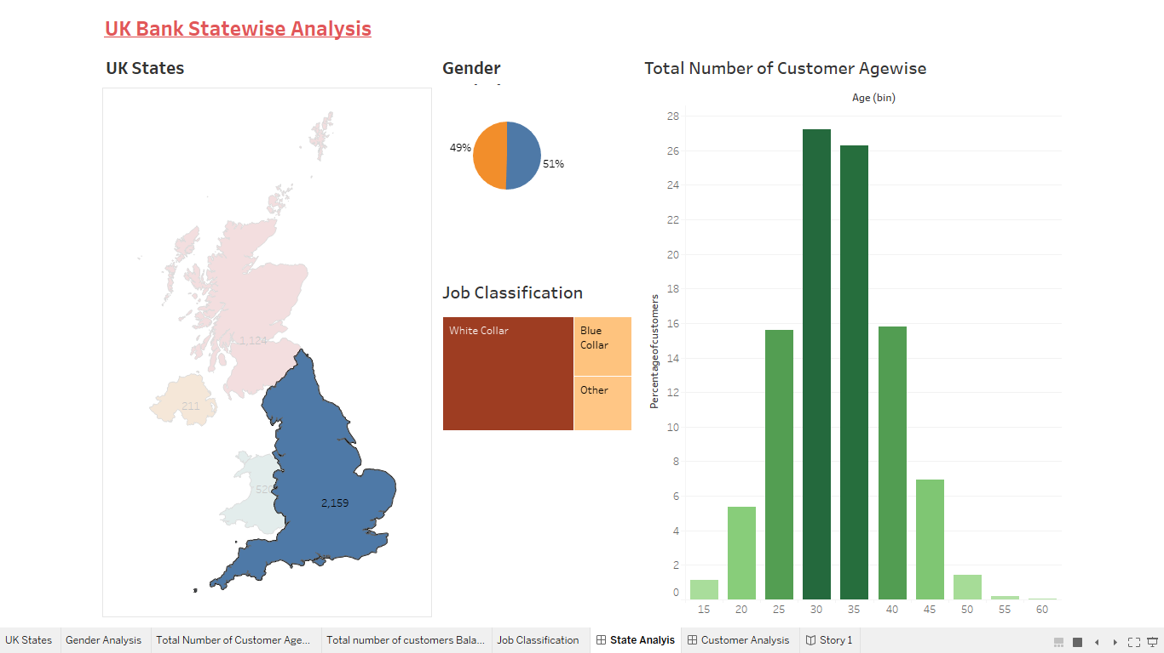

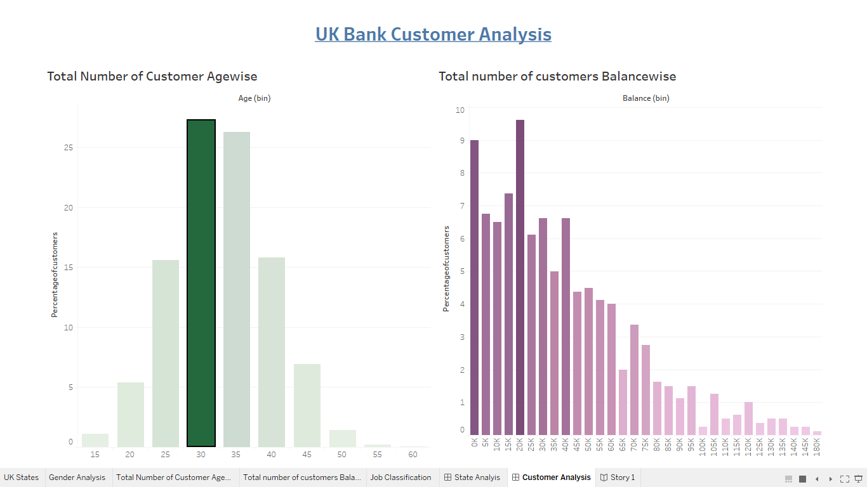

Story

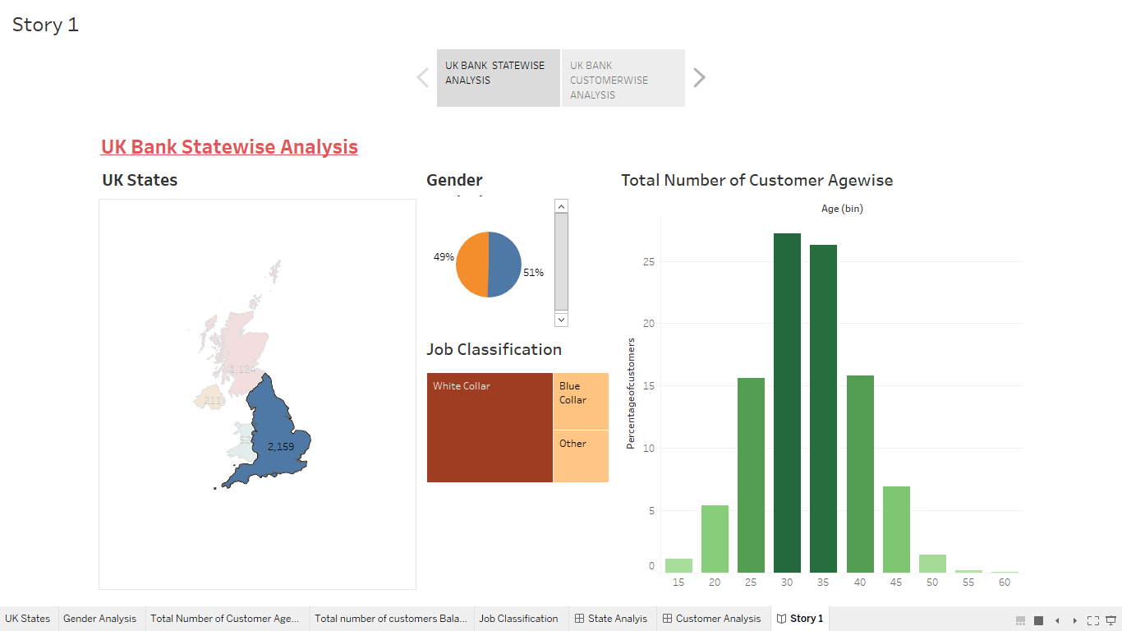

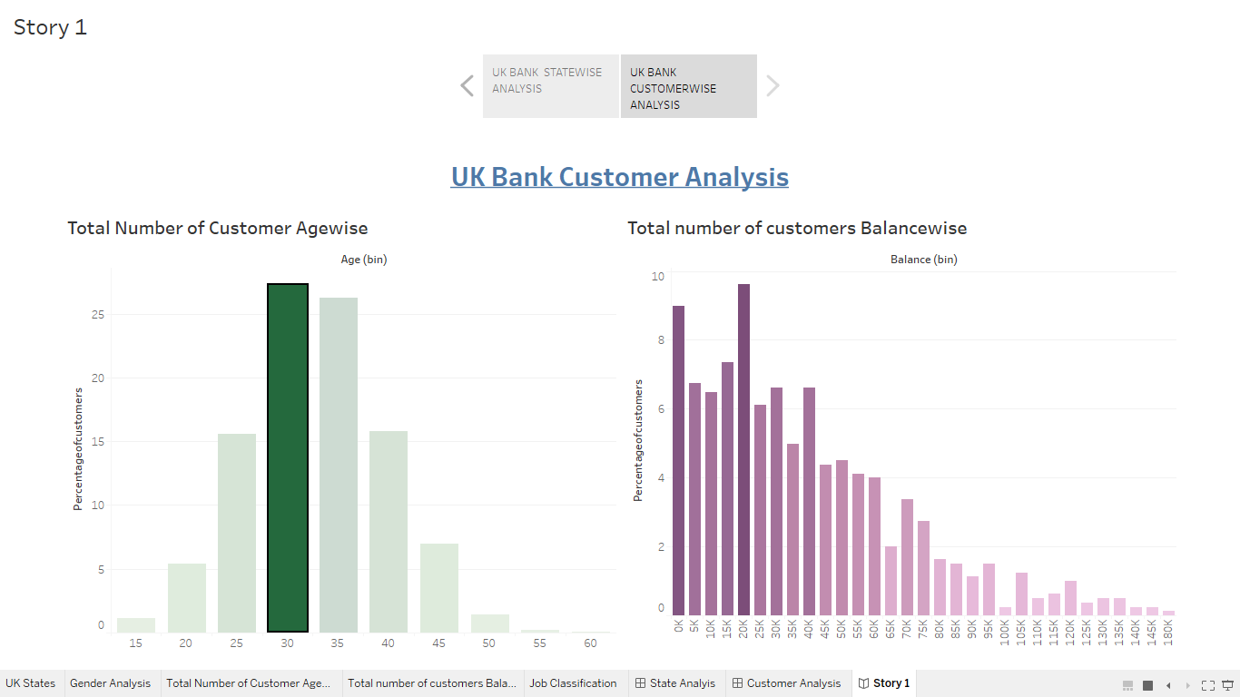

**DAY-07**

**17/10/2021**

**Name**: Harshal Acharya

**Roll No**: 12

**Batch**: B11

**Datasets:** Amazing Mart EU

Charts:

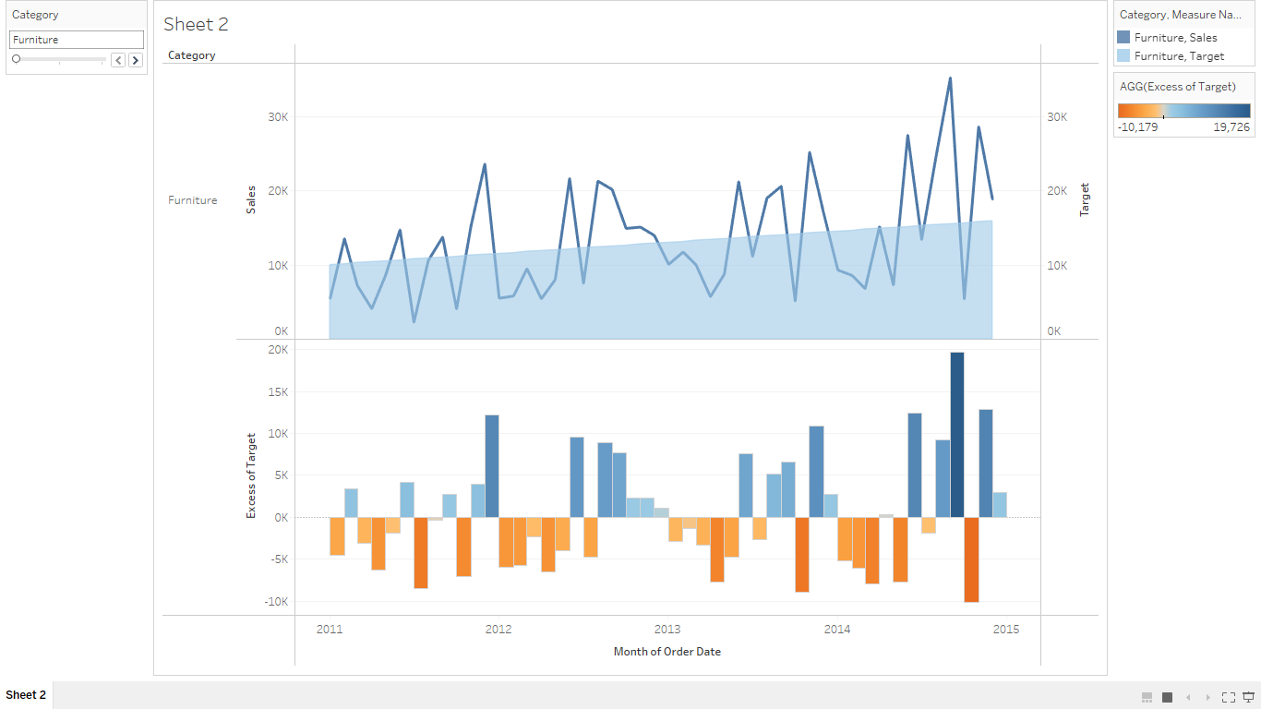

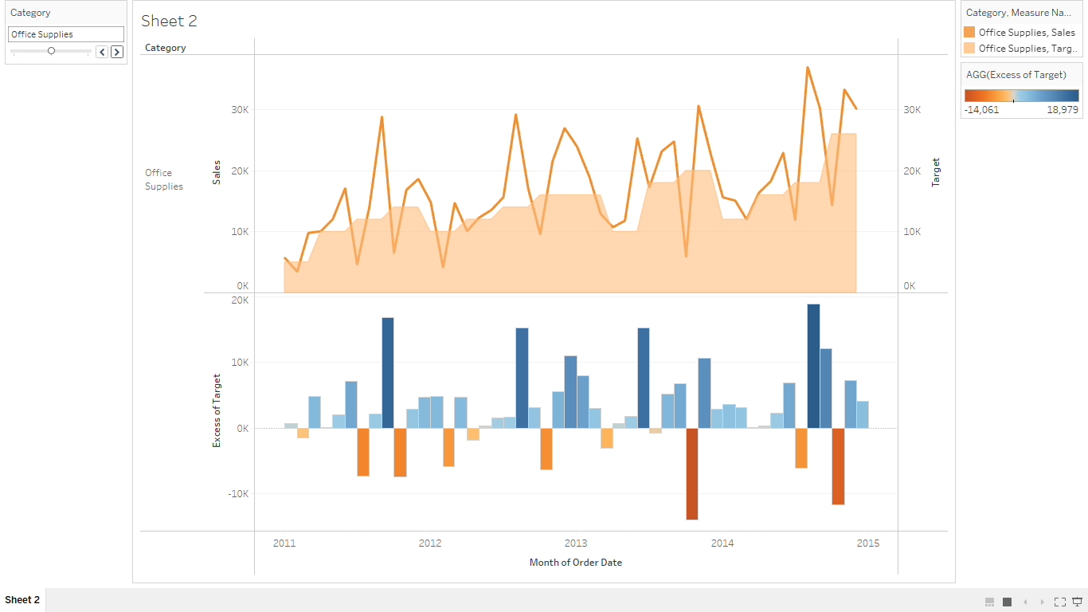

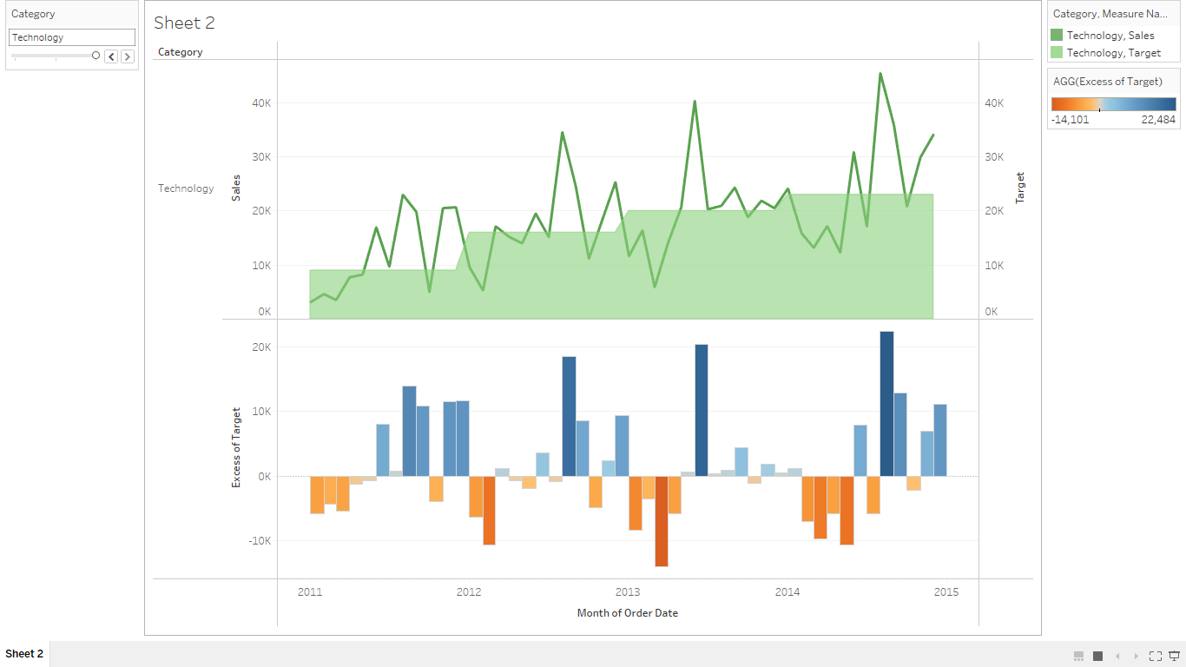

**Dataset:** Personal Vehical Sales Global

Use Of Data Cleanup,Interpreter and Pivot

